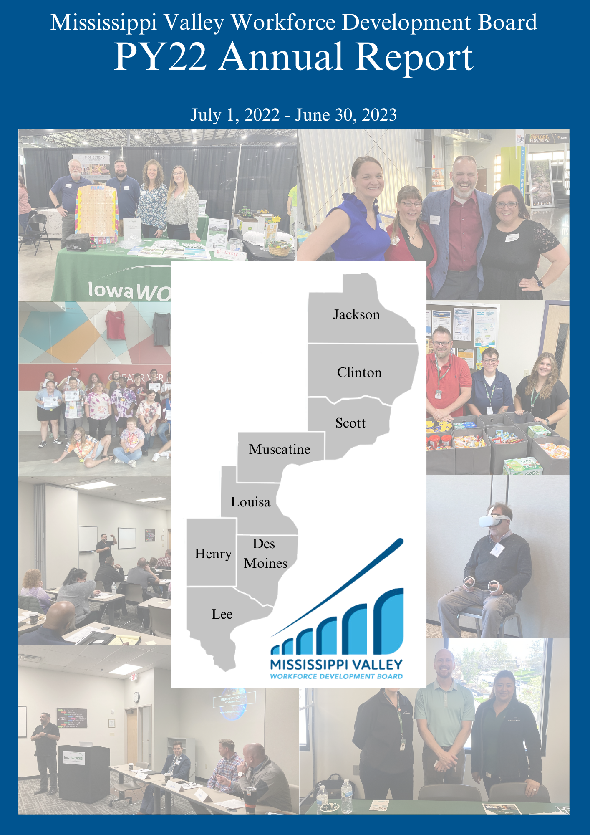

Message from the Executive Director
Dear Friends and Supporters,
As we reflect upon the journey of the past year, I am filled with an overwhelming sense of gratitude for the incredible community of supporters, volunteers, and partners who continue to make our mission a reality.
Over the last three years of our organization’s existence we have been driven by the belief that positive change is possible, even in the face of adversity. It's this unwavering optimism, combined with the tireless dedication of our team and the support of individuals like you, that allows us to achieve remarkable things year after year.
In this year's annual report, you will find a comprehensive overview of the impact we've made in our community and beyond. From the programs that have touched countless lives to the innovative initiatives that are shaping our future, each page is a testament to the power of collective effort and compassion.
As the Executive Director of this organization, I am honored to witness firsthand the transformation that occurs when people come together with a shared purpose. It is because of your belief in our vision, and your willingness to stand by us that we have been able to achieve so much.
While we celebrate our successes, we also recognize that there is still much work to be done. The challenges we face are complex and ever-evolving, but we are undeterred. With your continued support, we are prepared to meet these challenges head-on and to adapt and innovate as needed.
In the coming year, we have ambitious plans to expand our reach, deepen our impact, and further our commitment to the communities we serve. We will continue to invest in programs that address workforce issues, and we will work tirelessly to ensure that every dollar and every hour invested in us yields the greatest possible return in terms of positive change.
I invite you to explore our annual report, not only as a record of our achievements but as an invitation to be part of our future endeavors. Together, we can continue to write stories of hope, resilience, and progress.
We extend our heartfelt gratitude for standing by the Mississippi Valley Workforce Development Board, contributing to the betterment of the lives of those who reside in our communities.
Warm Regards,
Miranda Swafford, MPA
Miranda Swafford
Executive Director

Mississippi Valley Workforce Area
The counties in the Mississippi Valley Workforce Area include Jackson, Clinton, Scott, Muscatine, Louisa, Lee, Des Moines, and Henry. There are two comprehensive American Job Centers in our Local Area; Burlington IowaWORKS - 550 S Gear Avenue Ste 35, West Burlington, Iowa 52655, and Davenport IowaWORKS - 1801- E Kimberly Rd, Ste A, Davenport, Iowa 52806

Mission, Vision, Goals, and Objectives

Vision - Create strong local economies by developing a future-ready workforce of skilled workers prepared to meet the needs of current and emerging industries.

Mission - The Mississippi Valley Workforce Development Board will achieve our vision by strengthening collaboration with local businesses and job seekers. We will improve access to our dedicated workforce partners through a fully integrated one-stop delivery system. Decisions will be data-driven to enhance our local economies and the quality of life for our communities.

Goals
Manager Role Goals
- Develop effective board practices that oversee the operational efficiency and performance of the American Job Centers.
- Engage board members to strengthen management practices and controls to fulfill the objectives and responsibilities of being effective stewards of public funds.
Convener Role Goals
- Expand workforce services for individuals at all levels of skill and experience.
- Enhance and nurture strong partners to build a skilled and ready workforce through innovation and alignment across programs to provide a comprehensive set of solutions for businesses and job seekers.
- Implement strategies to ensure that the local workforce system meets the needs of businesses in the local area and that businesses have the opportunity to engage with the system in meaningful ways.
Strategist Role Goals
- Expand workforce services for individuals and businesses through a fully integrated one-stop delivery system that provides a seamless customer experience.
- Expand outreach and services to all rural areas in the Mississippi Valley Workforce Area.
- Conduct research to understand the needs of business and industry in the local area and use data to drive strategic decision-making.
- Develop a nimble and responsive talent delivery system that meets current employers’ needs and anticipates future challenges.
Optimizer Role Goals
- Continuously monitor performance and make policy or service adjustments to foster continuous improvement.
- Supplement public investment with commitments from industry, labor, public, and community partners to implement new ideas and strategies.

Adult, Dislocated Worker and Youth Program Highlights
- 366 Virtual Reality career exploration users
- $12,795 was awarded to 3 employers to upskill 39 employees
- 10 Businesses were provided Rapid Response Assistance
- $107,591.39 was paid to 27 Adults and Dislocated Workers for work based learning
- $248,944.28 in Scholarships was paid to 84 Adults and Dislocated Workers
- $212,179.53 was paid out in support services to 168 Adults and Dislocated Workers
- $116,972.660 was paid out to Youth participants in client incentives
- 323 Enrollments across all programs

System Highlights
- 21,162 Individuals were served through the Mississippi Valley IowaWORKS Centers
- 4,922 Job Seekers Participated in Center Workshops
- 2,081 local area employers were provided over 12,000 business services
- 541 Veterans were served during the year
- 37 multiple-employer job fairs were hosted by the two IowaWORKS Centers on-site and throughout the Mississippi Valley Workforce Area
- 27 recruitment and hiring events were hosted for specific employers
- 1,416 People with Disabilities were served and 203 were placed in employment with an average wage of $14.25 an hour

Board Funded Programs
The Mississippi Valley Workforce Development Board’s primary source of funding is provided through the Workforce Innovation and Opportunity Act, federal legislation passed in 2014 to provide Title I Adult, Dislocated Worker and Youth services. This program year the Mississippi Valley Workforce Development board rebranded our youth program to Accelerate Iowa. Most of the boards programs and services are provided through a contracted service provider that operates out of the IowaWORKS Centers.

Youth Program

Click here to visit the Youth Services page of the board’s website.
Our Youth Program focuses on helping young people, particularly those facing barriers to employment, to gain the skills and experience necessary to enter the workforce and achieve self-sufficiency.
The program is designed for young people between the ages of 14 and 24 who face various barriers to employment. These barriers may include a lack of education or job skills, low-income status, disabilities, or other challenges that hinder their ability to secure and maintain employment. Our program gives priority to serving at-risk youth, including those who have dropped out of school, are homeless, are in foster care, or are involved with the juvenile justice system. These individuals often face significant barriers to employment and may require additional support.
Our program offers a range of services to help youth prepare for and find employment. This includes educational services, job training, work experience opportunities, mentoring, career counseling, and support services such as transportation and childcare.
We focus on work-based learning opportunities, such as internships, apprenticeships, and on-the-job training, to help young people gain real-world experience and develop the skills employers are looking for.
Our program emphasizes the development of career pathways, which are structured plans that outline steps for career advancement and skill development in specific industries or occupations.

Adult and Dislocated Worker Program
This program is designed to assist two specific groups of individuals: adults who are seeking employment and job training, and dislocated workers who have lost their jobs due to economic factors such as plant closures or mass layoffs. Both programs provide a range of services to help participants obtain employment or improve their job prospects. These services may include job search assistance, career counseling, skills assessments, work-based learning, training, educational programs, and supportive services.
The program may fund training programs, including occupational skills training (scholarships), on-the-job training, apprenticeships, and education services such as adult basic education and English language learning classes.
Our program gives priority of service to veterans and eligible spouses for the Adult and Dislocated Worker programs. This means that veterans and their spouses are given preference in accessing program services.
Our Adult and Dislocated Worker Program plays a crucial role in helping adults and dislocated workers gain access to the resources and support they need to re-enter the workforce, obtain new skills, and advance their careers.

Adult, Dislocated Worker and Youth Enrollments
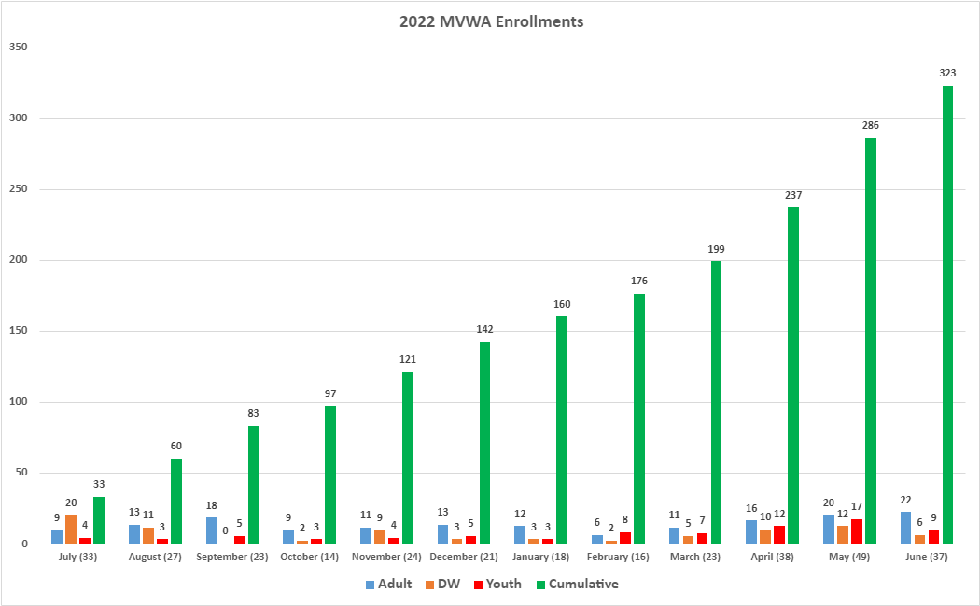

Federal Annual Performance Results
Adult
 |  | State Negotiated Rate (Goals) | Actual Rate  Q1 | Actual Rate  Q2 | Actual Rate  Q3 | Actual Rate  Q4
Employment 2nd Qtr. |  | 72.5% | 82.9% | 80.0% | 79.6% | 81.2%
Employment 4th Qtr. |  | 66.0% | 78.5% | 78.9% | 78.3% | 75.9%
Median Earnings 2nd Qtr. |  | $6,100 | $6,473 | $6,589 | $6,589 | $6,532
Credential Attainment |  | 65.0% | 77.1% | 76.6% | 79.2% | 78.2%
Measurable Skills Gain |  | 44.0% | 46.7% | 60.0% | 67.7% | 71.3%

Dislocated Worker
 |  | State Negotiated Rate (Goals) | Actual Rate  Q1 | Actual Rate  Q2 | Actual Rate  Q3 | Actual Rate  Q4
Employment 2nd Qtr. |  | 85.0% | 83.7% | 85.7% | 82.1% | 81.0%
Employment 4th Qtr. |  | 85.0% | 88.0% | 83.7% | 79.2% | 81.3%
Median Earnings 2nd Qtr. |  | $8,900 | $8,744 | $10,038 | $9,260 | $9,327
Credential Attainment |  | 69.0% | 81.8% | 78.8% | 79.4% | 78.8%
Measurable Skills Gain |  | 44.0% | 53.8% | 63.4% | 63.1% | 70.1%

Youth
 |  | State Negotiated Rate (Goals) | Actual Rate  Q1 | Actual Rate  Q2 | Actual Rate  Q3 | Actual Rate  Q4
Employment 2nd Qtr. |  | 73.0% | 71.9% | 68.9% | 70.6% | 72.1%
Employment 4th Qtr. |  | 73.0% | 80.0% | 80.0% | 63.2% | 67.2%
Median Earnings 2nd Qtr. |  | $3,700 | $3,454 | $3,376 | $3,696 | $3,299
Credential Attainment |  | 52.0% | 41.2% | 44.0% | 39.3% | 43.3%
Measurable Skills Gain |  | 35.0% | 24.3% | 27.3% | 44.0% | 47.4%

Adult, Dislocated Worker Investments and Participants Served

$107,591.39 $248,944.48

Work-Based Learning (27) Scholarships (84)

$212,179.53 $13,473.09 94.22%

Support Service (168) On-the-Job Training (3) Customer Satisfaction Rate

Youth Investments and Participants Served
$47,615.59 $23,760.00 94.22%
Work Experience (17) Scholarships (19) Customer Satisfaction Rate
$38,805.92 $116,972.60 $11,895.69
Support Services (132) Youth Incentives (109) On-the-Job Training (8)

Business Partners for Work Based Learning/On-the-Job Training

- PTV Accounting
- Stronghurst Collision & Repair
- Little Angels Childcare
- Stuff ETC Inc
- Alfagomma
- YMCA
- Visiting Angels of the Quad Cities
- Community Action of SEIA
- Clinton Substance Abuse Council Inc
- Cedar River Ranch/Haven
- Burlington Municipal Waterworks
- Community Health Center of SEIA
- Main at Locust Pharmacy Clini
- Cedar River Ranch/Haven
- Hope Haven Area Development
- Community Action of SEIA
- Romatherapy
- Grandma's Goody Jar
- Katun Corporation
- Main at Locust Pharmacy Clinic
- Burlington Comm. School District
- Eagle View Community Health
- Pirate's Bay
- Carwash
- K9 Resort
- Youth WEX
- Rec Plex
- CA Head Start
- Stuff ETC Inc
- Cedar River Ranch/Haven
- Renaissance Resale Boutique
- Borghi USA Inc
- Cory Richards American Family Insurance
- ISA Balloon Design and More
- YMCA
- Katun Corporation
- Northwest Bank and Trust
- Pet Bath & Beyond
- PAWS
- Precision Metal Works
- UnityPoint Health - Rock Island
- Des Moines County Humane Society
- Pritchard Broadcasting
- Petersen Insurance & Financial Agency LLC

Virtual Reality
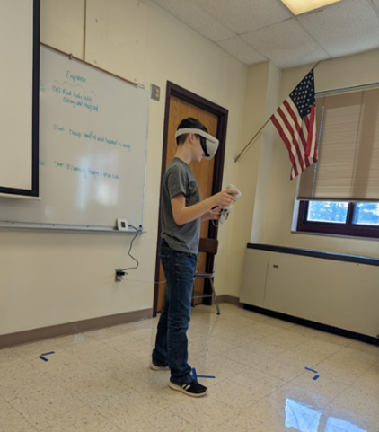
During this program year Accelerate Iowa implemented twenty virtual reality headsets into service delivery. These were used to enhance career fairs and introduce local area youth to new career possibilities through hands-on Career Exploration.
Accelerate Iowa Career Navigators attended Burlington STEM Fest in February 2023, where attendees had the opportunity to explore careers using the headsets. Accelerate Iowa also hosted Career Exploration events throughout the Mississsippi Valley Workforce Area, which were attended by local employers, school district staff, and community partners.
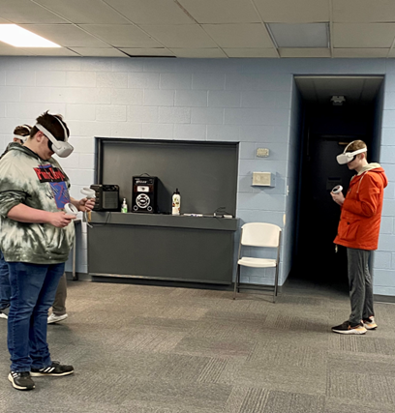
The Virtual Training Facility offered youth the opportunity to connect immersive instructional simulations to real-world applications at work experience placements. Options include hospitality and tourism, automotive technology, skilled trades, warehousing and storage, public safety, and manufacturing. 85% of simulations were mastered by users in the Virtual Training Facility.

366

Career Exploration Users

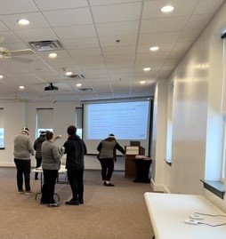
13
Virtual Training Facility Students

Adult, Dislocated Worker and Youth Credentials Earned
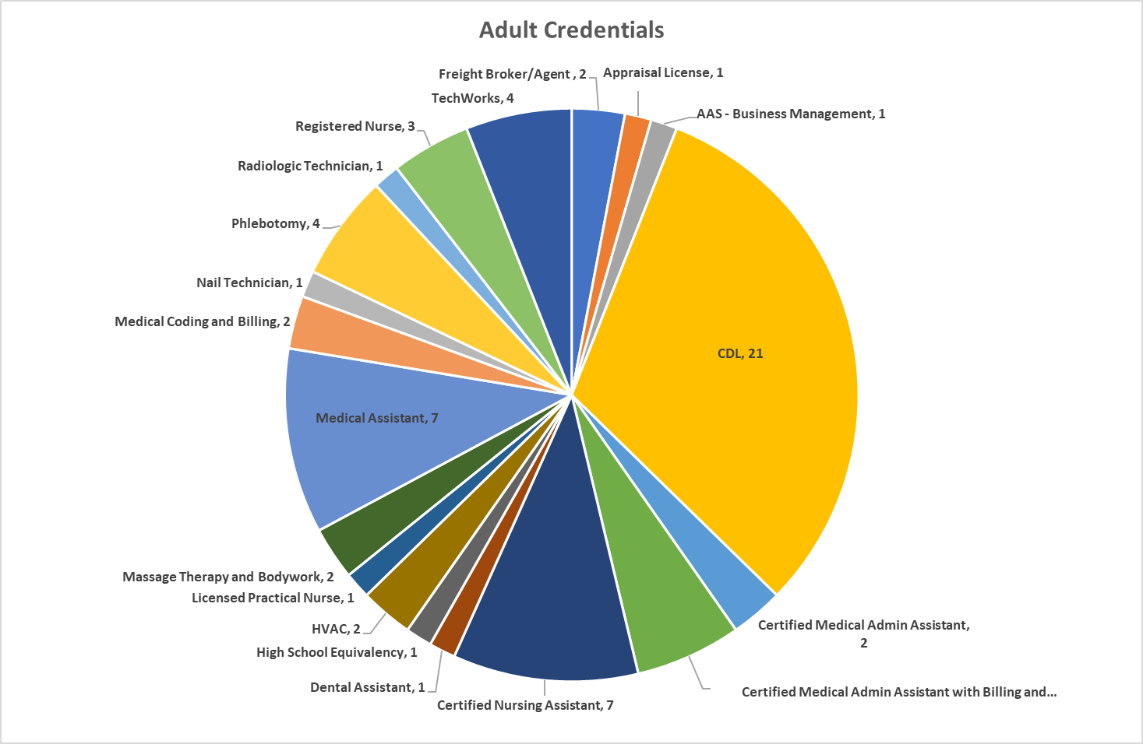
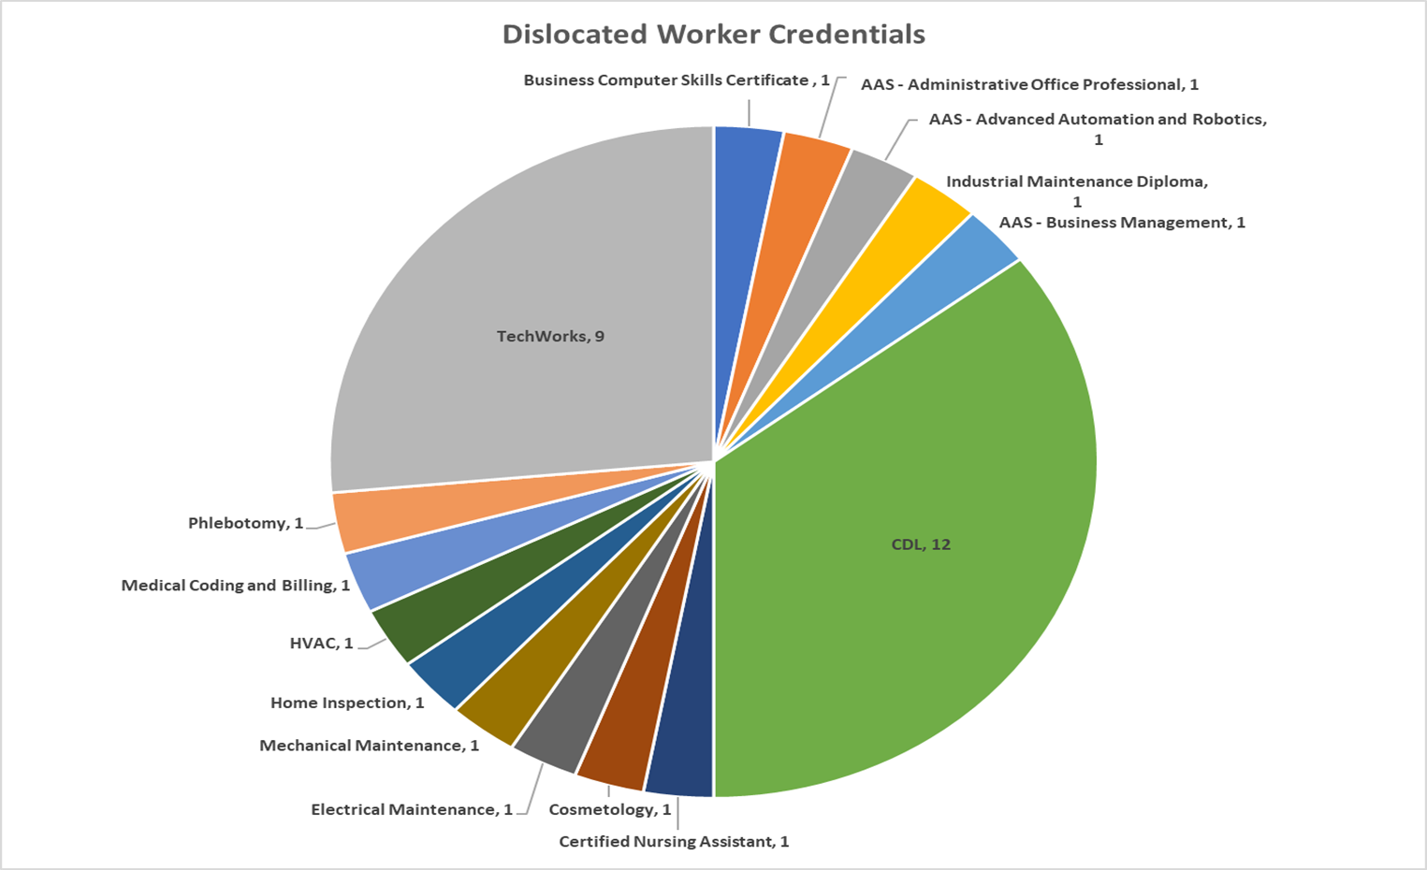
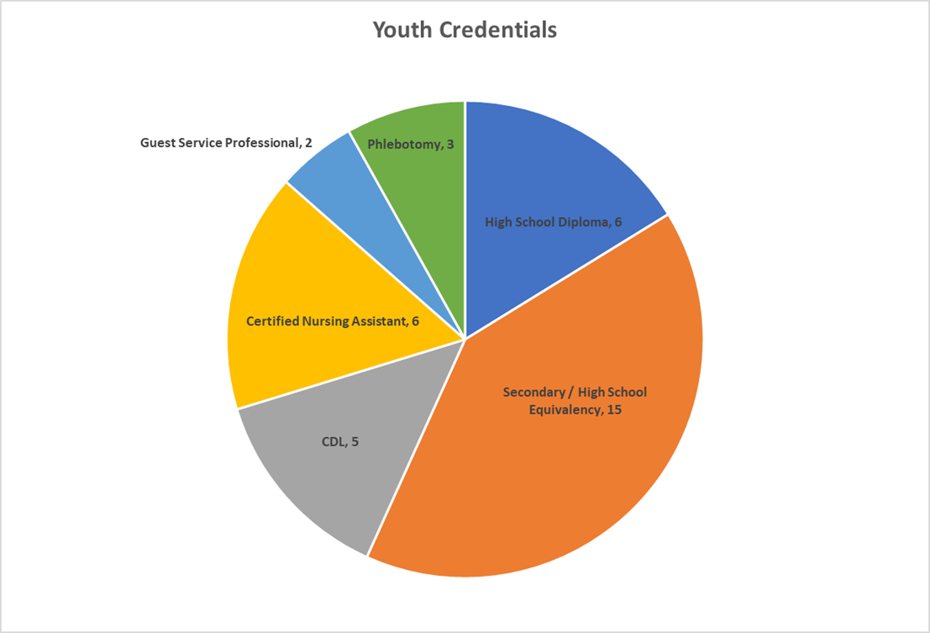

Rapid Response

Rapid Response activities are provided to businesses experiencing downsizing or layoffs. The following businesses were offered Rapid Response services in PY22 and the number of employees affected:
Number of Businesses | Number of Employees Affected | Number of Services Provided
14 | 1,012 | 36

Retrain & Retain Grant Program

In January of 2023, the board launched a new incumbent worker training program, known in the area as the Retrain & Retain Grant Program. Companies can be reimbursed for employee training that is focused on industry or business-specific skills, technical or computer skills, or foundational such as leadership, teamwork, and management. Preference is given to training that represents significant skill upgrades for employees and/or the greatest potential for impacting the business’ competitiveness. Click here to learn more by visiting the board’s website.

$12,795 3 39
Awarded Businesses Employees
The three businesses who were awarded the Retrain & Retain grant during PY22 were Car A. Nelson & Co., Novelis, Inc., and Black Cat Parts. Employees were trained on PartsRig loads and signal cranes, supervisor Fundamentals, effective training techniques, and supervisor and the Law.
Businesses used this funding to expand capacity, to use worker training to divert layoffs, increase employee skills and competencies, and to remain viable and competitive.

Adult, Dislocated Worker and Youth Participant Success Stories
In partnership with Iowa Vocational Rehabilitation Services, the city of Burlington, and the Accelerate Iowa Youth program, Phillip is participating in a work experience at the Burlington Regional Rec Plex. Phillip started his employment journey while in high school. He participated in pre-employment transition services through the Transition Alliance Program (TAP) and Vocational Rehabilitation. He also participated in the Vocational Rehabilitation summer program for two years. Through that time, Phillip developed an employment goal to work in conservation or a parks department role. Phillip is an Eagle Scout and loves nature, when discussing Phillip’s ideal employment setting, he stated “anything outdoors!” John, Phillips direct supervisor at the Rec Plex shared that he is doing a good job and has advocated for workplace accommodations, such as written instructions. Phillip’s grandma is very proud of him and stated that his success is attributed to not only his hard work, but also Vocational Rehabilitation and Accelerate Iowa Youth services.
Accelerate Iowa and Iowa Vocational Rehabilitation worked together to find a first job for a Davenport young adult, Mercedes. Stuff ETC. was happy to partner with both programs to facilitate this exciting opportunity for Mercedes through Accelerate Iowa's Work Based Learning program. Mercedes started her work experience by utilizing our Virtual Reality headsets. She successfully completed and got paid for her time practicing her skills in hospitality and customer service to prepare for her first day at Stuff ETC. After a few weeks on the job, she brought up her apprehension about getting moved to the cash register to her career navigator, Robert. After that conversation, Robert set up cashier practice for Mercedes in our IowaWORKS office. She practiced her customer service with our staff, made change for purchases, and most importantly, left that day a lot less nervous about being moved to the cash register. After 520 hours of paid experience, Mercedes was hired full time by Stuff ETC., received a pay raise, and will be eligible for benefits. Accelerate Iowa helped her build confidence in herself, try new things, and find a job to add to her resume. This opportunity launched her future in the local workforce. She is now one of the first smiling faces you see when walking into the Stuff ECT. location in Davenport.
While working on her medical billing and coding certification, Adult Employment and Training at IowaWORKS helped Rebecca connect to a career she didn't know she would enjoy. In August 2022, Rebecca and her career navigator, Sumita, worked together to find her a job more closely related to the medical field than the customer service positions she had held in the past. Sumita and Jamie, our business service consultant, met with Rebecca to identify potential work-based learning opportunities. After applying with local hospitals and pharmacies, Main at Locust Pharmacy hired Rebecca and agreed to partner through an on-the-job training opportunity. We were able to support Rebecca by purchasing her required uniform and study book for her pharmacy technician test. We were able to support a local, small business, Main at Locust Pharmacy, by reimbursing part of Rebecca's wages during her agreed upon training period. Rebecca successfully completed her on-the-job training in February of 2023, she is still studying for her pharmacy technician certification sponsored by Main at Locust Pharmacy and should test around August 2023. She successfully completed her medical billing and coding certification as of July 2023. Rebecca is still working at Main at Locust Pharmacy and intends to use the knowledge she has gained through her occupational skills training and on-the-job training for the rest of her life.

IowaWORKS Centers
The board plays a crucial role in the operation and oversight of American Job Centers (AJCs), otherwise known as IowaWORKS Centers, which are part of the publicly funded workforce development system in the United States. Boards are responsible for several key functions related to the operation of the IowaWORKS Centers, including to coordinate with various partners, including employers, educational institutions, service providers, and community organizations, to ensure that centers meet the needs of job seekers and employers in the local area.
The Board is responsible for planning, coordinating, reducing duplication of services and maximizing resources through the IowaWORKS network of partners. Additionally, the board is tasked with ensuring that they effectively serve the workforce needs of their communities and adhere to federal and state regulations. Their role is critical in connecting job seekers with employment opportunities and helping employers find skilled workers.
Boards contract with One-Stop Operators that assume the unique responsibility within the system for “coordinating” the service delivery of workforce partners. There are 15 required programs that must be provided through the IowaWORKS system.

IowaWORKS Center Customer Satisfaction
Month | Satisfaction Rate
July | 100%
August | 91.40%
September | 92.50%
October | 69.40%
November | 85.10%
December | 85.70%
January | 66.70%
February | 85%
March | 78%
April | 96%
May | 82%
June | 80%

IowaWORKS Center Customers

IowaWORKS Workshop Attendance
Workshop | Attendees
Career Services | 43
Resume | 671
Job Search | 858
Financial Literacy | 32
Interviewing | 1,210
Career Interest | 169
Digital Literacy | 8
Personal Growth | 287
Work Readiness | 155
Job Finding Club | 998
Labor Market Info | 25
Unemployment | 440
Other | 26

Referrals
In this program year the One Stop Operator oversaw a formal referral process for all required workforce partners in the Local Area. Referrals to and from programs are both tracked and reported to the board. Referral partners include workforce system partners and community organizations.

Employer Engagement Services
The Board developed a business services plan as guidance for the provision of Business Engagement and Business Services in the Mississippi Valley Workforce Area. The purpose of the plan is to outline the strategic vision of business service provision through IowaWORKS Centers. The board established a Business Committee in January of 2023 to provide guidance and support to the partners in ensuring implementation of this plan.
Each IowaWORKS Center has a business services team led by a board staff. These teams consist of staff from multiple workforce partners. The team first completed a self-assessment of their level of integration and an asset map of all business services provided in the Local Area. Upon completion of these tools the teams developed a strategic plan on how they would work together moving forward to reduce duplication of services and employer fatigue with an implementation date of July 1, 2023. A list of business services provided can be located at this link.
The Davenport and Burlington IowaWORKS centers continued to have regularly scheduled job fairs, hosting multiple employers on site and at locations throughout the Mississippi Valley Workforce Area. The Burlington and Davenport offices held 37 job fairs, which were attended by 1,150 job seekers. The IowaWORKS centers also partnered with specific employers to host recruitment and hiring events. There were 27 hiring events attended by 168 job seekers.
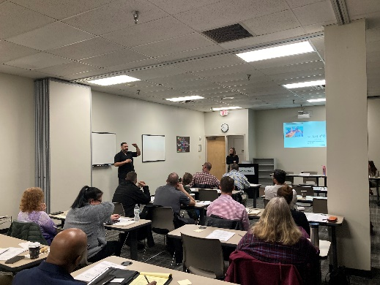
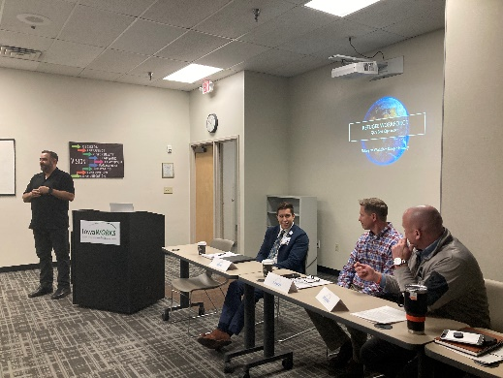
The Davenport office has begun discussing having more focused hiring events geared towards specific industries and job seekers such as healthcare, government, and re-entry as well as implementing more reverse job fairs. The reverse job fair for the Quad City Steamwheelers was successful and brought back again in PY22!
In March 2023, in collaboration with the Quad City Chamber of Commerce, World Relief refugee resettlement agency, and the Department of Health and Human Services, and the Iowa Bureau of Refugee Services, IowaWORKS hosted area employers for a three-part event focused on engaging the refugee community, making the workplace refugee-friendly, and investing in the long-term success of the refugee workforce. In May, these agencies collaborated again to host a Refugee and Immigrant Job Fair at Eastern Iowa Community College, which was attended by 36 employers, 7 community resources, and 96 refugee and immigrant job seekers. Interpreters were provided by World Relief for this event and laptops were available on-site so that attendees could receive support completing applications.

Business Services Provided
2,081 local area employers were provided with 12,789 business services in this program year. These services include but are not limited to assisting employers with accessing untapped labor pools, rapid response activities, job order follow-up and assistance, recruitment assistance, and guidance related to the establishment of Registered Apprenticeships.
Business Service | Total Employers | Total Services
Assisted Employer with Accessing Untapped Labor Pools | 106 | 123
Automatic Service – Job Order Created | 379 | 5,572
Continued Employer Engagement | 47 | 61
Employers view internal resumes | 147 | 4,820
New Employer Engagement | 96 | 100
Notification to Employer of Potential Applicant | 23 | 30
Notification to Employer of Resumes via Virtual Recruiter | 2 | 21
Planned Layoff Response | 5 | 8
Provided Candidate Pre-Screening | 7 | 9
Provided Employer Information and Support Services | 568 | 842
Provided Incumbent Worker Training Services | 4 | 4
Provided Job Fair Services | 182 | 347
Provided Job Order Follow-up/Assistance | 131 | 219
Provided Rapid Response / Business Downsizing Assistance | 14 | 28
Provided Strategic Planning / Econ. Development Activities | 20 | 29
Provided Training Services | 46 | 58
Provided Workforce Recruitment Assistance | 205 | 352
Referred Qualified Applicants | 70 | 112
Registered Apprenticeship - Handoff to Office of App’ship | 7 | 9
Registered Apprenticeship - In-Depth Meeting | 12 | 34
Registered Apprenticeship - Intro Meeting | 7 | 8
Registered Apprenticeship - Program Registered | 3 | 3
Total | 2,081 | 12,789

System-wide Partners & Services
The Workforce Innovation and Opportunity Act (WIOA) is a federal law in the United States that governs workforce development programs and services. WIOA requires the collaboration of various partners and the provision of specific services to help individuals access employment, education, and training opportunities. The following section highlights some of our key partners enrollments, services, performance and success stories. For a list of partners that are not co-located that provide services through the IowaWORKS Centers please visit https://www.mississippivalleyworkforce.org/partners

Enrollments
PY22 Enrollments
 | Burlington | Davenport | TOTAL
Jobs for Veterans State Grant | 10 | 60 | 70
Migrant and Seasonal Farm Workers | 15 | 48 | 63
Wagner-Peyser | 1,382 | 1,980 | 3,362
Vocational Rehabilitation | 676 | 740 | 1,416
Adult Education | 523 | 931 | 1,454

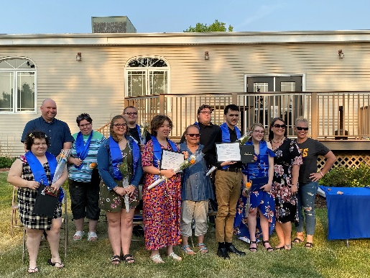
Serving Job Seekers with Disabilities
Vocational Rehabilitation is co-located in the Burlington and Davenport IowaWORKS Centers and are an integral part of the workforce system. Vocational Rehabilitation staff participate in the IowaWORKS Center’s integrated business services teams and center partner management meetings. The Board has identified individuals with disabilities as the 4th priority of service for services, showing their continued dedication to serving this population.
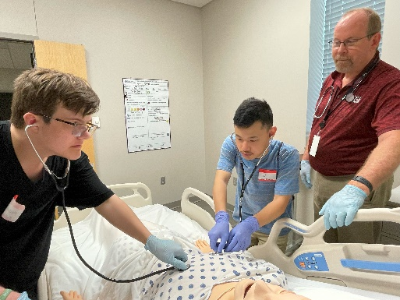
In May 2023, Vocational Rehabilitation had our Project Search Student graduation. This was an especially unique year for the Muscatine Project Search Program because this is the year the program took on students from outside districts including Louisa Muscatine High School and Durant High School. This is also our biggest year, our class size coming in at 8 students. We are also proud to announce that prior to graduation night we were able to get half the class placed in paid positions in the community. The other half we have applications out and pending.
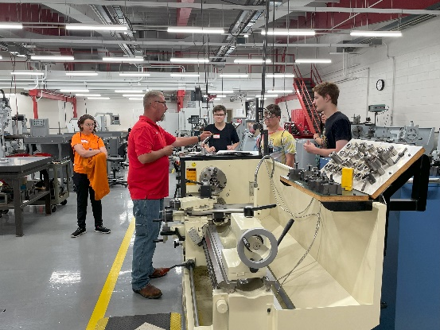
The Burlington office partners with Southeastern Community College PTC, Burlington Transition Alliance Program (TAP), and Fort Madison TAP to provide pre-employment transition activities. The Summer Program this year provided services to 42 students in Des Moines, Lee, Louisa, and Henry Counties. We could not make this happen without the help of our local education agencies, workforce partners, community service organizations, and our local businesses! The local team has demonstrated phenomenal teamwork and collaboration to make each daily event successful. Every Wednesday, students participated in work-based learning at volunteer sites in their local communities such as local parks, organic farms, community gardens, horse stables, and food banks.

Veterans Services
IowaWORKS collaborates with the Illinois Department of Economic Security, St. Ambrose University, the Rock Island Arsenal, and other community stakeholders to host a series of 3 annual Quad Cities Success Job Fairs. These events serve to be a bridge to employment for Veterans, Civilians, Transitioning Soldiers & the Community. Planning, promoting, and coordinating continues throughout the year and is inclusive of Veteran Resources, Veteran-friendly employers, and other Veteran allies.
- Total Number of Distinct Veterans/Service Members/Spouse Served: 541
- Total Services Provided: 8,964

Transition Assistance Program Collaboration
One of the biggest accomplishments for the Davenport IowaWORKS team has been the evolving partnership with the Rock Island Arsenal and Transition Assistance Program (TAP) program. An agreement was made to host the TAP program series at the IowaWORKS Center. Service members are provided information and tools to help them prepare for their move from military to civilian life. These transitioning service members are introduced to the wide array of services offered by the IowaWORKS system, including the Veteran Career Planners.
There were four TAP program classes held between July 1, 2022, and June 30, 2023. Each class had a cohort of about 25 service members. Veteran Career Planners began inviting successfully transitioned service members to speak to the class in a segment titled “Mentors”. Davenport Mayor, Mike Matson was our last featured Mentor, garnering positive feedback from the cohort.

Other Veteran Related Services and Partnerships
One Veteran Career Planner participates in a monthly Veteran’s Networking event, geared at connecting employers and resource providers with Veterans, transitioning service members and their families. In the past year, 1/3 of our Veteran Career Planner’s referrals have come from the Quad Cities Vet Net. Additionally, in collaboration with the Greater Muscatine Area Chamber of Commerce, our Veteran Career Planners successfully launched Muscatine’s first ever Veteran’s networking event which hosted 21 people in attendance, resulting in interview requests for two transitioning service members and one referral to the Veteran Career Planner. Requests are coming in from Clinton and Dubuque to launch similar groups.
A new collaboration was recently established with the Public Private Partnership Office (P3O) and Home Base Iowa (HBI). This office helps Army Reservists connect with employment services and opportunities. HBI was able to work with P3O to brief Reservists on everything HBI and IowaWORKS has to offer. This provides a more local resource for the Service Members in addition to what P3O has to offer.
Job postings on the statewide job board in IowaWORKS go out to Veterans for first viewing for the first 24 hours. Annual staff trainings are held on Priority of Service, which gives preference to veterans and eligible spouses when accessing services. The Davenport IowaWORKS team was recently selected to receive one of the Veteran Incentive Awards for excellence in practice in serving Veterans.
Two Burlington staff attend the monthly Incarcerated Veterans Group at Mt. Pleasant Correctional Facility and provide one on one case management and employment services to those veterans through the Jobs for Veterans State Grant (JVSG) Program.

Collaboration with Iowa National Guard (ING)
The Burlington IowaWORKS office regularly partners with the local Iowa National Guard Units. In the early spring of each year, the ING holds a Trade Expo for high school students. Approximately 200 students from Henry, Lee, Des Moines, and Louisa counties attended a half-day expo where trade occupations with registered apprenticeships are highlighted. Businesses in attendance offer hands-on simulations of their different occupations. Additionally, IowaWORKS co-presents with the ING regarding labor market information for these occupations. In June of each year, the ING hosts a summer Fitness Camp. IowaWORKS has been fortunate enough to partner with this event for several years. IowaWORKS staff give information to high school student attendees regarding services offered. Staff also participate in the closing ceremony each year. Both events are excellent outreach opportunities for high school students, and guard members, as well.
The Davenport and Burlington IowaWORKS teams have also conducted outreach and collaboration with the local National Guard units by attending drill weekends to provide information regarding IowaWORKS services to Guard Members looking to advance their civilian careers. IowaWORKS team members have also attended yellow ribbon ceremonies.

Offender Re-Entry
The Davenport Office has two Offender Workforce Development Specialist (OWDS) certified staff, while the Burlington office has three. These individuals are tasked with building support networks so re-entering citizens can be successfully released from incarceration with better job prospects.
Typically, career planners provide outreach to community-based work release and county jail settings to provide career services. Plans and discussions have begun with the 6th Judicial Corrections in Muscatine to provide career services to those incarcerated in this jail-based setting, to inquire how their inmates can be served. At the QC Success Fair, 12 justice involved citizens attended.
The Mississippi Valley Workforce Area has one Re-Entry Career Planner located in Mt. Pleasant Correctional Facility, which is a minimum-security facility that houses approximately one thousand men. Around 10% of these are being released at any given time. Since starting the position in March of 2023, the re-entry career planner has served over 190 individuals. Activities range from career counseling/assessments, registration in IowaWORKS, resume assistance, mock interviews, job referrals, job applications, and communication with partner agencies such as the Department of Transportation, Iowa Vocational Rehabilitation Services, and Department of Human Services.
Not all individuals released from incarceration are required to stay in contact, so it is difficult to know the exact number of people who successfully gained employment immediately after release. One tactic used by the re-entry career planner is to petition for a different area of release based on employment. Typically, an incarcerated individual will return to the community they left when they were convicted. This does not always allow for the individual to have the best job opportunities. The re-entry career planner has been able to work with the Department of Corrections and plan for releases to different communities based on an accepted job offer that will allow for self-sufficiency.
April was National Re-Entry Month and a Davenport Career Planner/OWDS hosted the Pastries for Purpose breakfast in recognition of the barriers faced by returning citizens and their achievements, which was attended by 12 justice involved citizens. She also collaborated with the 7th Judicial District to organize a two-day event at the work release center in Davenport. The first day was a Mock Interview event which offered 28 attendees the opportunity to interview with employers and receive feedback in a low-stress environment to continue developing their interview skills and gain self-confidence. A local barber, New Style Hair Academy, also partnered to offer free haircuts to 15 attendees. Day Two was a job and resource fair which was attended by 13 employers, 7 community resources, and 50 job-seekers.

Registered Apprenticeship
The Teacher Para Registered Apprenticeship (TPRA) Grant rolled out in June of 2022, to address the teacher and paraeducator shortage in Iowa. Business Marketing Specialists collaborated with the school districts, Department of Education, and Office of Apprenticeship to develop these programs.
RA activities conducted include:
- Number of initial meetings held 8
- Number of in-depth meetings held 34
- Number of handoffs to Office of Apprenticeship 9
Programs Developed | Business | Date Registered
TPRA | Burlington Community School District | 9/9/2022
TPRA | Davenport Community School District | 10/3/2022
Baker (Expansion) | Calamus-Wheatland Community School District | 10/14/2022
Restaurant Manager | Chick-Fil-A | 2/5/2023
Childcare Worker (Expansion) | Calamus-Wheatland Community School District | 2/13/2023
Emergency Medical Technician (EMT) | Bettendorf Community School District | 4/8/2023
Heating, Ventilation, & Air Conditioning (HVAC) | Family Heating & Cooling | 6/1/2023

System Partner Performance Results

Wagner Peyser
Wagner-Peyser
 |  | State Negotiated Rate (Goals) | Actual Rate  Q1 | Actual Rate  Q2 | Actual Rate  Q3 |  | Actual Rate  Q4
Employment 2nd Qtr. |  | 60.0% | 66.2% | 68.4% | 69.7% |  | 72.3%
Employment 4th Qtr. |  | 67.0% | 69.1% | 71.2% | 69.9% |  | 69.3%
Median Earnings 2nd Qtr. |  | $6,600 | $7,011 | $7,575 | $7,860 |  | $8,231

Adult Education and Literacy

SCC AEL
Participants | PY22
ABE (grade level 1-8) | 341
HSE (grade level 9-12) | 128
English as a Second Language | 54
Total Participants | 523

Graduates
Corrections | 39
Community | 49
Total Graduates | 88
Took 1 or More HiSET
Corrections | 51
Community | 34
Total Tested | 85

EICC AEL
Participants | PY22
ABE (grade level 1-8) | 497
HSE (grade level 9-12) | 207
English as a Second Language | 227
Total Participants | 931

Graduates
Corrections | 5
Community | 195
Total Graduates | 200
Took 1 or More HiSET
Corrections | 5
Community | 244
Total Tested | 249

Vocational Rehabilitation
County Name | PY2022 Count of Successful Closures (26-0) | PY2022 Average of Closure Hours Worked Per Week | PY2021 Average of Closure Hourly Wage | PY2022 Count of Participants Unsuccessful Closures (28-0) | Total Participants Served | Participants Co-Enrolled in other WIOA programs | Percent Co-Enrolled
Clinton | 28 | 27 | $13.79 | 20 | 196 | 7 | 3.6%
Des Moines | 38 | 29 | $14.22 | 37 | 315 | 111 | 35.2%
Henry | 17 | 34 | $16.91 | 12 | 96 | 17 | 17.7%
Jackson | 8 | 28 | $15.83 | 7 | 55 | 1 | 1.8%
Lee | 24 | 25 | $13.27 | 33 | 193 | 24 | 12.4%
Louisa | 10 | 37 | $18.20 | 7 | 72 | 3 | 4.2%
Muscatine | 24 | 27 | $14.38 | 13 | 94 | 4 | 4.3%
Scott | 54 | 27 | $13.09 | 40 | 395 | 72 | 18.2%
Total | 203 | 28 | $14.25 | 169 | 1416 | 239 | 16.9%

System Partners Participant Success Stories
In helping TH achieve his goal of becoming a Welder, Iowa Vocational Rehabilitation Services utilized valuable partnerships within Muscatine Community College (MCC). Resources were utilized through MCC’s Adult Education Center, the Disability Services Coordinator, as well as the Welding Department, helped to ensure success. This came in the form of assistance with accommodations, receiving help with adult literacy, and receiving local job leads and assistance with interview preparation. With the support of all partners, TH was able to successfully navigate classes during the COVID-19 pandemic and earned a high GPA, as well as employment in the field of his training. TH currently holds a successful position at Raymond Corporation in Muscatine as a Welder. TH has incorporated his newly gained skills in welding into his free-time activities. TH utilizes these skills in restoring classic cars, building armor and shields for Renaissance Fairs, and building custom made knives for customers.
Reentry Career Advisor Anthony Brau met with Craig several times during his incarceration at Mt. Pleasant Correctional Facility. Over the course of several appointments, he was able to identify his key strengths as a warehouse worker and create a resume that highlighted his abilities and accomplishments. After creating a resume he was proud of, we began the job search process prior to release. Only 2 weeks after being released, Craig had several interviews and was able to choose a full-time job working with X-PAC, giving him the opportunity to make a sustainable living and time to enjoy his new life outside of incarceration.
Reentry Career Advisor Anthony Brau met with Nick several times during his incarceration at Mt. Pleasant Correctional Facility (MPCF). During their first visit, Anthony reviewed IowaWORKS services and got to know Nick, what he was interested in doing upon release, and how he might be able to help. At their next meeting, they got to work on updating and polishing his resume. Because of his performance at Lomont through the injection molding apprenticeship program at MPCF, Nick was able to receive a letter of recommendation from his supervisor in the tool and die department. Though he was initially interested primarily in working at MSI Molding in Cedar Rapids, Nick applied for several jobs in the area to better his chances of finding employment upon release. MSI Molding did offer Nick a position, but he was able to turn it down in lieu of a more desired position with Johnson Gas Appliances earning $24.50/hour, with benefits to start after 30 days. Nick reached out after being on the job a short time to let Anthony know how he has progressed and express his gratitude. From Nick:
"Thank you for helping me before I left Mt. Pleasant. I had interview at MSI but had to turn it down, I got a job at Johnson Gas appliances doing sheet metal work pay is $24.50 an hr. medical after 30 days and 401k starts after 90.its a small shop with 11 guys at this location. The resume you made me was so good and perfect. I had alot of job choices I had to pick and choose. That was great being able to pick one I liked and not have to just settle with what i got. Thank you again so much.”

the Future of Workforce
As we embark on Program Year 23, there are numerous exciting developments on the horizon for the Mississippi Valley Workforce Development Board. Despite anticipated cuts to our WIOA federal funding allocations we remain optimistic and confident that we can be the leader in workforce services to assist our businesses and job seekers in our eight county service area.
Strategic Planning for the Future: We are initiating a comprehensive three-year strategic planning process that will serve as the compass guiding our priorities and objectives. This strategic roadmap will, in turn, shape our Request for Proposals, Contracts, and our essential 4-year mandated WIOA Local Plan.
National Engagement: In this program year, our Board has been privileged to be selected for participation in two prestigious national initiatives. We are among only 16 teams chosen nationwide for the Department of Labor Job Quality Academy and one of just 20 teams selected for the Jobs for the Future Workforce Communities of Action. These initiatives, set to launch in the upcoming year, grant us access to invaluable national expertise, technical assistance, and actionable support. Through these initiatives, we are poised to address some of our most significant workforce challenges.
Recognition: Implementation of the innovative Virtual Reality headsets into our youth work experience program has landed us speaking presentations at the Iowa ACTE and National Association of Workforce Development Professionals National Youth Symposium conferences in the upcoming year.
Sector Partnerships: We are excited to announce the transition of the sector partnership convener's role from local community colleges to the board in the coming year. This exciting change promises to unlock numerous opportunities for enhanced collaboration, innovation, streamlined service delivery, and the maximization of resources.
Diversifying Funding and Expanding Support: To bolster our capacity for additional programming, our Board is committed to establishing goals aimed at diversifying our funding sources and broadening our donor base.
Federal Compliance Projects Ahead: In the forthcoming program year, we have several important federal compliance projects to undertake. This includes the critical task of updating and negotiating the Memorandum of Understanding and Infrastructure Funding Agreement with all 15 WIOA-required workforce partners. Moreover, we are mandated to furnish a comprehensive 4-year local plan that delineates how the system will collaborate to address our local workforce needs effectively. You can access a copy of our most recent local plan by visiting this link.
We are excited about the journey ahead and remain dedicated to serving our community's workforce development needs with innovation, diligence, and commitment. Together, we will shape a brighter future for the Mississippi Valley.

