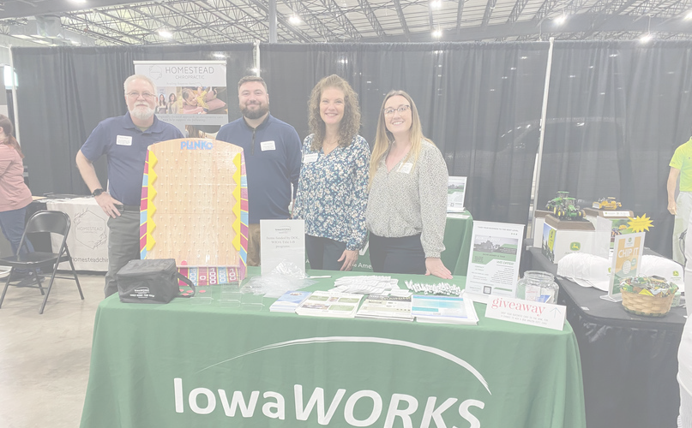
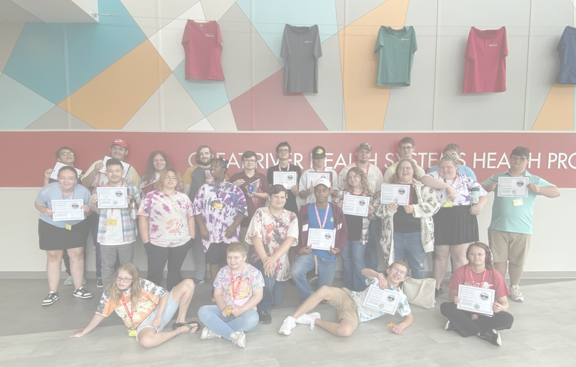
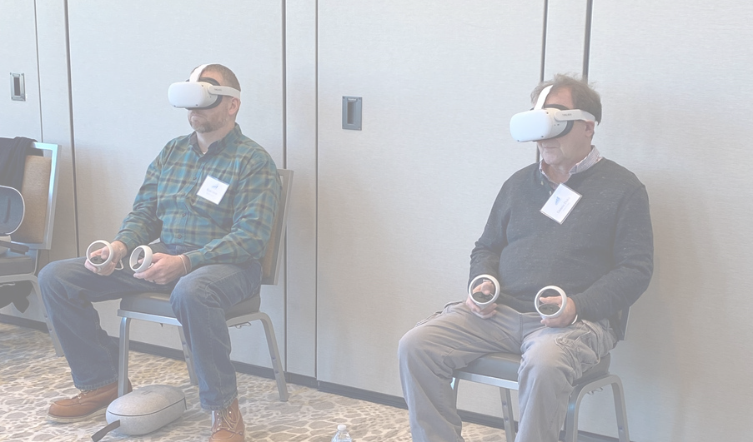
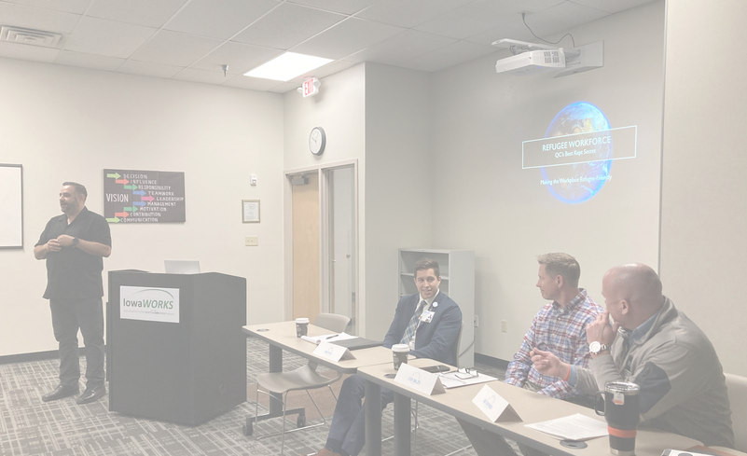
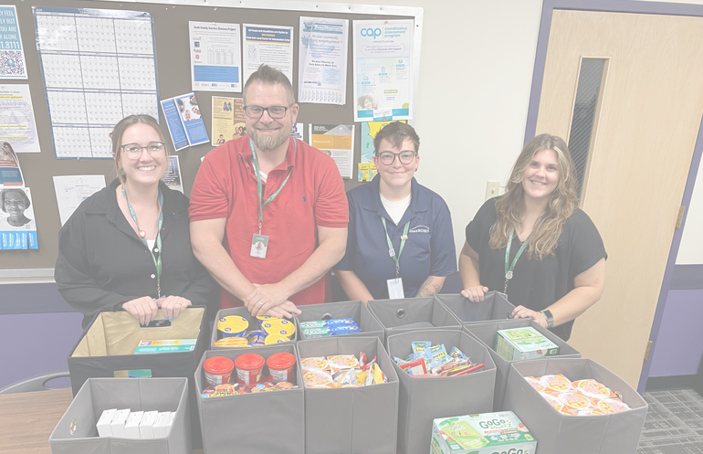
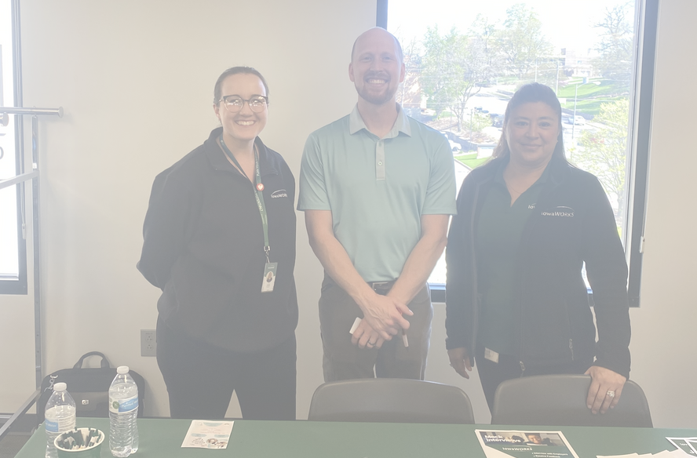
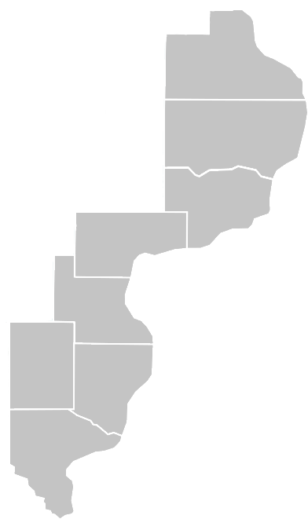
Mississippi Valley Workforce Development Board

Local Plan
Program Year 2024 - 2027

Jackson

Clinton

Scott
Muscatine

Louisa

Henry Des Moines

Lee

SECTION 1 – INFRASTRUCTURE 3
LOCAL WORKFORCE DEVELOPMENT AREA 3
BOARD COMMITTEES 3
BOARD MEMBERS 4
FISCAL AGENT 5
MISSISSIPPI VALLEY WORKFORCE DEVELOPMENT BOARD STAFF 5
COMPETITIVELY SELECTED PROVIDERS 9
OFFICE LOCATIONS 10
PROCESS TO DRAFT THE LOCAL PLAN 10
SECTION 2 – STRATEGIC PLANNING ELEMENTS 11
INDUSTRY SNAPSHOT 11
OCCUPATIONAL SNAPSHOT 13
INDUSTRY CLUSTERS 14
IN-DEMAND INDUSTRIES 15
LOCAL IN-DEMAND OCCUPATIONS 15
SHORT-TERM INDUSTRY PROJECTIONS 17
LONG-TERM INDUSTRY PROJECTIONS 19
OCCUPATION PROJECTIONS 22
EMPLOYER NEEDS 22
POPULATION 23
EMPLOYMENT TRENDS 25
UNEMPLOYMENT RATE 26
WAGE TRENDS 26
AWARD GAPS 27
ONLINE JOB POSTINGS FOR 30 DAY TIME PERIOD 27
SKILL GAPS 30
EDUCATIONAL ATTAINMENT 30
WORKFORCE CHALLENGES 32
STRENGTHS AND WEAKNESSES 33
EMPLOYMENT NEEDS OF EMPLOYERS 37
VISION, MISSION, AND GOALS 37
STRATEGIES 38
ONE-STOP OPERATOR STRATEGIES 40
SECTION 3 – IowaWORKS SYSTEM COORDINATION 43
PROGRAMS INCLUDED IN THE SYSTEM 43
LOCAL STRATEGIES 44
EXPAND ACCESS 46
EMPLOYER ENGAGEMENT 47
MVWDB BUSINESS COMMITTEE 49
ECONOMIC DEVELOPMENT 49
SECTOR PARTNERSHIPS 49
ONE-STOP LINKAGES WITH UNEMPLOYMENT INSURANCE 49
TRANSITIONAL JOBS 50
ON-THE-JOB TRAINING 50
INCUMBENT WORKER TRAINING 50
CUSTOMIZED TRAINING 51
REGISTERED APPRENTICESHIP 51
COORDINATION WITH ECONOMIC DEVELOPMENT 51
ENTREPRENEURIAL TRAINING 52
IOWA SELF-EMPLOYMENT (ISE) 52
Mississippi Valley Workforce Area 2024 -2027 Local Plan Page 1 of 89

ELIGIBLE TRAINING PROVIDERS 53
ACCESS 53
ACCESSIBILITY 54
ROLES AND CONTRIBUTIONS OF ONE-STOP CENTER PARTNERS 56
ADULT AND DISLOCATED WORKER SERVICES 57
RAPID RESPONSE 58
14 ELEMENTS 60
ACTIVITIES FOR YOUTH WHO ARE INDIVIDUALS WITH DISABILITIES 63
75% OUT OF SCHOOL YOUTH REQUIREMENT 64
20% WORK EXPERIENCE REQUIREMENT 65
NEEDED SERVICES IN MVWA 65
YOUTH STANDING COMMITTEE 65
WAIVER 66
SECONDARY AND POSTSECONDARY EDUCATION PROGRAMS 67
TITLE II GRANT PROVIDER 68
SUPPORT SERVICES 69
WAGNER PEYSER 71
ADULT EDUCATION AND LITERACY COORDINATION 72
AEFLA APPLICATION REVIEW PROCESS 73
AGREEMENTS 73
PROCUREMENT PROCESS 73
PERFORMANCE 80
TRAINING SERVICES 81
PUBLIC COMMENT PERIOD 85
INTEGRATED, TECHNOLOGY- ENABLED SYSTEM 85
PRIORITY OF SERVICE 86
VETERANS PRIORITY OF SERVICE 87
PUBLIC COMMENTS RECEIVED 89

SECTION 1 – INFRASTRUCTURE
Question 1

A description of the local workforce development system in the local area.
- Describe the local workforce delivery system in the local workforce development area (LWDA), including the following:
  - Name of the LWDA
  - Identification of the counties included in the LWDA
  - A roster of all LWDB members, including the organization representing and title/role and the city/county each is from, and identification of the LWDB Chairperson
  - Identification of Subcommittees of the LWDB and the chair of each
  - Identification of the Fiscal Agent (entity responsible for disbursal of Title I grant funds)
  - Identification of all LWDB Staff and a brief description of their role(s)
  - Identification of the competitively selected WIOA Title I Adult, Dislocated Worker, and Youth service providers
  - Identification of the One-Stop Operator for the local area
  - Identification of the office locations in the local area, including:
    - Comprehensive One-Stop locations
    - Affiliated sites
    - Specialized Centers
  - A description of the process used to draft the local plan

LOCAL WORKFORCE DEVELOPMENT AREA
The Mississippi Valley Workforce Development Board (MVWDB) oversees the workforce system in Jackson, Clinton, Scott, Muscatine, Louisa, Henry, Des Moines, and Lee counties in Iowa known as the Mississippi Valley Workforce Area (MVWA). There are 19 MVWDB members, with Dennis Duke serving as the board chair. The board structure consists of an Executive, Finance, Operations, Youth, Business, and Disability Access Committees.

BOARD COMMITTEES
Committee | Chair
Executive | Dennis Duke
Finance | Ryan Drew
Operations | Matthew Nicol
Youth | Jacob Nye
Business | Mandy Parchert
Disability Access | Cynthia Whalen

BOARD MEM | BERS
First Name | Last Name | County | Affiliation | Organization | Title
Dennis | Duke | Des Moines | Business | Carl A Nelson & Co | Project Manager and Co-Owner
Kirby | Phillips | Muscatine | Business | Muscatine Power & Water | Human Resources Supervisor
Andy | Sokolovich | Clinton | Economic Development | Grow Clinton | Vice President of Economic Development
Matthew | Nicol | Muscatine | Business | HNI  Corporation | MCR Staffing Manager
Joyce | Stimpson | Des Moines | Business | CNH Industrial America LLC | Human Resource Manager
Carol | Reynolds | Muscatine | Business | Kent Corporation | Vice President of Human Resources and Communication
Mandy | Parchert | Muscatine | Business | HNI  Corporation | Manager, University and Community Relations
Lori | Bassow | Scott | Business | Sterilite | Human Resource Manager
Heather | Halbrook | Des Moines | Business | Doran & Ward Packaging | Human Resource Manager
Kimberly | Jaber | Scott | Business | Berry Global, Inc. | Human Resource Manager
Caitlin | Bliesener | Des Moines | Business | Great River Health | Talent Acquisition Specialist
Ryan | Drew | Des Moines | Joint Labor/Mgt. | I.U.O.E. Local 150 | Business Representative
Cory | Bergfeld | Scott | Labor | I.B.E.W. Local 145 | Business Manager
Jacob | Nye | Henry | Labor | I.B.E.W. Local 13 | Business Manager
Nick | Flogel | Scott | Labor | Carpenters Local 4 | Business Representative

Regina | Matheson | Scott | Higher Education | St. Ambrose University | Associate Vice President of Academic Grants and Sponsored Programs
Martha | Bell | Des Moines | Title II | AEL | Director
Cynthia | Whalen | Des Moines | Title IV | IVRS | Supervisor
Rick | Ernst | Scott | Title III | IWD | Operations Manager

FISCAL AGENT
Central Iowa Juvenile Detention Center (CIJDC)
Fiscal Director, Kassie Ruth 2317 Rick Collins Way Eldora, IA 50627

Responsibilities:
- Responsible for drawing down on all grant funds awarded to the MVWDB in a timely manner to ensure smooth operations of the activities funded by such monies.
- Review all monitoring reports (whether conducted by local, state, or federal oversight personnel) and respond timely to any findings or recommendations therein. Hire an independent firm to conduct an annual financial audit in accordance with Generally Accepted Accounting Principles (GAAP)and in accordance with the provisions of 2 CFR 200, Subpart F. Develop and prepare monthly financial statements, and month end information.
- Respond to and correct any financial audit findings in a timely manner and shall consider any recommendations of the auditors in consultation with the MVWDB Executive Director and County Lead Elected Official (CLEO).
- Maintain all accounting records and documentation necessary to produce all financial documentation listed herein and necessary to support audit and monitoring functions.
- Prepare accurate monthly financial statements in accordance with GAAP, which shall be provided to the County Elected Officials (CEO) and MVWDB no less often than monthly.
- Provide Technical Assistance to subrecipients- To the extent it has expertise in the area for which assistance is requested, CIJDC will provide technical assistance on any financial questions or guidance requested by subrecipients of Workforce Innovation and Opportunity Act (WIOA) or other government funds.
- Conduct financial monitoring of the MVWDB service providers not less than annually including the monitoring of the board’s Title I Adult, Dislocated Worker, Youth Program providers, and the One-Stop Operator.

MISSISSIPPI VALLEY WORKFORCE DEVELOPMENT BOARD STAFF
Executive Director – Miranda Swafford
Responsibilities:

- Serve as liaison to the MVWDB and the Executive Committee; work closely with the MVWDB chair; interface between MVWDB and the community; participate in and/or staff other community, government, and board committees as necessary.
- Provides staff support to the Board, CEOs, and its committees.
- Represent the MVWDB at regional, national, and local meetings and conferences.
- Works collaboratively with the state and other local workforce boards across Iowa.
- Coordinate with Iowa Workforce Development and American Job Center Divisions and/or outside government agencies; develop and modify policies and standard operating procedures to ensure program compliance with regulatory requirements and changes for the Local Area.
- Keep up-to-date and analyze existing and proposed legislation, regulations, and directives for impact on program operations.
- Transform workforce metrics, policies, and mandates into actionable goals and ensure sufficient development of the system and proper allocation of resources.
- Develop criteria for evaluating systems and measurement of performance and effectiveness of existing and proposed Workforce Innovation and Opportunity Act activities.
- Directs the fiscal and reporting processes for federal, state, and local grants in accordance with applicable regulations and has the ability to appropriately delegate and oversee the successful completion of those duties.
- Direct monitoring and oversight of board contracts and grants received by the MVWDB and recommend system changes that will improve service quality.
- Adhere to all Code of Federal Regulations, the Workforce Innovation and Opportunity Act, Iowa Workforce Development policy, regulations, and Standard Operating Procedures as it pertains to Title I programming.
- In coordination with Iowa Workforce Development Labor Market Information division, Direct the development of labor market studies, surveys, analysis, and reports related to community employment and employer skills development needs.
- Develop, implement, modify, and update a 4-year local plan at the direction of the board.
- Develop the Memorandum of Understanding which includes the Infrastructure Funding Agreement and have an understanding of various cost-sharing methodologies.
- Direct and oversee the procurement of service providers, vendors, and oversee contract management.
- Work collaboratively with financial staff to provide regular and timely financial reports including information specific to each contract to the board and CEOs.
- Maintain a thorough understanding of how Workforce Innovation and Opportunity Act funds (and other funds under the local board) can be spent including limitations and requirements.
- Be knowledgeable of past and current performance levels of the local area and be informed of trends in the local market which are impacting or could impact future performance outcomes.
- Manage all board staff including human resource functions.
- Oversee and direct all phases of the administration of the MVWDB including local and regional planning, budget oversight, proposal development, contract management, monitoring and evaluation of programs, and community relations.
- Performs other Local Board Required Functions under federal and Iowa code as required

by the MVWDB and CEOs

Strategic Partnership Specialist – Tyler Lanz
Responsibilities:
- Assist the Executive Director and the CEOs to coordinate and generate board member involvement and commitment while ensuring staff support to MVWDB, its executive committee, and all standing and ad hoc committees including recruitment, orientation, and continuous training of workforce board members.
- Assist the executive director to serve as the voice of MVWDB at the local, state, and national levels through attendance at conferences, meetings, and presentations.
- Oversee the Business Services Teams at the One Stop Centers, scheduling meetings, helping to set goals, and providing guidance as needed to form a successful and productive team.
- Ensure coordinated business services with MVWA Partners, One Stop staff, and other community partners.
- Oversee and direct the Workforce Innovation and Opportunity Act Incumbent Worker Training Grant program.
- Provide support and coordination to the MVWDB Business Committee.
- Gather, comprehend, and effectively communicate Labor Market Information to drive workforce system decision-making.
- Through community conversations and focus groups, engage existing partners, and build relationships with new businesses, educational institutions, and community-based organizations related to sector strategies.
- Serve as the neutral convener for sector partnerships; keep the partnership on track and moving forward to accomplish the goals of the businesses in the partnership. The convener is the backbone of the sector partnership, providing administrative, project management, and facilitation support to keep the partnership focused and productive.
- Represents MVWDB in the community to recognize, assess, and respond to community needs and concerns; coordinate efforts with various service providers, government officials, and economic development organizations to resolve issues of mutual concern, and prepare reports noting trends or escalating issues.
- Build partnerships with private sector leaders to gather information about current or projected hiring needs, collect employer feedback about existing workforce services, and broker the development of new initiatives to fill skill gaps, as needed.
- Develop a partnership scope to guide decision-making on entities to approach new partnerships (e.g., based on the needs of customers or a gap in existing service delivery).
- Based on the needs of local area and data, propose innovative programming to the board and Chief Elected Officials.
- Research trends and best practices in industry sectors and promote and support the education of area employers and business advocates.
- Lead efforts to develop and implement career pathways with representatives of secondary and postsecondary education programs.
- Conduct Workforce Development training on sector partnerships.
- Attend all relevant workforce board committee meetings and have appropriate staff provide administrative support including minutes, agendas, and other related documents.

Compliance Officer – Mandy Tripp
Responsibilities:
- Assist the Executive Director and the CEOs to coordinate and generate board member involvement and commitment while ensuring staff support to MVWDB, its executive committee, and all standing and ad hoc committees including recruitment, orientation, and continuous training of workforce board members.
- Oversee recruitment and compliance of the board membership in accordance with WIOA membership requirements.
- Lead oversight and monitoring of all workforce development-related policy and programs per state and federal regulations.
- Conducts evaluation and internal monitoring of workforce activities and uses statistical sampling, audit, and observation techniques to evaluate compliance with policies and procedures and adherence to contract requirements.
- Gather, comprehend, and effectively communicate Labor Market Information to drive workforce system decision-making.
- Oversee the One Stop Certification process in partnership with the One Stop Operator to certify the effectiveness, physical and programmatic accessibility, and continuous improvement of One-Stop centers.
- Serve as the local area Equal Opportunity Officer.
- Implement a continuous quality improvement process through the continuing review of operations and administrative systems to increase performance and quality.
- On a quarterly basis reconcile the infrastructure funding and resource-sharing agreements required under WIOA and renegotiate at the direction of the Executive Director when necessary.
- Produce monthly IowaWORKS reports that track performance relating to contract requirements.
- Directs the implementation and monitoring of the submission of corrective action plans and maintains corrective action logs for both state and local monitoring.
- Develop board policies, as needed, to translate statutory, regulatory, and state direction into operational parameters, guidelines, and requirements.
- Ensure social media compliance with local policies and processes.
- Research other funding opportunities. write grant applications and respond to Requests for Proposals and other competitive solicitations.
- Advise the MVWDB and the Executive Director on policy implications in meeting performance standards; provide training and technical assistance to the service provider on policy implications in developing operational procedures.
- Maintain and update quality control protocols for required data entry and documentation; coordinate with the service provider and Iowa Workforce Development to resolve and correct data quality and documentation problems; identify frequent or systemic errors and coordinate with the Administrator and the service provider to develop solutions.
- Compile and review program data for internal performance monitoring; prepare reports for review and submission to the MVWDB and Iowa Workforce Development; maintain a report calendar and ensure the integrity and timeliness of required reporting.
- Oversee and lead special projects as directed.
- Attend all relevant workforce board committee meetings and have appropriate staff provide administrative support including minutes, agendas, and other related documents.

Communications Assistant – Vacant
Responsibilities:
- Assist in developing assigned committee meeting agendas in coordination with the chairperson, Executive Director, and other board staff.
- Prepare minutes of assigned committees and ensure that all members are kept apprised of meetings and activities.
- Serve as a point of contact for board members for information and technical assistance.
- Perform administrative functions for the MVWDB, Board Members, Executive Director, and other board staff.
- Assist in all areas which require support. Consistently apply a high level of understanding and awareness of board goals, priorities, values, and other relevant information to effectively navigate inquiries and requests.
- Compile reports, issue meeting announcements, and record appropriate data collection of meetings.
- Format and edit executive correspondence, presentations, reports, policies, requests for proposals, and contracts.
- Manage the executive director’s calendar and meeting schedule, using initiative and judgment to prioritize.
- Perform light accounts payable and various financial payment processing.
- Manage the board website including uploading documents and creating pages.
- Manage and coordinate communications between the Board and community partners and respond to letters and general correspondence and inquiries.
- Provides administrative support in preparing for monitoring, audits, RFPs, procurements, and other workforce-related activities.
- Coordinate facility arrangements for various meetings including Directors, funders, and partner meetings.
- Coordinate and participate in committee or group planning for special and recurring events.
- Design and generate flyers, brochures, and other outreach and educational materials to support MVWA initiatives and events.
- Assist in the development of a systemwide Outreach Strategy and growing the local area social media networks.
- Track and manage special projects to support MVWDB as assigned by the Executive Director.

COMPETITIVELY SELECTED PROVIDERS
Title I Adult, Dislocated Worker, and Youth Arbor E&T, LLC dba Equus Workforce Solutions 9510 Ormsby Station Road Suite 104
Louisville, KY 40223
Project Director: Shannon Weaver

One-Stop Operator
Arbor E&T, LLC dba Equus Workforce Solutions 9510 Ormsby Station Road Suite 104

Louisville, KY 40223

OFFICE LOCATIONS
Comprehensive Center Name | Burlington IowaWORKS
One Stop Operator | Nick Clayton
Title III Operations Manager Name and Title | Tim Snyder, Operations Supervisor
Mailing Address | 550 S Gear Avenue, Suite 35 West Burlington, IA 52655
Operating Hours | 8:00 a.m. – 4:30 p.m.
Phone | 319-753-1671
Email | burlingtoniowaworks@iwd.iowa.gov
Website | www.iowaworks.gov
Local Website | www.mississippivalleyworkforce.org

Comprehensive Center Name | Davenport IowaWORKS
One Stop Operator | Nick Clayton
Title III Operations Manager Name and Title | Rick Ernst, Operations Manager
Mailing Address | 1801 E Kimberly Road, Suite A Davenport, IA 52807
Operating Hours | 8:00 a.m. – 4:30 p.m.
Phone | 563-445-3200
Email | davenportiowaworks@iwd.iowa.gov
Website | www.iowaworks.gov
Local Website | www.mississippivalleyworkforce.org

PROCESS TO DRAFT THE LOCAL PLAN
At the direction of the MVWDB the executive director collaborated with all required workforce partners to provide input on their respective sections. Input was gathered through meetings and email communications. A local plan agenda item was included on all board and committee meetings throughout the process to provide updates and review input and suggestions. Each board committee provided input on questions related to their relevant activities and reviewed and approved final versions of the local plan. The local plan in its entirety was reviewed and approved by the MVWDB executive committee and CEOs at their regularly scheduled February 2024 meetings.

SECTION 2 – STRATEGIC PLANNING ELEMENTS

Questions in this section are designed to address the aspects of the local area’s labor force, such as its composition and the determination of skills gaps between the talent needed by employers in the local area and the knowledge and skills held by workers and job seekers. It is recommended that these plans include data samples and streamlined graphics and tables that support the narrative provided. The local board must cite the source(s) used to collect all or part of the local area labor market.

Question 1
Economic Analysis: Include a local area analysis of the:
- Economic conditions including existing and emerging in-demand industry sectors and occupations.
- Employment needs of employers in existing and emerging in-demand industry sectors and occupations.

INDUSTRY SNAPSHOT
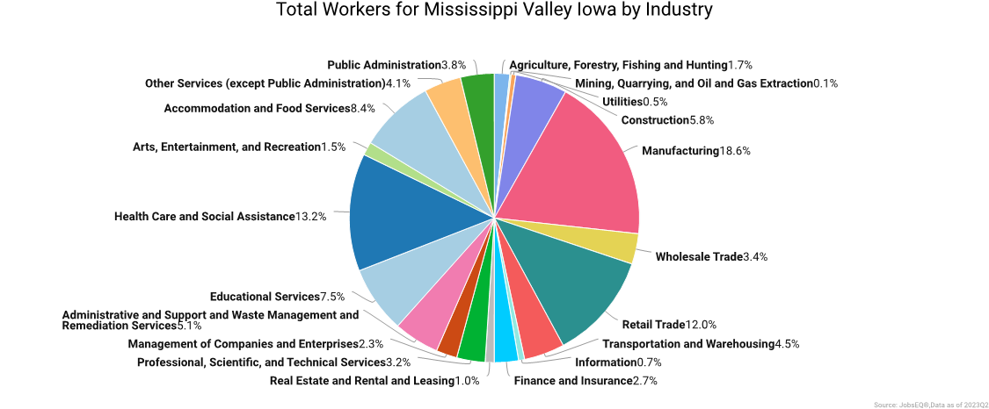
The largest sector in the MVWA is Manufacturing, employing 36,496 workers. The next-largest sectors in the Local Area are Health Care and Social Assistance (25,916 workers) and Retail Trade (23,573).
High location quotients (LQs) indicate sectors where a Local Area has high concentrations of employment compared to the national average. The sectors with the largest LQs in the Local Area are Manufacturing (LQ = 2.33), Management of Companies and Enterprises (1.47), and Retail Trade (1.21).

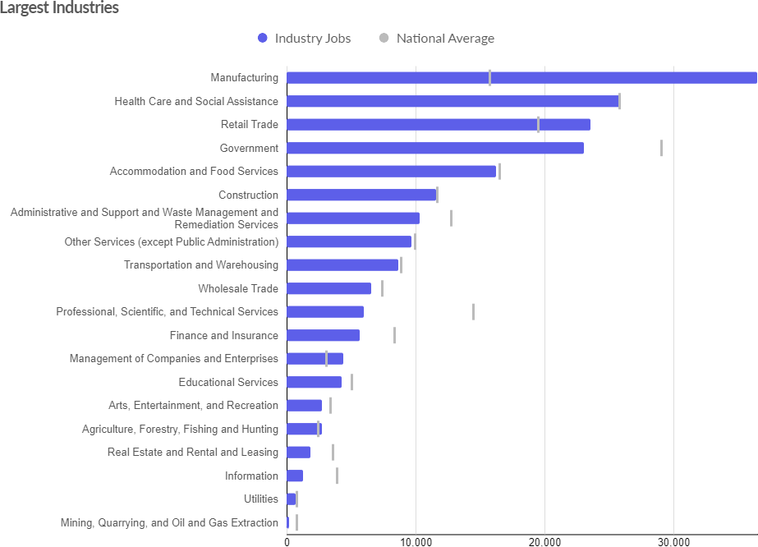

Source: Employment data from Lightcast Q4 2023 Data Set

NAICS | Description | 2027 Jobs | 2023-  2027 %  change | 2022 Jobs | 2022 Employment Concentration | 2027 Employment Concentration | Current salary/wages
11 | Agriculture, Forestry, Fishing and Hunting | 1,444 | 6% | 1,327 | 0.75 | 0.81 | $38,682
21 | Mining, Quarrying,  and Oil and Gas Extraction | 208 | (3%) | 214 | 0.32 | 0.31 | $58,583
22 | Utilities | 612 | (8%) | 681 | 1.02 | 0.91 | $106,010
23 | Construction | 9,711 | (0%) | 9,684 | 1.02 | 1.00 | $67,204
31 | Manufacturing | 38,102 | 3% | 36,165 | 2.35 | 2.43 | $70,210
42 | Wholesale Trade | 6,668 | 1% | 6,502 | 0.90 | 0.92 | $76,484
44 | Retail Trade | 22,876 | 0% | 22,781 | 1.22 | 1.24 | $33,926
48 | Transportation and Warehousing | 8,145 | 1% | 7,997 | 0.99 | 0.94 | $58,538
51 | Information | 1,216 | 0% | 1,210 | 0.33 | 0.31 | $56,725
52 | Finance and Insurance | 5,540 | 1% | 5,475 | 0.68 | 0.67 | $77,391
53 | Real Estate and Rental and Leasing | 1,563 | 2% | 1,515 | 0.52 | 0.52 | $50,565
54 | Professional,  Scientific, and Technical Services | 5,502 | 4% | 5,213 | 0.41 | 0.40 | $70,359
55 | Management of Companies and Enterprises | 5,527 | 17% | 4,406 | 1.46 | 1.72 | $112,979
56 | Administrative and Support and Waste Management and Remediation Services | 8,895 | (4%) | 9,421 | 0.82 | 0.75 | $43,477
61 | Educational Services | 4,126 | 2% | 3,997 | 0.86 | 0.86 | $28,891
62 | Health Care and Social Assistance | 25,306 | 3% | 24,259 | 0.98 | 0.96 | $52,350
71 | Arts, Entertainment, and Recreation | 2,820 | 8% | 2,497 | 0.89 | 0.95 | $21,237
72 | Accommodation and Food Services | 16,544 | 2% | 15,996 | 0.99 | 0.99 | $19,985
81 | Other Services (except Public Administration) | 7,565 | (0%) | 7,629 | 0.94 | 0.92 | $31,563
90 | Government | 23,576 | 2% | 23,032 | 0.79 | 0.81 | $48,732
 |  | 195,946 | 2% | 190,000 |  |  | $52,783
Source: Employment data from Lightcast Q4 2023 Data Set

Over the next 4 years employment in MVWA is projected to grow by 3% overall after a 6% decrease from 2017-2022. The fastest growing sector within the self-sufficiency threshold set by local policy is Management of Companies and Enterprises with a 17% increase projected by the end of 2027. The strongest forecast by the number of jobs over this period is expected for Management of Companies and Enterprises (+1121 jobs), Agriculture, Forestry, Fishing and Hunting (+117 jobs), and Professional, Scientific, and Technical Services (+289).

OCCUPATIONAL SNAPSHOT
The largest major occupation group in the MVWA is Production Occupations, employing 21,647

workers. The next-largest occupation groups are the Transportation and Material Moving Occupations (20,060 workers) and Office and Administrative Support Occupations (19,848 workers).

Occupation groups in the MVWA with the highest median annual earnings per worker are Management Occupations ($84,604.55), Computer and Mathematical Occupations ($75,721.60), and Architecture and Engineering Occupations ($75,718.28). The unemployment rate in the Local Area varied among the major groups from 2% among Healthcare Support Occupations and Practitioners to 28% among Production Occupations.
Over the next 4 years, the fastest growing occupation group in the MVWA is expected to be Computer and Mathematical Occupations with a +6% growth rate. The strongest forecast by number of jobs over this period is expected for Transportation and Material Moving Occupations (+10,600 jobs) and Production Occupations (+10,517). Over the same period, the highest separation demand (occupation demand due to retirements and workers moving from one occupation to another) is expected in Food Preparation and Serving Related Occupations (3052 jobs) and Transportation and Material Moving Occupations (2,511 jobs) annually through 2027.

SOC | Description | 2022  Jobs | 2027  Jobs | 2023 - 2027  Openings | 2022  Hires | 2022  Separatio  ns | Median Annual Earnings | 2023 - 2027  % Change | Annual Replacement  Jobs
35-0000 | Food Preparation and Serving Related Occupations | 15,959 | 16,238 | 12,525 | 22,703 | 22,627 | $25,590.75 | 1% | 3,052
53-0000 | Transportation and Material Moving Occupations | 20,060 | 20,616 | 10,599 | 18,240 | 17,511 | $38,743.29 | 2% | 2,511
41-0000 | Sales and Related Occupations | 16,690 | 16,886 | 9,872 | 15,056 | 14,973 | $29,609.21 | 1% | 2,389
51-0000 | Production Occupations | 21,647 | 22,399 | 10,517 | 13,158 | 13,129 | $43,199.83 | 2% | 2,365
43-0000 | Office and Administrative Support Occupations | 19,848 | 19,522 | 9,133 | 13,371 | 14,017 | $37,862.60 | (2%) | 2,225
31-0000 | Healthcare Support Occupations | 7,877 | 8,382 | 5,162 | 7,005 | 6,651 | $33,678.00 | 5% | 1,165
25-0000 | Educational Instruction and Library Occupations | 10,850 | 11,184 | 4,343 | 4,906 | 4,720 | $44,824.34 | 2% | 1,010
37-0000 | Building and Grounds Cleaning and Maintenance Occupation | 6,912 | 7,128 | 4,064 | 7,521 | 7,499 | $31,714.47 | 2% | 959
11-0000 | Management Occupations | 10,720 | 11,517 | 3,943 | 4,886 | 4,509 | $84,604.55 | 5% | 831
49-0000 | Installation, Maintenance, and Repair Occupations | 9,212 | 9,602 | 3,618 | 4,802 | 4,665 | $51,872.08 | 3% | 816
47-0000 | Construction and Extraction Occupations | 8,899 | 8,992 | 3,304 | 6,246 | 6,427 | $52,574.30 | 1% | 762
39-0000 | Personal Care and Service Occupations | 3,972 | 4,266 | 3,326 | 5,114 | 5,091 | $24,837.48 | 5% | 756
13-0000 | Business and Financial Operations Occupations | 8,471 | 9,062 | 3,238 | 4,537 | 4,154 | $63,779.09 | 5% | 699
29-0000 | Healthcare Practitioners and Technical Occupations | 10,114 | 10,306 | 2,739 | 3,367 | 3,249 | $64,575.71 | 2% | 586
33-0000 | Protective Service Occupations | 3,011 | 3,150 | 1,483 | 2,052 | 2,015 | $48,985.06 | 3% | 340
21-0000 | Community and Social Service Occupations | 2,875 | 3,072 | 1,176 | 1,327 | 1,235 | $44,133.14 | 5% | 254
27-0000 | Arts, Design, Entertainment, Sports, and Media Occupations | 2,322 | 2,403 | 1,092 | 1,660 | 1,664 | $42,810.29 | 2% | 244
17-0000 | Architecture and Engineering Occupations | 3,170 | 3,382 | 1,114 | 1,217 | 1,187 | $75,718.28 | 4% | 235
15-0000 | Computer and Mathematical Occupations | 3,616 | 3,937 | 1,147 | 1,684 | 1,431 | $75,721.60 | 6% | 227
45-0000 | Farming, Fishing, and Forestry Occupations | 1,225 | 1,286 | 800 | 1,255 | 1,207 | $30,365.54 | 3% | 186
19-0000 | Life, Physical, and Social Science Occupations | 1,191 | 1,244 | 518 | 601 | 561 | $58,065.42 | 3% | 115
55-0000 | Military-only occupations | 738 | 732 | 323 | 327 | 315 | $72,807.80 | (0%) | 80
23-0000 | Legal Occupations | 623 | 638 | 176 | 197 | 178 | $70,564.59 | 2% | 39
 |  | 190,000 | 195,946 | 94,213 | 141,233 | 139,013 |  | 2% | 21,846
Source: Employment data from Lightcast Q4 2023 Data Set

INDUSTRY CLUSTERS
A cluster is a geographic concentration of interrelated industries or occupations. The industry cluster in the Mississippi Valley Workforce Area with the highest relative concentration is Metal & Product Mfg. with a location quotient of 4.03. This cluster employs 5,706 workers in the region with an average wage of $86,972. Employment in the Metal & Product Mfg. cluster is projected to contract in the region by about 1.6% per year over the next ten years.

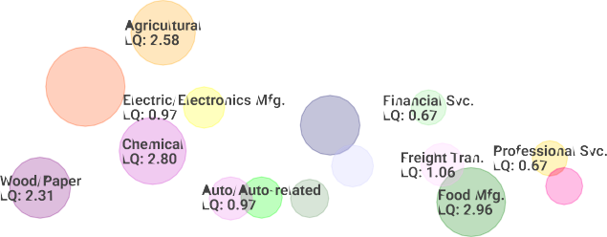

Location quotient and average wage data are derived from the Quarterly Census of Employment and Wages, provided by the Bureau of Labor Statistics, imputed where necessary, and updated through 2023Q1 with preliminary estimates updated to 2023Q2. Forecast employment growth uses national projections from the Bureau of Labor Statistics adapted for regional growth patterns.

IN-DEMAND INDUSTRIES
In August 2023 the MVWDB developed and approved a local In-demand Industries Policy. The Mississippi Valley Workforce Area (MVWA) has identified target sectors based on anecdotal evidence from employers, studies, and analyses conducted by workforce partners, such as the Iowa Workforce Development in-demand lists, the Future Ready Iowa Last Dollar Scholarship, and Lightcast’s economic overview. Those power sectors identified are Advanced Manufacturing, Construction, Information Technology, Healthcare, Transportation, Distribution, and Logistics.

NAICS | Description | 2023  Jobs | 2027  Jobs | 2023 -  2027 %  Change | Current Wages,  Salaries, & Proprietor Earnings | 2022  Employment Concentration | 2027  Employment Concentration
54 | Professional, Scientific, and Technical Services | 5,300 | 5,502 | 4% | $70,359 | 0.41 | 0.40
62 | Health Care and Social Assistance | 24,505 | 25,306 | 3% | $52,350 | 0.98 | 0.96
31 | Manufacturing | 36,974 | 38,102 | 3% | $70,210 | 2.35 | 2.43
48 | Transportation and Warehousing | 8,079 | 8,145 | 1% | $58,538 | 0.99 | 0.94
23 | Construction | 9,717 | 9,711 | (0%) | $67,204 | 1.02 | 1.00
 |  | 84,576 | 86,766 | 3% | $63,549
Source: Employment data from Lightcast Q4 2023 Data Set

The in-demand industries were chosen based on the following criteria: the industry belongs to a sector with high potential for sustained demand or growth in the local area, aligns with target industry clusters within the local area, supports economic growth priorities, and addresses industry-specific shortages.

LOCAL IN-DEMAND OCCUPATIONS
The in-demand occupation standard used to determine eligible occupations for training activities

considers various factors, such as 3-digit SOC Code from Labor Market Data available through Lightcast, projected 2% job growth based on 3-year projections, earning a self-sufficiency wage as defined by MVWDB, other factors taken into consideration were turnover rate, minimum skills required, average entry-level wages for the occupation. The committee of board members also chose exceptions for the list based on local demand. Those exceptions listed by SOC code are: 47-5000,17-3000, 33-3000, 23-2000,25-4000,47-2000,43,5000,29-2000,47-1000,51-
3000,51-8000,49-2000, 39-4000,53-4000,27-4000, 51-7000

SOC | Description | Median Annual Earnings
53-5000 | Water Transportation Workers | $57,399.85
51-5100 | Printing Workers | $37,795.27
15-2000 | Mathematical Science Occupations | $78,841.99
39-1000 | Supervisors of Personal Care and Service Workers | $36,895.20
11-2000 | Advertising, Marketing, Promotions, Public Relations, and Sales Managers | $122,639.07
11-3000 | Operations Specialties Managers | $100,659.29
31-2000 | Occupational Therapy and Physical Therapist Assistants and Aides | $53,878.00
45-1000 | Supervisors of Farming, Fishing, and Forestry Workers | $60,898.69
19-2000 | Physical Scientists | $78,390.73
21-1000 | Counselors, Social Workers, and Other Community and Social Service Specialists | $42,815.20
17-2000 | Engineers | $91,168.34
13-1000 | Business Operations Specialists | $64,249.45
19-3000 | Social Scientists and Related Workers | $74,884.78
51-1000 | Supervisors of Production Workers | $64,261.25
17-1000 | Architects, Surveyors, and Cartographers | $70,364.90
15-1200 | Computer Occupations | $75,512.78
49-9000 | Other Installation, Maintenance, and Repair Occupations | $52,630.22
37-1000 | Supervisors of Building and Grounds Cleaning and Maintenance Workers | $38,695.56
41-4000 | Sales Representatives, Wholesale and Manufacturing | $59,901.50
19-5000 | Occupational Health and Safety Specialists and Technicians | $70,893.02
11-9000 | Other Management Occupations | $80,717.57
27-3000 | Media and Communication Workers | $53,689.46
51-2000 | Assemblers and Fabricators | $44,013.61
11-1000 | Top Executives | $73,379.79
13-2000 | Financial Specialists | $62,650.38
45-4000 | Forest, Conservation, and Logging Workers | $35,518.95
51-9000 | Other Production Occupations | $42,270.88
53-2000 | Air Transportation Workers | $93,457.85
41-3000 | Sales Representatives, Services | $51,727.75
51-4000 | Metal Workers and Plastic Workers | $43,486.30
25-3000 | Other Teachers and Instructors | $36,543.77
25-2000 | Preschool, Elementary, Middle, Secondary, and Special Education Teachers | $55,672.54
25-1000 | Postsecondary Teachers | $69,928.86
23-1000 | Lawyers, Judges, and Related Workers | $97,924.56
53-7000 | Material Moving Workers | $35,826.75
33-2000 | Firefighting and Prevention Workers | $43,639.75

53-1000 | Supervisors of Transportation and Material Moving Workers | $56,491.80
29-9000 | Other Healthcare Practitioners and Technical Occupations | $55,616.09
49-1000 | Supervisors of Installation, Maintenance, and Repair Workers | $73,178.08
19-4000 | Life, Physical, and Social Science Technicians | $44,946.38
41-1000 | Supervisors of Sales Workers | $42,217.81
53-3000 | Motor Vehicle Operators | $43,214.76
47-3000 | Helpers, Construction Trades | $36,707.34
43-1000 | Supervisors of Office and Administrative Support Workers | $49,892.96
19-1000 | Life Scientists | $72,383.73
49-3000 | Vehicle and Mobile Equipment Mechanics, Installers, and Repairers | $46,375.06
47-4000 | Other Construction and Related Workers | $50,963.24
29-1000 | Healthcare Diagnosing or Treating Practitioners | $72,289.02
47-5000 | Extraction Workers | $47,069.02
17-3000 | Drafters, Engineering Technicians, and Mapping Technicians | $61,917.14
33-3000 | Law Enforcement Workers | $59,434.73
23-2000 | Legal Support Workers | $46,069.44
25-4000 | Librarians, Curators, and Archivists | $39,289.42
47-2000 | Construction Trades Workers | $50,534.25
43-5000 | Material Recording, Scheduling, Dispatching, and Distributing Workers | $46,030.71
29-2000 | Health Technologists and Technicians | $46,559.11
47-1000 | Supervisors of Construction and Extraction Workers | $68,040.16
51-3000 | Food Processing Workers | $39,730.12
51-8000 | Plant and System Operators | $61,739.68
49-2000 | Electrical and Electronic Equipment Mechanics, Installers, and Repairers | $52,322.95
39-4000 | Funeral Service Workers | $37,325.25
53-4000 | Rail Transportation Workers | $69,642.55
27-4000 | Media and Communication Equipment Workers | $45,779.60
51-7000 | Woodworkers | $47,407.59
31-1100 | Home Health and Personal Care Aides; and Nursing Assistants, Orderlies, and Psychiatric Aides | $33,198.35
Source: Employment data from Lightcast Q4 2023 Data Set

SHORT-TERM INDUSTRY PROJECTIONS
The table below from Iowa Workforce Development Labor Market Division shows the short- term industry forecast by NAICS code for 2022Q2, total growth and the projected percent change.

 |  | 2022Q2 | 2024Q2
 | NAICS | Estimated | Projected | Total | Percent
Industry Description | Code | Employment | Employment | Growth | Change
Total All Industries (Nonag) | 000 | 207,860 | 211,580 | 3,720 | 1.8%
Self-employed and Unpaid Family Workers | 671 | 19,115 | 19,320 | 205 | 1.1%
Forestry and Logging | 113 | 10 | 10 | 0 | 0.0%
Fishing, Hunting, and Trapping | 114 | 5 | 5 | 0 | 0.0%
Support Activities for Agriculture | 115 | 160 | 160 | 0 | 0.0%
Mining (except Oil and Gas) | 212 | 255 | 255 | 0 | 0.0%
Support Activities for Mining | 213 | 0 | 0 | 0 | 0.0%

Utilities | 221 | 1,065 | 1,055 | -10 | -0.9%
Construction of Buildings | 236 | 1,965 | 2,065 | 100 | 5.1%
Heavy and Civil Engineering Construction | 237 | 1,085 | 1,115 | 30 | 2.8%
Specialty Trade Contractors | 238 | 7,045 | 7,140 | 95 | 1.3%
Food Manufacturing | 311 | 8,410 | 8,510 | 100 | 1.2%
Beverage and Tobacco Products | 312 | 250 | 275 | 25 | 10.0%
Textile Mills | 313 | 0 | 0 | 0 | 0.0%
Textile Product Mills | 314 | 40 | 35 | -5 | -12.5%
Apparel Manufacturing | 315 | 0 | 0 | 0 | 0.0%
Leather and Allied Product Manufacturing | 316 | 0 | 0 | 0 | 0.0%
Wood Product Manufacturing | 321 | 140 | 140 | 0 | 0.0%
Paper Manufacturing | 322 | 635 | 630 | -5 | -0.8%
Printing and Related Support Activities | 323 | 810 | 780 | -30 | -3.7%
Petroleum and Coal Products Manufacturing | 324 | 5 | 5 | 0 | 0.0%
Chemical Manufacturing | 325 | 2,245 | 2,300 | 55 | 2.4%
Plastics and Rubber Products | 326 | 3,305 | 3,340 | 35 | 1.1%
Nonmetallic Mineral Product Manufacturing | 327 | 1,330 | 1,340 | 10 | 0.8%
Primary Metal Manufacturing | 331 | 4,415 | 4,590 | 175 | 4.0%
Fabricated Metal Manufacturing | 332 | 3,635 | 3,660 | 25 | 0.7%
Machinery Manufacturing | 333 | 5,215 | 5,215 | 0 | 0.0%
Computer and Electronic Product | 334 | 620 | 620 | 0 | 0.0%
Electrical Equipment, Appliance and Component Manufac. | 335 | 670 | 650 | -20 | -3.0%
Transportation Equipment Manufacturing | 336 | 1,260 | 1,260 | 0 | 0.0%
Furniture and Related Product | 337 | 2,705 | 2,660 | -45 | -1.7%
Miscellaneous Manufacturing | 339 | 335 | 340 | 5 | 1.5%
Merchant Wholesalers, Durable Goods | 423 | 3,995 | 3,975 | -20 | -0.5%
Merchant Wholesalers, Nondurable Goods | 424 | 2,165 | 2,155 | -10 | -0.5%
Wholesale Electronic Markets and Agents | 425 | 270 | 270 | 0 | 0.0%
Motor Vehicle and Parts Dealers | 441 | 3,035 | 3,020 | -15 | -0.5%
Furniture and Home Furnishings Stores | 442 | 615 | 610 | -5 | -0.8%
Electronics and Appliance Stores | 443 | 815 | 810 | -5 | -0.6%
Building Material and Garden Equipment | 444 | 2,470 | 2,485 | 15 | 0.6%
Food and Beverage Stores | 445 | 4,495 | 4,530 | 35 | 0.8%
Health and Personal Care Stores | 446 | 1,120 | 1,070 | -50 | -4.5%
Gasoline Stations | 447 | 2,835 | 2,840 | 5 | 0.2%
Clothing and Clothing Accessories Stores | 448 | 870 | 835 | -35 | -4.0%
Sporting Goods, Hobby, Book and Music Stores | 451 | 745 | 750 | 5 | 0.7%
General Merchandise Stores | 452 | 4,815 | 4,865 | 50 | 1.0%
Miscellaneous Store Retailers | 453 | 945 | 920 | -25 | -2.6%
Nonstore Retailers | 454 | 630 | 665 | 35 | 5.6%
Air Transportation | 481 | 5 | 5 | 0 | 0.0%
Rail Transportation | 482 | 1,455 | 1,455 | 0 | 0.0%
Water Transportation | 483 | 140 | 140 | 0 | 0.0%
Truck Transportation | 484 | 2,960 | 2,940 | -20 | -0.7%
Transit and Ground Passenger Transport | 485 | 705 | 775 | 70 | 9.9%
Pipeline Transportation | 486 | 50 | 50 | 0 | 0.0%
Scenic and Sightseeing Transportation | 487 | 5 | 5 | 0 | 0.0%

Support Activities for Transportation | 488 | 625 | 665 | 40 | 6.4%
Postal Service | 491 | 670 | 660 | -10 | -1.5%
Couriers and Messengers | 492 | 805 | 825 | 20 | 2.5%
Warehousing and Storage | 493 | 2,260 | 2,330 | 70 | 3.1%
Publishing Industries | 511 | 370 | 350 | -20 | -5.4%
Motion Picture and Sound Recording | 512 | 175 | 200 | 25 | 14.3%
Broadcasting (except Internet) | 515 | 185 | 175 | -10 | -5.4%
Telecommunications | 517 | 335 | 330 | -5 | -1.5%
Internet Service Providers, Web Search | 518 | 120 | 120 | 0 | 0.0%
Other Information Services | 519 | 5 | 5 | 0 | 0.0%
Monetary Authorities - Central Bank | 521 | 0 | 0 | 0 | 0.0%
Credit Intermediation and Related Activities | 522 | 2,775 | 2,770 | -5 | -0.2%
Securities, Commodity Contracts, and Other Investments | 523 | 430 | 430 | 0 | 0.0%
Insurance Carriers and Related Activities | 524 | 1,810 | 1,795 | -15 | -0.8%
Funds, Trusts, and Other Financial Vehicles | 525 | 10 | 10 | 0 | 0.0%
Real Estate | 531 | 1,030 | 985 | -45 | -4.4%
Rental and Leasing Services | 532 | 455 | 445 | -10 | -2.2%
Lessors of Nonfinancial Intangible Assets | 533 | 0 | 0 | 0 | 0.0%
Professional, Scientific, and Technical Services | 541 | 5,235 | 5,385 | 150 | 2.9%
Management of Companies and Enterprises | 551 | 4,275 | 4,520 | 245 | 5.7%
Administrative and Support Services | 561 | 9,145 | 9,250 | 105 | 1.1%
Waste Management and Remediation | 562 | 560 | 595 | 35 | 6.3%
Educational Services | 611 | 15,645 | 15,710 | 65 | 0.4%
Ambulatory Health Care Services | 621 | 8,260 | 8,430 | 170 | 2.1%
Hospitals | 622 | 6,215 | 6,375 | 160 | 2.6%
Nursing and Residential Care Facilities | 623 | 5,540 | 5,510 | -30 | -0.5%
Social Assistance | 624 | 4,355 | 4,355 | 0 | 0.0%
Performing Arts, Spectator Sports, and Related Industries | 711 | 575 | 665 | 90 | 15.7%
Museums, Historical Sites, and Similar Institutions | 712 | 100 | 105 | 5 | 5.0%
Amusement, Gambling, and Recreation Industries | 713 | 1,955 | 2,195 | 240 | 12.3%
Accommodation | 721 | 2,340 | 2,810 | 470 | 20.1%
Food Services and Drinking Places | 722 | 13,785 | 14,555 | 770 | 5.6%
Repair and Maintenance | 811 | 2,130 | 2,190 | 60 | 2.8%
Personal and Laundry Services | 812 | 1,375 | 1,500 | 125 | 9.1%
Religious, Grantmaking, Civic, Professional Organizations | 813 | 3,405 | 3,525 | 120 | 3.5%
Private Households | 814 | 125 | 130 | 5 | 4.0%
Federal Government | 910 | 615 | 615 | 0 | 0.0%
State Government, Excluding Education and Hospitals | 920 | 1,510 | 1,500 | -10 | -0.7%
Local Government, Excluding Education and Hospitals | 930 | 6,785 | 6,920 | 135 | 2.0%
* Information on this NAIC suppressed Totals may not equal due to rounding
Source: Labor Force and Occupational Analysis Bureau, Iowa Workforce Development

LONG-TERM INDUSTRY PROJECTIONS
The below table retrieved from Iowa Workforce Development Labor Market Division shows the long-term industry forecast by NAICS code through 2030 total growth, and the percent change projected.

 |  | 2020 | 2030
 | NAICS | Estimated | Projected | Total | Percent
Industry Description | Code | Employment | Employment | Growth | Change
Total All Industries (Nonag) | 000 | 197,120 | 223,640 | 26,520 | 13.5%
Warehousing and Storage | 493 | 1,980 | 3,300 | 1,320 | 66.7%
Administrative and Support Services | 561 | 9,295 | 13,220 | 3,925 | 42.2%
Accommodation | 721 | 2,055 | 2,865 | 810 | 39.4%
Construction of Buildings | 236 | 1,795 | 2,480 | 685 | 38.2%
Specialty Trade Contractors | 238 | 6,505 | 8,115 | 1,610 | 24.8%
Couriers and Messengers | 492 | 795 | 1,250 | 455 | 57.2%
Ambulatory Health Care Services | 621 | 8,155 | 10,540 | 2,385 | 29.2%
Heavy and Civil Engineering Construction | 237 | 915 | 1,275 | 360 | 39.3%
Transportation Equipment Manufacturing | 336 | 1,275 | 1,725 | 450 | 35.3%
Professional, Scientific, and Technical Services | 541 | 5,050 | 6,030 | 980 | 19.4%
Management of Companies and Enterprises | 551 | 3,365 | 4,065 | 700 | 20.8%
Educational Services | 611 | 14,060 | 16,780 | 2,720 | 19.3%
Amusement, Gambling, and Recreation Industries | 713 | 1,500 | 2,040 | 540 | 36.0%
General Merchandise Stores | 452 | 4,485 | 5,125 | 640 | 14.3%
Truck Transportation | 484 | 3,200 | 3,770 | 570 | 17.8%
Performing Arts, Spectator Sports, and Related Industries | 711 | 310 | 520 | 210 | 67.7%
Food Services and Drinking Places | 722 | 12,405 | 13,965 | 1,560 | 12.6%
Personal and Laundry Services | 812 | 1,345 | 1,690 | 345 | 25.7%
Wood Product Manufacturing | 321 | 160 | 265 | 105 | 65.6%
Transit and Ground Passenger Transport | 485 | 390 | 520 | 130 | 33.3%
Support Activities for Transportation | 488 | 630 | 805 | 175 | 27.8%
Motion Picture and Sound Recording | 512 | 105 | 190 | 85 | 81.0%
Self Employed and Unpaid Family Workers | 671 | 18,650 | 19,525 | 875 | 4.7%
Hospitals | 622 | 5,875 | 6,335 | 460 | 7.8%
Nursing and Residential Care Facilities | 623 | 5,965 | 6,565 | 600 | 10.1%
Repair and Maintenance | 811 | 1,975 | 2,215 | 240 | 12.2%
Support Activities for Agriculture | 115 | 160 | 210 | 50 | 31.3%
Nonmetallic Mineral Product Manufacturing | 327 | 1,335 | 1,500 | 165 | 12.4%
Motor Vehicle and Parts Dealers | 441 | 2,950 | 3,195 | 245 | 8.3%
Furniture and Home Furnishings Stores | 442 | 545 | 655 | 110 | 20.2%
Health and Personal Care Stores | 446 | 1,175 | 1,320 | 145 | 12.3%
Credit Intermediation and Related Activities | 522 | 2,830 | 3,080 | 250 | 8.8%
Securities, Commodity Contracts, and Other Investments | 523 | 435 | 500 | 65 | 14.9%
Insurance Carriers and Related Activities | 524 | 1,740 | 1,920 | 180 | 10.3%
Social Assistance | 624 | 4,400 | 4,810 | 410 | 9.3%
Forestry and Logging | 113 | 5 | 10 | 5 | 100.0%
Primary Metal Manufacturing | 331 | 4,300 | 4,580 | 280 | 6.5%
Rental and Leasing Services | 532 | 435 | 495 | 60 | 13.8%
Private Households | 814 | 135 | 160 | 25 | 18.5%
Local Government, Excluding Education and Hospitals | 930 | 6,305 | 6,655 | 350 | 5.6%
Food Manufacturing | 311 | 8,315 | 8,680 | 365 | 4.4%
Electrical Equipment, Appliance and Component Manufac. | 335 | 895 | 970 | 75 | 8.4%
Sporting Goods, Hobby, Book and Music Stores | 451 | 645 | 710 | 65 | 10.1%

Waste Management and Remediation | 562 | 445 | 505 | 60 | 13.5%
Museums, Historical Sites, and Similar Institutions | 712 | 85 | 100 | 15 | 17.6%
Fabricated Metal Manufacturing | 332 | 3,520 | 3,650 | 130 | 3.7%
Machinery Manufacturing | 333 | 5,215 | 5,440 | 225 | 4.3%
Merchant Wholesalers, Durable Goods | 423 | 4,190 | 4,330 | 140 | 3.3%
Nonstore Retailers | 454 | 355 | 380 | 25 | 7.0%
Water Transportation | 483 | 130 | 145 | 15 | 11.5%
Religious, Grantmaking, Civic, Professional Organizations | 813 | 1,160 | 1,235 | 75 | 6.5%
Beverage and Tobacco Product | 312 | 145 | 155 | 10 | 6.9%
Chemical Manufacturing | 325 | 2,210 | 2,285 | 75 | 3.4%
Furniture and Related Product | 337 | 3,150 | 3,270 | 120 | 3.8%
Building Material and Garden Equipment | 444 | 2,295 | 2,375 | 80 | 3.5%
Miscellaneous Store Retailers | 453 | 850 | 905 | 55 | 6.5%
Pipeline Transportation | 486 | 45 | 50 | 5 | 11.1%
Internet Service Providers, Web Search | 518 | 175 | 190 | 15 | 8.6%
Real Estate | 531 | 1,065 | 1,120 | 55 | 5.2%
Miscellaneous Manufacturing | 339 | 315 | 330 | 15 | 4.8%
Wholesale Electronic Markets and Agents | 425 | 300 | 315 | 15 | 5.0%
Food and Beverage Stores | 445 | 4,390 | 4,480 | 90 | 2.1%
Clothing and Clothing Accessories Stores | 448 | 785 | 820 | 35 | 4.5%
Rail Transportation | 482 | 1,425 | 1,465 | 40 | 2.8%
Broadcasting (except Internet) | 515 | 195 | 205 | 10 | 5.1%
Merchant Wholesalers, Nondurable Goods | 424 | 2,080 | 2,105 | 25 | 1.2%
Electronics and Appliance Stores | 443 | 975 | 1,000 | 25 | 2.6%
Fishing, Hunting and Trapping | 114 | 10 | 10 | 0 | 0.0%
Mining (except Oil and Gas) | 212 | 230 | 235 | 5 | 2.2%
Support Activities for Mining | 213 | 0 | 0 | 0 | 0.0%
Textile Mills | 313 | 0 | 0 | 0 | 0.0%
Apparel Manufacturing | 315 | 5 | 5 | 0 | 0.0%
Leather and Allied Product Manufacturing | 316 | 0 | 0 | 0 | 0.0%
Petroleum and Coal Products Manufacturing | 324 | 0 | 0 | 0 | 0.0%
Air Transportation | 481 | 0 | 0 | 0 | 0.0%
Scenic and Sightseeing Transportation | 487 | 5 | 5 | 0 | 0.0%
Monetary Authorities - Central Bank | 521 | 0 | 0 | 0 | 0.0%
Funds, Trusts, and Other Financial Vehicles | 525 | 10 | 10 | 0 | 0.0%
Lessors of Nonfinancial Intangible Assets | 533 | 0 | 0 | 0 | 0.0%
Computer and Electronic Product | 334 | 705 | 700 | -5 | -0.7%
Federal Government | 910 | 715 | 710 | -5 | -0.7%
State Government, Excluding Education and Hospitals | 920 | 1,500 | 1,495 | -5 | -0.3%
Other Information Services | 519 | 15 | 10 | -5 | -33.3%
Utilities | 221 | 795 | 710 | -85 | -10.7%
Textile Product Mills | 314 | 65 | 55 | -10 | -15.4%
Paper Manufacturing | 322 | 700 | 630 | -70 | -10.0%
Printing and Related Support Activities | 323 | 810 | 790 | -20 | -2.5%
Plastics and Rubber Products | 326 | 3,175 | 3,000 | -175 | -5.5%
Gasoline Stations | 447 | 2,720 | 2,700 | -20 | -0.7%
Postal Service | 491 | 665 | 610 | -55 | -8.3%
Publishing Industries | 511 | 340 | 240 | -100 | -29.4%
Telecommunications | 517 | 310 | 245 | -65 | -21.0%
Source: Labor Force and Occupational Analysis Bureau,

Iowa Workforce Development

OCCUPATION PROJECTIONS
The below table retrieved from Iowa Workforce Development Labor Market Division shows the long-term occupational projections by SOC code from 2020 estimates to 2030 projections sorted by the annual growth rate percentage and limited to the top 14 occupations that meet the self- sufficiency wage set by local policy.

SOC | Occupational Titles | 2020  Estimated | 2030  Projected | Numeric Change | Annua l Growt h Rate  (%)
15-1212 | Information Security Analysts | 95 | 165 | 70 | 7.4
29-1171 | Nurse Practitioners | 200 | 330 | 130 | 6.5
11-9021 | Construction Mgrs | 380 | 560 | 180 | 4.7
27-2012 | Producers & Directors | 55 | 85 | 25 | 4.5
15-1256 | Software Developers & Software Quality Assurance Analysts & Testers | 590 | 855 | 265 | 4.5
29-1071 | Physician Assistants | 90 | 130 | 40 | 4.4
31-2021 | Physical Therapist Assistants | 115 | 165 | 50 | 4.3
11-9111 | Medical & Health Services Mgrs | 610 | 845 | 235 | 3.9
25-1071 | Health Specialties Teachers, Postsecondary | 195 | 270 | 75 | 3.8
13-1081 | Logisticians | 160 | 220 | 60 | 3.8
29-1127 | Speech-Language Pathologists | 165 | 225 | 60 | 3.6
29-2032 | Diagnostic Medical Sonographers | 80 | 105 | 25 | 3.1
33-1090 | Miscellaneous First-Line Supvs, Protective Service Wkrs | 65 | 85 | 20 | 3.1
37-3012 | Pesticide Handlers, Sprayers, & Applicators, Vegetation | 100 | 130 | 30 | 3.0
Source: Labor Force and Occupational Analysis Bureau, Iowa Workforce Development

EMPLOYER NEEDS
In the Mississippi Valley Workforce Area, employers are consistently in search of qualified talent to meet both immediate job demands and to support future growth and expansion plans. Specifically, in sectors like healthcare, employers require applicants with the essential skills and credentials, such as licenses issued by relevant state boards. While not all industries necessitate formalized or lengthy training programs for entry-level positions, there are available resources to address various needs, including transitional jobs, work experience, short-term pre-vocational services, on-the-job training, and incumbent worker training.

The dynamic nature of job content and skill requirements underscores the importance for employers to establish mechanisms for ongoing education and skills enhancement. To stay competitive in the global economy, businesses must innovate and adopt more efficient, high- value production systems that rely on highly skilled workers. The evolving landscape of technologically advanced job skills calls for a more flexible education and workforce training

system, leading to a growing demand for accessible career pathways and the retraining of incumbent workers to adapt to new processes.

Over the next four years, the MVWA will continue to integrate incumbent worker training into its programs, focusing on upskilling existing employees and supporting apprenticeship programs that combine work and training for sustainable careers.

Beyond specific credentials, employers across industries consistently express a need for soft skills among applicants, community support for affordable childcare, housing, and transportation, and a reduction in turnover. The MVWA advocates for an industry partnership structure that enables the workforce development system to swiftly respond to the changing needs of local businesses. Collaborating with key ecosystem industries, the MVWA will actively engage partners from secondary and post-secondary institutions to develop industry-specific curricula and skills, ensuring a comprehensive spectrum of education and training from entry to senior-level positions.

Question 2
Workforce Analysis: Include a current analysis of:
- The knowledge and skills needed to meet the employment needs of employers in the local area, including employment needs in in-demand industry sectors and occupations.
- An analysis of the local workforce, including current labor force employment and unemployment data, information on labor market trends, and education and skill levels of the workforce, including individuals with barriers to employment.

POPULATION
The population in the Mississippi Valley Workforce Area was 387,575 per American Community Survey data for 2017-2021. The region has a civilian labor force of 196,410 with a participation rate of 63.7%.

Geographic Distribution
County | Employees
Scott County, Iowa | 86,780
Muscatine County, Iowa | 20,100
Jackson County, Iowa | 10,340
Des Moines County, Iowa | 17,300
Henry County, Iowa | 9,170
Lee County, Iowa | 13,890
Louisa County, Iowa | 5,840
Clinton County, Iowa | 9,240

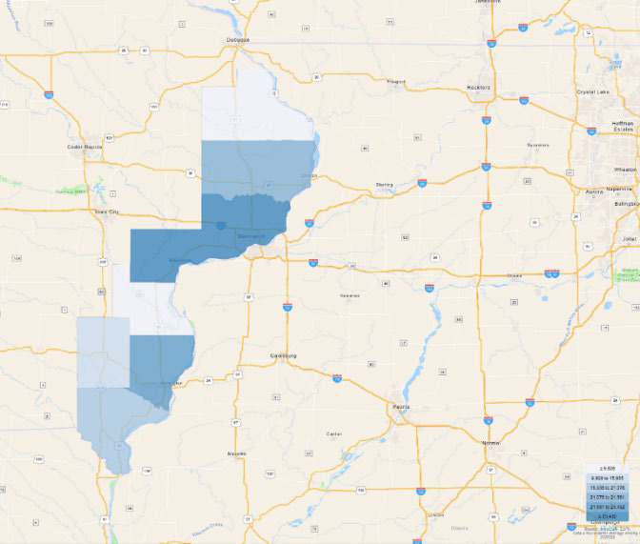
Source October 2023 Monthly Labor Force Data from Iowa Workforce Development

In the Mississippi Valley workforce Area, 18.6% of individuals aged 25 to 64 hold a bachelor's degree or higher, contrasting with the national average of 22%. The population under 18 years old aligns closely with state and national percentages at 23.3%. However, this demographic constitutes a substantial portion of the local future labor force, presenting a valuable opportunity to educate them on current and emerging workforce needs. While the percentage of disconnected youth is slightly higher than the state level, the number of children in single-parent families is significantly elevated at 35%, surpassing the state's 29.6%.

The median household income in the Mississippi Valley Workforce Area stands at $62,390, with a median house value of $145,879. Educational attainment in MVWA closely mirrors the state level until the bachelor's degree level, where MVWA is at 18.6%, compared to the state of Iowa's 21.8%. The poverty level in MVWA is marginally higher at 11.9% compared to the state's 11%. Moreover, 11.6% of households in MVWA receive food stamps and Supplemental Nutrition Assistance Program (SNAP) benefits, contrasting with the state level of 9.6%.

Examining the chart below, it's evident that individuals with disabilities in MVWA face significant underemployment compared to the state average. Given the projected stability in MVWA's population, there is a heightened importance in training and educating the current workforce to meet the evolving demands of businesses.
 |  | Percent |  |  | Value
Mississippi Valley Iowa |  | Iowa | USA | Mississippi Valley Iowa | Iowa | USA
Demographics
Population (ACS) | — | — | — | 387,575 | 3,179,090 | 329,725,481
Male | 49.7% | 50.0% | 49.5% | 192,781 | 1,590,001 | 163,206,615
Female | 50.3% | 50.0% | 50.5% | 194,794 | 1,589,089 | 166,518,866
Median Age² | — | — | — | 40.4 | 38.3 | 38.4
Under 18 Years | 23.3% | 23.3% | 22.5% | 90,366 | 742,175 | 74,234,075
18 to 24 Years | 8.1% | 10.0% | 9.2% | 31,318 | 317,031 | 30,339,089
25 to 34 Years | 12.0% | 12.4% | 13.8% | 46,337 | 394,731 | 45,360,942
35 to 44 Years | 12.4% | 12.4% | 12.9% | 48,229 | 392,662 | 42,441,883
45 to 54 Years | 12.3% | 11.7% | 12.6% | 47,741 | 371,831 | 41,631,458
55 to 64 Years | 14.0% | 13.2% | 13.0% | 54,327 | 420,118 | 42,829,413
65 to 74 Years | 10.6% | 9.9% | 9.6% | 41,080 | 313,218 | 31,590,619
75 Years and Over | 7.3% | 7.2% | 6.5% | 28,177 | 227,324 | 21,298,002
Race: White | 87.0% | 87.9% | 68.2% | 337,071 | 2,795,319 | 224,789,109
Race: Black or African American | 4.8% | 3.7% | 12.6% | 18,795 | 119,036 | 41,393,012
Race: American Indian and Alaska Native | 0.2% | 0.3% | 0.8% | 859 | 10,889 | 2,722,661
Race: Asian | 1.9% | 2.5% | 5.7% | 7,265 | 79,188 | 18,782,924
Race: Native Hawaiian and Other Pacific Islander | 0.1% | 0.1% | 0.2% | 251 | 4,182 | 615,557
Race: Some Other Race | 1.4% | 1.5% | 5.6% | 5,608 | 46,711 | 18,382,796
Race: Two or More Races | 4.6% | 3.9% | 7.0% | 17,726 | 123,765 | 23,039,422
Hispanic or Latino (of any race) | 7.1% | 6.4% | 18.4% | 27,638 | 203,048 | 60,806,969
Population Growth
Population (Pop Estimates)⁴ | — | — | — | 383,975 | 3,200,517 | 333,287,557
Population Annual Average Growth⁴ | -0.1% | 0.4% | 0.6% | -294 | 12,367 | 1,940,990
People per Square Mile | — | — | — | 96.1 | 57.3 | 94.3
Economic
Labor Force Participation Rate and Size (civilian population 16 years and over) | 63.7% | 66.9% | 63.4% | 196,410 | 1,686,696 | 166,672,597
Prime-Age Labor Force Participation Rate and Size (civilian population 25-54) | 84.7% | 87.0% | 82.5% | 120,232 | 1,006,410 | 106,173,534
Armed Forces Labor Force | 0.1% | 0.1% | 0.5% | 375 | 2,642 | 1,196,529
Veterans, Age 18-64 | 5.0% | 4.2% | 4.4% | 11,278 | 79,766 | 8,848,937

 |  | Percent |  |  | Value
Mississippi Valley Iowa |  | Iowa | USA | Mississippi Valley Iowa | Iowa | USA
Veterans Labor Force Participation Rate and Size, Age 18-64 | 81.4% | 81.4% | 77.0% | 9,185 | 64,933 | 6,809,906
Median Household Income² | — | — | — | $62,390 | $65,429 | $69,021
Per Capita Income | — | — | — | $34,185 | $34,817 | $37,638
Mean Commute Time (minutes) | — | — | — | 19.4 | 19.6 | 26.8
Commute via Public Transportation | 0.4% | 0.8% | 4.2% | 802 | 12,394 | 6,472,373
Educational Attainment, Age 25-64
No High School Diploma | 6.3% | 6.8% | 10.3% | 12,480 | 106,890 | 17,756,046
High School Graduate | 30.5% | 27.2% | 25.3% | 59,905 | 429,922 | 43,535,564
Some College, No Degree | 22.0% | 20.8% | 20.1% | 43,267 | 327,883 | 34,637,141
Associate's Degree | 13.3% | 13.5% | 9.3% | 26,226 | 212,954 | 15,944,395
Bachelor's Degree | 18.6% | 21.8% | 22.0% | 36,554 | 344,166 | 37,890,674
Postgraduate Degree | 9.3% | 10.0% | 13.1% | 18,202 | 157,527 | 22,499,876
Housing
Total Housing Units | — | — | — | 174,020 | 1,407,100 | 139,647,020
Median House Value (of owner-occupied units)² | — | — | — | $145,879 | $160,700 | $244,900
Homeowner Vacancy | 1.4% | 1.2% | 1.2% | 1,680 | 11,403 | 1,021,651
Rental Vacancy | 8.1% | 6.4% | 5.7% | 3,825 | 25,180 | 2,674,125
Renter-Occupied Housing Units (% of Occupied Units) | 27.5% | 28.4% | 35.4% | 43,000 | 362,924 | 43,858,831
Occupied Housing Units with No Vehicle Available (% of Occupied Units) | 6.2% | 5.6% | 8.3% | 9,650 | 71,746 | 10,349,174
Social
Poverty Level (of all people) | 11.9% | 11.0% | 12.6% | 45,119 | 339,695 | 40,661,636
Households Receiving Food Stamps/SNAP | 11.6% | 9.6% | 11.4% | 18,221 | 122,182 | 14,105,231
Enrolled in Grade 12 (% of total population) | 1.5% | 1.3% | 1.3% | 5,752 | 40,298 | 4,425,322
Disconnected Youth³ | 2.8% | 2.4% | 2.5% | 577 | 4,260 | 432,389
Children in Single Parent Families (% of all children) | 35.0% | 29.6% | 34.0% | 29,890 | 210,086 | 23,909,672
Uninsured | 4.7% | 4.9% | 8.8% | 17,884 | 152,516 | 28,489,142
With a Disability, Age 18-64 | 10.7% | 9.8% | 10.3% | 24,122 | 183,764 | 20,537,729
With a Disability, Age 18-64, Labor Force Participation Rate and Size | 44.9% | 50.7% | 44.2% | 10,832 | 93,223 | 9,068,973
Foreign Born | 3.7% | 5.5% | 13.6% | 14,264 | 173,864 | 44,844,808
Speak English Less Than Very Well (population 5 yrs and over) | 2.0% | 3.4% | 8.2% | 7,452 | 100,828 | 25,535,259
Source: JobsEQ®
- American Community Survey 2017-2021, unless noted otherwise
- Median values for certain aggregate regions (such as MSAs) may be estimated as the weighted averages of the median values from the composing counties.
- Disconnected Youth are 16-19 year olds who are (1) not in school, (2) not high school graduates, and (3) either unemployed or not in the labor force.
- Census Population Estimate for 2022, annual average growth rate since 2012. Post-2019 data for Connecticut counties are imputed by Chmura.

EMPLOYMENT TRENDS
As of 2023Q2, total employment for the Mississippi Valley Workforce Area was 194,817 (based on a four-quarter moving average). Over the year ending 2023Q2, employment increased 0.7% in the region.

Employment data are derived from the Quarterly Census of Employment and Wages, provided by the Bureau of Labor Statistics and imputed where necessary. Data are updated through 2023Q1 with preliminary estimates updated to 2023Q2.

UNEMPLOYMENT RATE
The unemployment rate for the Mississippi Valley workforce Area was 4.0% as of October 2023. The regional unemployment rate was higher than the national rate of 3.6%. One year earlier, in October 2022, the unemployment rate in the Mississippi Valley Workforce Area was 3.2%.
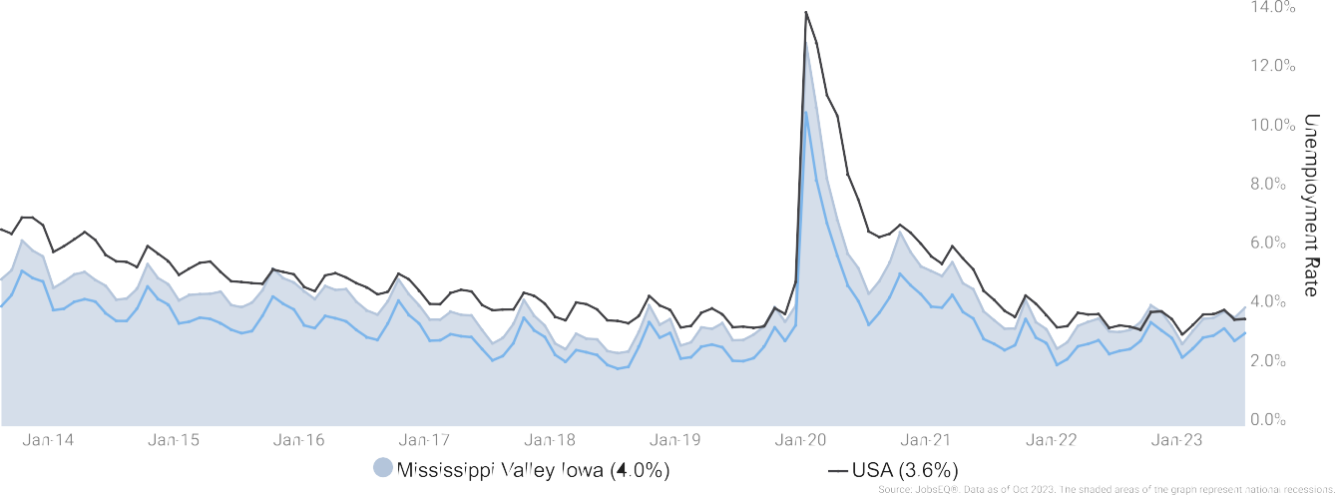

Unemployment rate data are from the Local Area Unemployment Statistics, provided by the Bureau of Labor Statistics and updated through October 2023.

WAGE TRENDS
The average worker in the Mississippi Valley Workforce Area earned annual wages of $54,904 as of 2023Q2. Average annual wages per worker increased 6.5% in the region over the preceding four quarters. For comparison purposes, annual average wages were $70,318 in the nation as of 2023Q2.

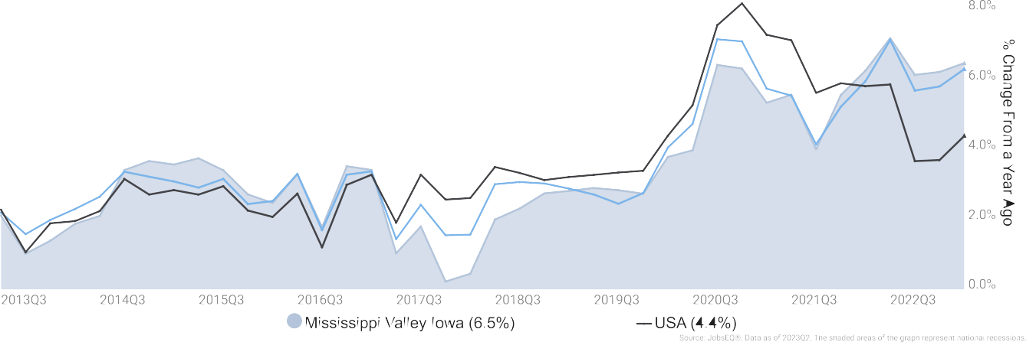
Annual average wages per worker data are derived from the Quarterly Census of Employment and Wages, provided by the Bureau of Labor Statistics and imputed where necessary. Data are updated through 2023Q1 with preliminary estimates updated to 2023Q2.

AWARD GAPS
Based on the below chart from JobsEQ® we can see that the areas that have the largest award gap are General and Operations Managers, Elementary School Teachers, Medical and Health Services Managers, Middle School Teachers, and Career/ Technical Education. This illustrates post-secondary education gaps for MVWA
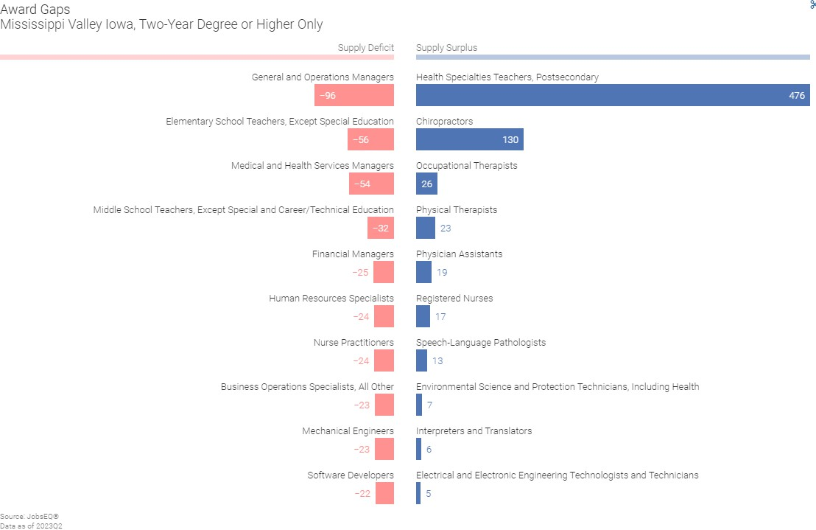

ONLINE JOB POSTINGS FOR 30 DAY TIME PERIOD

The below data reflects information pulled from online job postings for the 30-day period ending 11/30/23. The top posted occupations along with the job posting duration is demonstrated in the chart below.
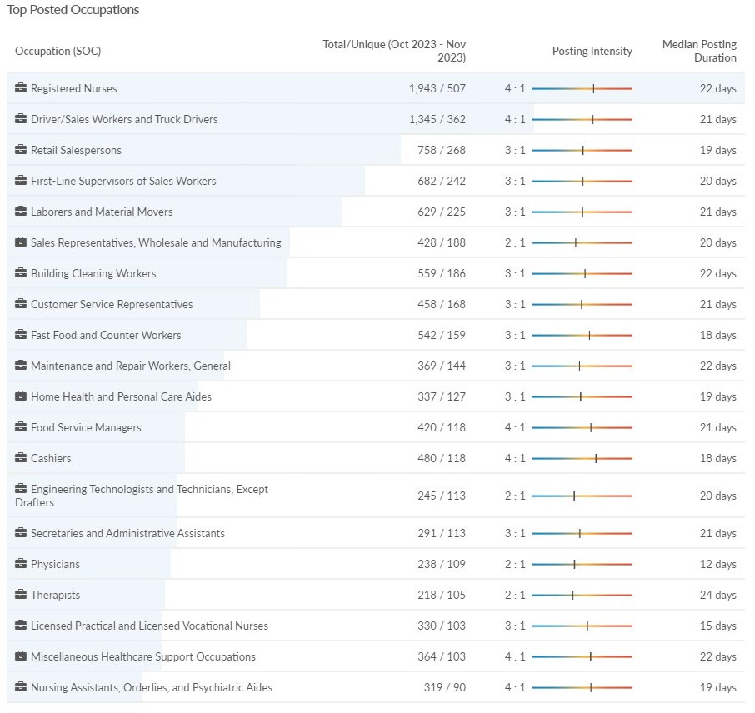
Source: Employment data from Lightcast Q4 2023 Data Set

The below data reflects information pulled from online job postings for the 30-day period ending 11/30/23. The top specialized skills are broken down by frequency in job postings and frequency in profiles.

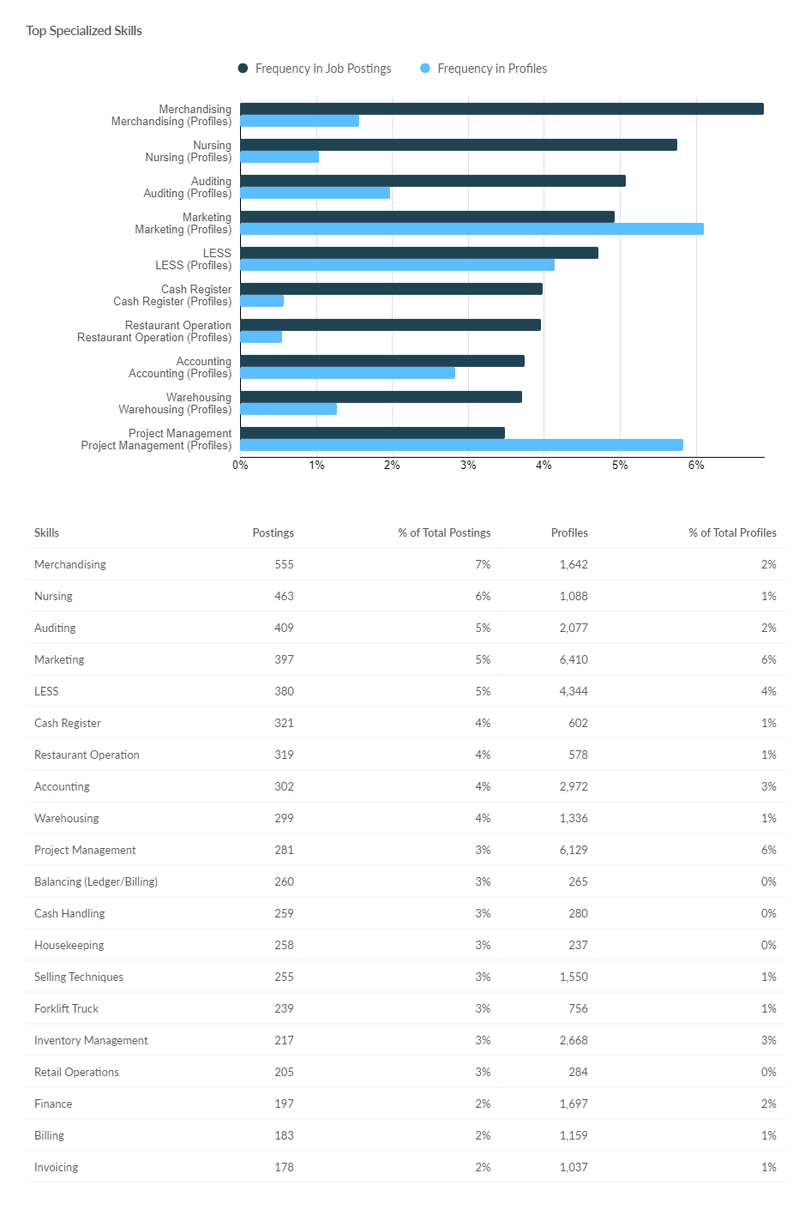

Mississippi Valley Workforce Development Board Page 29 of 89

SKILL GAPS
The below chart represents skill categories that have a gap of 100 or more based on data as of 2023Q2; openings and candidate sample compiled in January 2022.
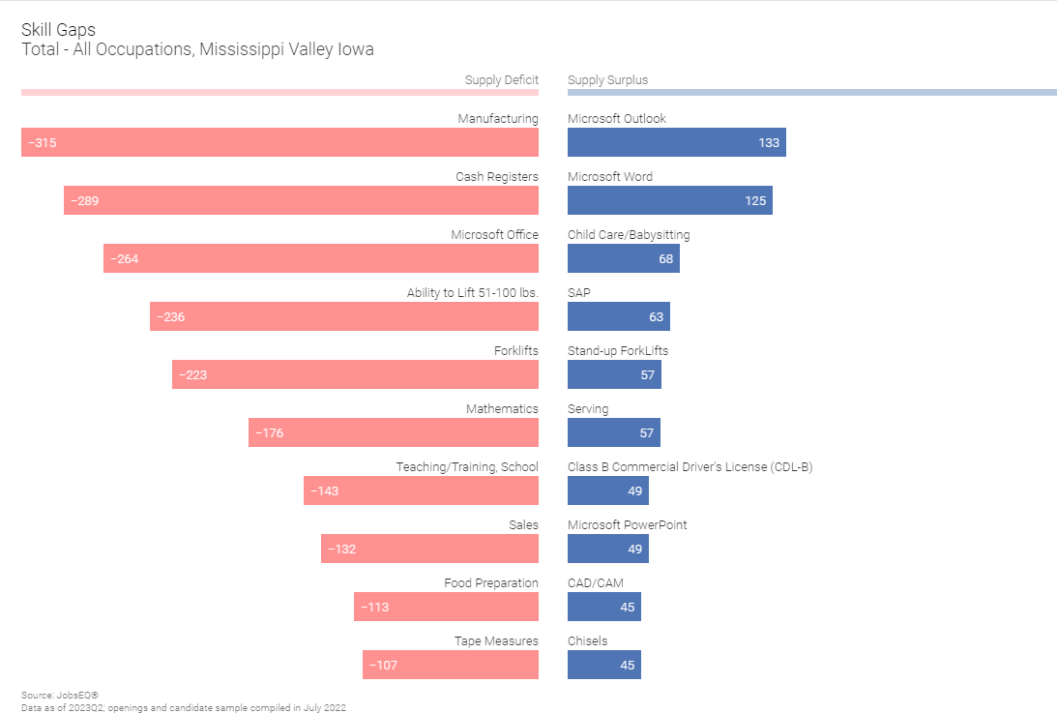

EDUCATIONAL ATTAINMENT
The chart below from Lightcast shows the projections for educational attainment by population for the MVWA from 2023-2027.
Educational attainment data are based on Lightcast's demographic data and the American Community Survey. Educational attainment data cover only the population aged 25 years or more and indicate the highest level achieved.

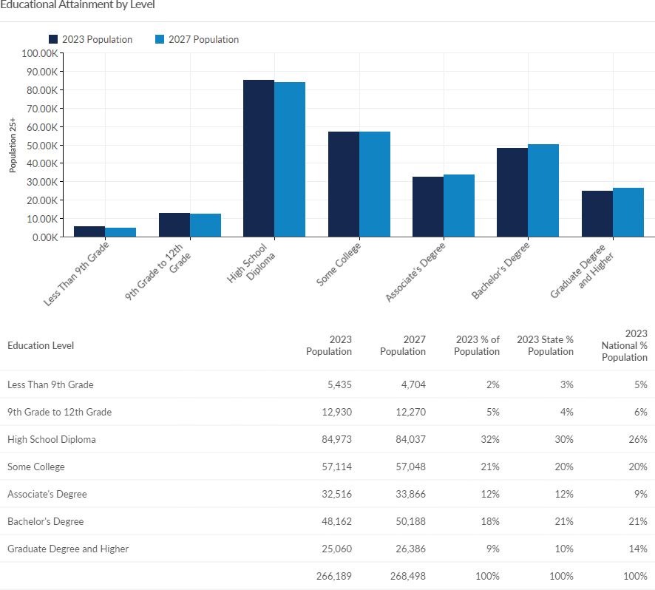
The following chart shows the Top 5 Educational Awards by Occupation in the MVWA consistent with local in-demand industries. Total given for all occupations in the MVWA for reference.

Title | 2 Year Awards & Certificates | 4 Year Awards | Postgraduate
Liberal Arts & Sciences | 660
Registered Nursing | 195 | 76
Medical/Clinical Assistant | 128
Welding Technology/Welder | 108
Business Admin & Management General | 61 | 45 | 75
Total for all Occupations | 2180 | 809 | 971
Source JobsEQ Data as of the 2021-2022 academic year, related occupations data of 2023Q2. Occupation demand data reflect annual average rates from the 10-year forecast.

WORKFORCE CHALLENGES
Iowa Workforce Development (IWD) conducted the seventh Workforce Needs Assessment Survey during the fall of 2022 through the spring of 2023. This survey collects information from employers across the state regarding their vacancies, workforce challenges, difficulties in hiring, perceptions of applicants, advertising outlets for job openings, and upcoming retirements— among other questions.

In October of 2022, 25,160 employers operating 39,254 locations in the State of Iowa were contacted and asked to participate in the survey. In the Mississippi Valley LWDA, 4,861 locations were contacted. By the end of the survey period (March 2023), IWD received 3,056 responses from employers in the Mississippi Valley LWDA, for a response rate of 62.9% (by locations contacted).
The top 5 significant workforce challenges identified by employers are illustrated in the chart below.
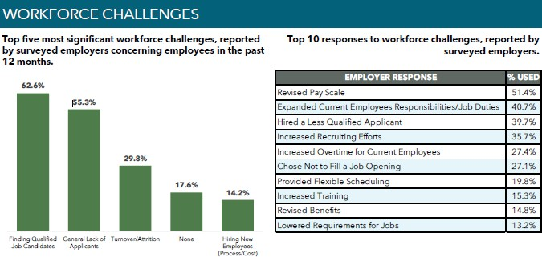

Source: Iowa Workforce Development Workforce Needs Assessment 2023
Employers were asked what skills applicants are lacking and the responses are illustrated in the pie charts below which aligns with the feedback we received in employer focus groups held in November 2023.

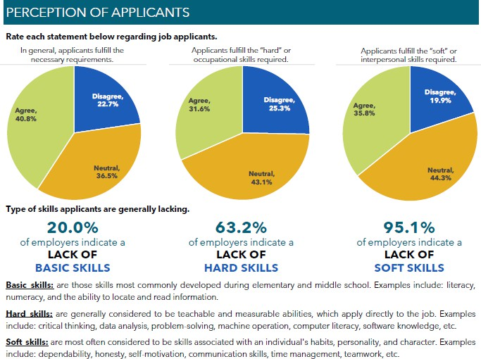
Source: Iowa Workforce Development Workforce Needs Assessment 2023

Question 3
Workforce Development, Education, and Training Analysis: Include an analysis of:
- The strengths and weaknesses of workforce development activities.
- Capacity to provide workforce development activities to address the education and skill needs of the workforce, including individuals with barriers to employment.
- The employment needs of employers.

STRENGTHS AND WEAKNESSES

Strengths
- An engaged and participatory board and CLEO that are open to innovation and exploring technological solutions.
- Partners have strong relationships with other service providers throughout the area including Chambers of Commerce and Economic Development organizations.
- The MVWA strengths center on a strong core partner team that is willing to collaborate to provide wrap-around services to meet the needs of the system customers.

- The Title II Adult Education and Literacy (AEL) program brings many strengths including geographical coverage, accessibility, affordability, access to educational services, and a strong success rate among its students.
- Title II Adult Education provides ESL classes on-site at businesses.
- Willingness of IowaWORKS Staff to travel to locations all over the Local Area to meet with individuals seeking services.
- IowaWORKS offers virtual appointments.
- The MVWDB is a 501(c)(3) nonprofit to leverage additional resources to support the system.

Weaknesses
MVWA has identified weaknesses below that present the new local area as areas of focus for growth and opportunities:
- MVWA has diverse counties and a dispersed population that present barriers to the efficient delivery of services.
- Gaps in coordination, communication, and alignment within the workforce development system. Even though progress has been made, gaps continue in the areas of coordination, communication, and alignment within the system. We are striving to become “One Workforce” and continue to make strides in seamless integration.
- Lack of public transportation remains one of the major weaknesses in the MVWA. A large portion of our population commutes for employment and training.
- Lack of adequate internet broadband capability. Many of the areas in the MVWA have poor quality and/or expensive internet service.
- Creating and sharing participant information across institutions to better measure outcomes. A common data-sharing system of State Agencies to eliminate duplication of services is needed to make all agencies more effective and productive.
- Accessible and affordable daycare, along with the lack of 2nd shift, overnight, and weekend childcare options.

Opportunities
- Focus on all 14 required youth elements.
- Develop more partnerships to provide youth services and events.
- Expand electronic and virtual access in rural counties.
- Standardize SOPs and policies across centers for consistency.
- Increase outreach to businesses about services available and reduce employer fatigue.
- Increase the use of online platforms for virtual job seeker services and businesses.
- Expand work-based learning opportunities.
- Increase job Quality in the MVWA.
- Diversify funding streams to support the system.
- Enhance board awareness, visibility, and influence in the community.

- Inform our communities about IowaWORKS services and break the perception that IowaWORKS is the unemployment office.

Capacity
MVWDB serves as the convener to bring together partners who are dedicated to meeting the demands of the workforce and the employers. Each partner offers unique strengths that will further enrich service delivery through collaboration. The partnerships engage the core agencies and programs, which are working to strengthen services, increase capacity, reduce duplication, and enhance educational integration.

MVWA will deliver a demand-driven system that focuses on building a workforce of high- skilled, high-wage jobs that will enable the employers of the Area to remain competitive. The One-Stop System is a comprehensive, integrated service delivery system that is responsive to the employment and training needs of the customers, including those with barriers to employment that we serve, and incorporates the products and services of our workforce system partners to ensure that customers’ needs are met without duplication of services and are delivered efficiently and effectively.

All workforce partner services can be accessed through the One-Stop Center. Services are either provided in-person on-site, through a cross-trained partner, or through a direct linkage through technology in a timely manner. Having the ability to connect job seekers to all workforce services through one center provides the most effective and efficient service delivery model and leads to greater outcomes for job seekers. Under WIOA, the One-Stop Center is the hub for referrals. One-Stop Center staff use a referral process and a follow-up process to ensure the participant receives the information and services required to be successful.

In the MVWA two comprehensive One-Stop centers have partner staff physically present to provide services to businesses and job seekers. At the Burlington IowaWORKS center the following partners have a physical presence in the centers: Title I Adult, Dislocated Worker, and Youth programs, Title III Wagner Peyser, Title IV Vocational Rehabilitation, Trade Assistance, Temporary Assistance for Needy Families (TANF), Senior Community Services Employment Program, Unemployment Compensation, Jobs for Veterans State Grant (JVSG), Reentry Employment Opportunities (REO), Reemployment Services and Eligibility Assessment Grants (RESEA), Reemployment Case Management (RCM), and Ticket to Work. At the Davenport Center, all of the above programs are present except SCSEP.

Due to the lack of transportation, MVWA One-Stop staff go “where the people are”. We understand that not everyone can travel to an AJC, so staff set up appointments, as needed, as well as schedule regular outreach meetings on specific days and times to provide services to the outlying counties we serve.
- All customers are encouraged to register in IowaWORKS to enable them to complete job search, resume preparation, and access other features that will assist them in their career path.

- Customers are provided with an orientation and complete an intake and assessment. This process encourages each participant to know their skills, explore career choices, and determine if any skills training, education, or certification is needed to meet their goals.
- Customers are offered workshops in a range of subjects, i.e., resume preparation, job search, networking, interviewing, and occupational exploration to assist them in a more effective job search and application procedure.
- For eligible individuals, work-based learning opportunities are available to address needs and are a good avenue to address soft skills needs.
- Job seekers are counseled on the availability of trainings such as Registered Apprenticeships, Pre-Apprenticeships, Internships, On-The-Job Training, and Work Experience.
- Participants are also provided with information on the eligible training provider list and educational opportunities available to them through the Career and Technical Education (CTE) program. Multiple education and training providers offer programs for customers at any level within the local area promoting consumer choice.
- Job seekers have the opportunity to obtain a National Career Readiness Certification (NCRC) using the ACT skills certification system.
- The One-Stop System partners, Business Services Team, and the MVWDB are all continually working to meet the employment needs of employers and enhance services to employers and job seekers.
- Local area staff meet with employers to market and expand Registered Apprenticeship, Pre- Pre-Apprenticeship, On-The-Job Training, Training, and Work Experience. All of these programs offer “Earn while you Learn” training methods.
Not only does the MVWA have two comprehensive centers but also the AEL program has Adult Education centers located on campuses in West Burlington, and Keokuk through Southeastern Community College and Clinton, Scott, and Muscatine Community Colleges through Eastern Iowa Community Colleges. In addition, AEL services are offered at college satellite centers in Ft. Madison, Mt. Pleasant, Maquoketa, West Liberty, and Columbus Junction. The geographical coverage of the program ensures that citizens throughout the Local Area have direct and full access to services within a short travel distance from their homes. In cooperation with the core partners, space can be made readily available at any of the above centers to accommodate representatives from IowaWORKS, Wagner Peyser, Vocational Rehabilitation, and the Department of the Blind, as well as any of their subcontractors and community partners, to conduct face-to-face meetings with their respective clients. This expanded community presence allows all collaborating partners to maintain physical visibility throughout the service area and provide personal services to their clientele.

Many opportunities for training and education assistance are available to customers in the MVWA. Through the local areas’ strong partnerships, collaboration to leverage services, provision of wrap-around services (including supportive services), and enhanced support for the customer exists and increases the likelihood for customers to take advantage of opportunities and achieve success. By building a better skilled and knowledgeable workforce, we will be able to

fulfill the employer’s needs for a skilled and ready pipeline of talent.

EMPLOYMENT NEEDS OF EMPLOYERS
A concern of employers has been the recruitment of people to live in the area as well as the readiness of the available labor force to enter employment. Basic skills which include literacy, numeracy, basic computer skills, and organization skills, in addition to many of the “soft skills” necessary to be successful, are described by employers as lacking. Included in these soft skills needs, employers identified social skills such as basic work ethic, dependability, and retention as necessary skills.

Soft Skills: Work readiness skills continue to surface as a critical need as expressed by employers, schools, and other stakeholders who struggle to deal with those who do not practice positive work ethic. IowaWORKS has long-term experience in accessing and presenting work readiness curricula which assists in addressing this issue. Workshops are offered each month to increase the soft skills needed by employers. PROMISE JOBS and RESEA programs require workshop participation as part of their programs.

The skills new workers (youth) lack, including basic work ethics, interviewing skills, basic academic skills, responsibility, organizational skills, and self-esteem can be addressed in paid work experiences. Additional service providers, including area schools, expand the ability to provide needed training for youth through the referral process and providing Pre-employment Training (PET). Those referrals will be made on an individual basis, meeting the needs of each person.

Hard Skills: We offer Basic Computer Training to individuals lacking digital literacy skills. IVRS also provides Customer Service Certificate Training. Services available to address Hard Skills include Occupational Skills Training, Skills Upgrade, Internships, On-the-Job Training, Registered Apprenticeship, Quality Pre-Apprenticeship, and Incumbent Worker Training. A focus on Customized Training will be a priority of MVWA in the next four years.
The National Career Readiness Certificate is a portable credential and a tool employers can utilize to assess the hard skills of individuals in Applied Math, Workplace Documents, and Graphic Literacy. This testing is also available in Spanish.

Question 4
Vision - Include a description of:
- The LWDB’s strategic vision to support the economic growth and economic self- sufficiency of the local area, including:
  - Goals for preparing an educated and skilled workforce, including youth and individuals with barriers to employment.
  - Goals relating to performance accountability measures based on the performance indicators.
- The LWDB’s strategic vision is to align local resources, required partners, and entities that carry out core programs to achieve the strategic vision and goals.

VISION, MISSION, AND GOALS

Vision - Create strong local economies by developing a future-ready workforce of skilled workers prepared to meet the needs of current and emerging industries.

Mission - The Mississippi Valley Workforce Development Board will achieve our vision through strengthening collaboration with local businesses and job seekers. We will improve access to our dedicated workforce partners through a fully integrated one-stop delivery system. Decisions will be data-driven to enhance our local economies and the quality of life for our communities.

Manager Role Goals
- Develop effective board practices that oversee the operational efficiency and performance of the American Job Centers.
- Engage board members to strengthen management practices and controls to fulfill the objectives and responsibilities of being effective stewards of public funds
Convener Role Goals
- Expand workforce services for individuals at all levels of skill and experience.
- Enhance and nurture strong partners to build a skilled and ready workforce through innovation and alignment across programs to provide a comprehensive set of solutions for businesses and job seekers.
- Implement strategies to ensure that the local workforce system meets the needs of businesses in the local area and that business has the opportunity to engage with the system in meaningful ways.
Strategist Role Goals
- Expand workforce services for individuals and businesses through a fully integrated one- stop delivery system that provides a seamless customer experience.
- Expand outreach and services to all rural areas in the MVWA.
- Research to understand the needs of business and industry in the local area and use data to drive strategic decision-making.
- Develop a nimble and responsive talent delivery system that meets current employers’ needs and anticipates future challenges.
Optimizer Role Goals
- Continuously monitor performance and make policy or service adjustments to foster continuous improvement.
- Supplement public investment with commitments from industry, labor, public, and community partners to implement new ideas and strategies.

Question 5
Strategies – Taking into account the analyses described in sections 1-3 above:
a. Describe the strategy to work with the entities that carry out the core programs and required partners to align resources available in the local area to achieve the strategic vision and goals described in section 4 above.

STRATEGIES
Though the workforce system has made improvements since the passage of WIOA there is a recognized need to increase capacity. The goal over the next four years is to establish access to

all workforce system services regardless of where the individual client or employer is located. To reach this goal, the following strategies will be implemented.
- All individuals will have direct access to the necessary services regardless of where they enter the system, whether it be through the AJC or connection with a partner program or agency. This approach supports an integrated workforce system so that any customer who walks into any AJC can be served seamlessly by any staff member.
- Expand the ability of all partners in the network to inform clients of workforce system services. This will be the result of extensive cross-training.
- Co-enrollment is another important strategy to provide services to a customer that a specific program might not be able to fund themselves. This is where the crosswalk of services available will be needed to address customer needs. Co-enrollment provides the ability to use multiple funding sources and share accountability for an individual.
- All system partners who encounter clients that are lacking secondary school credentials or need basic skill remediation/ESL are referred to Title II partners.
- Identify and expand means to share information about training opportunities to entry- level workers - especially in tune with the preparation for under-utilized populations such as veterans, ex-offenders, people with disabilities, adults with limited English proficiency, older workers, youth, and families on TANF in the Local Area.
- Expand the use of technology. Given Iowa’s diverse local needs, it cannot be assumed that all who need to travel to the current comprehensive sites will be able to do so. To address the barriers of distance, childcare, transportation, and schedules that many people face, services will be available digitally. These services will include up-to-date and comprehensive employment and training websites with links to partner websites. In addition, resources will be accessible through the use of videoconferencing and live chat with a direct connection to the IowaWORKS Centers.
- Identify duplication of services and gaps within the current workforce delivery system and draft policies and collaborative agreements to maximize resources that foster a more unified and consistent approach to the provision of workforce delivery services.
- Create a system of common forms, referrals, and data entry to streamline services and reduce duplication of efforts.
- Expand work-based learning opportunities, resources, accommodations, and supports needed to secure and maintain self-sustaining employment so that all workers can realize their full potential.
- Collaborate with Career and Technical Education (CTE) programs to increase the availability and accessibility of high-quality programs to all youth, including disconnected youth.
- Through continuous evaluations the MVWDB will support continuous improvement of the AJC by identifying which strategies work better for different populations.
- Bring a diversity of stakeholders together to review and create effective policies, programs, and opportunities for our current and future workforce.

- MVWDB will receive reports quarterly from the core partners that provide integrated data to inform the MVWDB for policy decision-making. This information also drives how the workforce system needs to change, innovate, or align services to meet the needs of job seekers and business customers.
- The MVWDB, as a strategic leader will facilitate public-private partnerships, support sector strategies, and career pathways that advance opportunities for all workers and job seekers.
- The MVWDB will work to ensure that workforce and economic development goals are aligned.
- The MVWA will convene a unified business services team that will consist of one representative from all required partners that provide business services in the Local Area.

ONE-STOP OPERATOR STRATEGIES
The IowaWORKS One-Stop Operator, working collaboratively with the IowaWORKS partners and MVWDB, shall drive the formation of an integrated, innovative IowaWORKS system. The One- Stop Operator shall ensure that IowaWORKS center employees, regardless of funding source, represent the IowaWORKS System and not his/her individual program.

It is the responsibility of the One-Stop Operator to work with partners, especially those co- located in the centers, to maximize their active participation in the center and to meet and exceed their programs’ performance goals. The One-Stop Operator will actively engage partners to make sure they receive the maximum benefit and coordination by being in the Centers.

The Operator will eliminate duplication where possible of common administrative functions and services, manage the public funds involved efficiently, and ensure that team management and quality staff performance occur in a seamless, integrated environment.

One-Stop Operator Responsibilities
- Printed material and other written information at the Center must be language accessible to a diverse population of job seekers. Whenever feasible, language barriers should be removed so that all visitors to the Center feel welcome and can benefit from the experience. Outreach materials should be available in alternative languages, when appropriate.
- WIOA consistently emphasizes the need for services targeted to persons with disabilities and individuals with barriers to employment, including individuals who receive public assistance or are otherwise low-income and/or basic skills deficient. Outreach and services shall include efforts to encourage the use of the IowaWORKS system by groups that need employment and training services to become more skilled and employable on the path to financial self-sufficiency.
- All staff on the skills floor must have the ability to provide basic information on all partner programs participating in the IowaWORKS (including those partners electronically linked and/or physically located outside the Center) and to guide customers through online processes. A partner toolkit for all staff must be developed that provides

basic information about each program, populations served, and any basic registration information.
- Meet all requirements regarding compliance with State and Federal disability laws and procedures for ensuring universally accessible physical and program environments for all customers. It is required that the Operator ensures that the IowaWORKS Centers adhere to the standards and expectations set forth in the national Equal Opportunity Self‐ Assessment Guides and checklists.
- Keep up to date a physical list of community resources and contact information that will be available to IowaWORKS customers. Such resources might include DHS, food banks, shelters, mental health, etc.
- Will develop and implement Standard Operating Procedures (SOPs) for the IowaWORKS Mississippi Valley centers to include protocols for the services, processes, and functions that impact the workforce system’s ability to operate in an integrated fashion.
- Will prepare regular reports and recommendations for MVWDB staff related to IowaWORKS Center policy development, enhancements, and performance. The Operator shall formulate and implement required action plans for improvement.
- Through an IowaWORKS systemwide outreach plan with monthly activities identified and agreed upon by all partners increase visibility of programs and services in the community by creating a clearly defined value proposition and humanizing our services. Outreach efforts should be based on targeted groups identified through data. Examine the ROI on different outreach efforts so that the most effective outlets can be maximized. 1 outreach activity should be conducted per month and reported to the board on a monthly basis.
- Track referrals made and outcomes of referrals utilizing the local referral form.
- In an effort to reach remote communities with high levels of poverty and to break down the walls of the IowaWORKS System, the One-Stop Operator should encourage the centers to offer IowaWORKS services outside the walls of the local center on an as- needed basis. The term “On-the-Go” can be used for any event (not a permanent location) hosted by the IowaWORKS Centers in which job seekers are given information and access to services. The Operator shall report to MVWDB, all IowaWORKS “On-the-Go” activities across the community.
- For consistency the One-Stop Operator will oversee the social media team, hold monthly social media team meetings, and complete the monthly social media calendar. The One- Stop Operator shall be responsible for ensuring the consistent utilization of IowaWORKS social media calendar by IowaWORKS partners.
- Maintain a customer satisfaction survey of at least 85% and provide updates regarding issues pertaining to customer complaints that are substantive to the required partners operating in the IowaWORKS centers. Take action to correct any areas of concern.
- Facilitate 3 core partner meetings quarterly and 1 required partner meeting quarterly with agendas driven by strategic goals defined in the WINTAC and through the One-Stop Certification process. Topics that must be discussed are ways to reach common goals (i.e., performance, financial, customer satisfaction), how to leverage resources across partner organizations, discuss programmatic and financial issues faced by the partners as

well as any misunderstandings that may exist between participating partners (troubleshooting of issues), and share details on flagship programs, events, and initiatives and discuss ways to reduce duplication of services and further integration across programs.
- Coordinate a minimum of 4 cross-training activities for center staff/individuals each quarter and two in-person in-service days each program year. Create and manage an innovative solution to educate partners (and internal staff) on the services provided by IowaWORKS as well as the other one-stop partners’ organizations.
- Use the WINTAC document to measure and set goals for integration of system partners. This document should be kept up to date.
- Ensure that an Informational Presentation is made available to the public regarding the full array of services available through the IowaWORKS system, including all partner services conducted at the IowaWORKS site and any other pertinent resources to ensure access to successful employment. Informational Presentations can be conducted in individual or group settings, depending on demand and the need for center efficiency. The frequency of delivery of the Informational Presentations shall be included in a master calendar and published for the public, on at least a quarterly basis. One‐on‐one sessions should also be available for the public, when necessary.
- Oversee the One-Stop Certification process of all IowaWORKS Centers in the MVWA and maintain those standards while striving for continuous improvement. Quarterly, the Operator shall submit to the MVWDB areas identified as needing improvement along with a Plan of Action to accomplish continuous improvement tasks.
- Schedule Wednesday morning meetings (except one Wednesday a month). This schedule will be developed on a quarterly basis.
- Assist the board with ensuring that the Memorandum of Understanding and all Attachments with all one-stop partners is executed, adhered to by all parties, as well as tracking completion, updates, and expiration of activities outlined.

SECTION 3 – IowaWORKS SYSTEM COORDINATION

Question 1
The workforce development system in the local area, including the identification of:
- The programs that are included in the system.
- Describe the steps the LWDB will take to locally implement and support the state strategies identified in the State Plan and work with the entities carrying out core programs and other workforce development programs, including programs of study authorized under the Carl D. Perkins Career and Technical Education Act of 2006, to support service alignment.

PROGRAMS INCLUDED IN | THE SYSTEM
Program | Partner | Center Locations
Title I Adult | Core Partner | Davenport and Burlington
Title I DW | Core Partner | Davenport and Burlington
Title I Youth | Core Partner | Davenport and Burlington
Title II AEL | Core Partner | Davenport and Burlington
Title III Wagner-Peyser | Core Partner | Davenport and Burlington
Title IV Vocational Rehabilitation | Core Partner | Davenport and Burlington
Iowa Department for the Blind | Core Partner | Davenport and Burlington
Career and Technical Education - EICC | Required Partner | Davenport
Career and Technical Education – SCC | Required Partner | Burlington
Trade | Required Partner | Davenport and Burlington
SCSEP | Required Partner | Davenport and Burlington
Native American Programs | Required Partner | Davenport
National Farmworker Jobs Program (NFJG) | Required Partner | Davenport and Burlington
TANF | Required Partner | Davenport and Burlington
Unemployment Compensation | Required Partner | Davenport and Burlington
Jobs for Veterans State Grant (JVSG) | Required Partner | Davenport and Burlington
Reentry Employment Opportunities (REO) | Required Partner | Davenport and Burlington

RESEA | Required Partner | Davenport and Burlington
Ticket to Work | Additional Partner | Davenport and Burlington
Home Base Iowa | Additional Partner | Davenport and Burlington
ReEmployment Case Management (RCM) | Additional Partner | Davenport and Burlington

LOCAL STRATEGIES
State Goals
Goal I: Increase the engagement and awareness of Iowa’s current, potential, and future workforce to the continuum of high-quality education, training, and career opportunities in Iowa.
State Strategy 1.1: Align and implement an accessible, integrated service delivery model incorporating all workforce system partners.

Local Strategy: Promote a no wrong door approach by providing extensive cross training to all workforce partners so that customers can enter at any place in the system for services.

Local Strategy: Continue efforts for further integration by assessing duplication of services across partners and finding ways to maximize resources by increasing collaboration.

Local Strategy: Continue to assess accessibility of centers and program services to further enhance accessibility options.

State Strategy 1.2: Ensure all Iowa students have opportunities for meaningful work-based learning experiences.

Local Strategy: Apply to be the Work Based Learning Intermediary for the school systems to reduce duplication of services, allowing services to be expanded.

Local Strategy: Invest in technology to provide career exploration and other activities to prepare students for work-based learning opportunities.

Local Strategy: Convene youth work-based learning providers to improve collaboration.

State Strategy 1.3: Target services to underserved populations, including individuals with disabilities, minorities, returning citizens, women, rural Iowans, new citizens, veterans, etc.

Local Strategy: Develop a systemwide outreach plan based on LMI data to target specific populations with specific outreach activities identified by partner.

Local Strategy: Humanize our programs through outreach that speak to different lifestyles and demographic groups.

Goal II: Increase employer engagement and awareness of the IowaWORKS system as the premier provider of business services for a skilled and diverse workforce.
State Strategy 2.1: Support local workforce boards in the development and enhancement of sector partnerships.
Local Strategy: Collaborate with IWD on training sessions to support local implementation of sector boards.

Local Strategy: Start 3 new sector boards over the next four-year local plan period.

State Strategy 2.2: Create and implement a unified and collaborative business engagement model.

Local Strategy: Invest in technology to streamline business services across organizations to develop more coordinated and targeted outreach.

Local Strategy: Continue to work on reducing employer fatigue through business service team meetings, the single point of contact approach and IowaWORKS Branding.

Local Strategy: Review on a quarterly basis the local business services strategic plan and make updates as needed for further integration.

State Strategy 2.3: Increase the awareness and engagement by employers in work- based learning opportunities.

Local Strategy: Develop common language across all programs to simplify the message to employers about work-based learning opportunities.

Local Strategy: Develop quarterly what is work based learning virtual webinars for employers to be introduced to WBL and to provide a platform for Q&A.

Local Strategy: Develop an employer award program that recognizes those employers that are champions of the workforce system.

Question 2
Describe how the LWDB will work with the entities carrying out the core programs to:
- Expand access to employment, training, education, and supportive services for eligible

individuals, particularly individuals with barriers to employment.
- Facilitate the development of career pathways and co-enrollment, as appropriate, in core programs.
- Improve access to activities leading to a recognized postsecondary credential, including a credential that is an industry-recognized certificate or certification, portable, and stackable.

EXPAND ACCESS
WIOA partners are actively collaborating to establish a business model centered around delivering services seamlessly to customers, transcending individual programs and job titles. The referral process, encompassing introductions and direct linkages, enhances access to the system and its services. WIOA partners are transitioning to a new platform, UniteUs, facilitating expanded follow-up reporting and granting the One Stop Operator access to a broader array of data points through a unified referral system.

Continuous cross-training ensures that all Core Partners' staff can adeptly address diverse customer needs, offering easily accessible entry points into the system. Cross-training occurs several times quarterly through Wednesday morning meetings, job shadowing, partner-specific presentations, and biannual in-service days attended by staff from Davenport and Burlington IowaWORKS, fostering collaboration and system knowledge.

The Workforce Development system is accessible through any core partner program within the Area, with multiple physical and electronic access points expanding in the upcoming year.
Orientation sessions explaining the workforce development system will be available at partner locations within the Area. Core partners remain committed to delivering services to all eligible individuals, including those with barriers to employment.

Tailoring services to customer needs, the system, in collaboration with Core and Required partners, comprehensively addresses employability requirements. Career Navigators provide information on community resources, Labor Market Information, occupational training, and support services. They facilitate referrals when necessary and share information on training providers, grants, and scholarships.
In the realm of Employment Services, an Integrated Employer Outreach toolkit, coupled with communication from Integrated Business Services Teams, will aim to enhance access to employer services, fostering increased job development, recruitment, and placement. Efforts focus on improving opportunities for individuals with disabilities to secure Competitive Integrated Employment.

For Training Services, MVWA will develop outreach materials to promote work-based learning opportunities and training programs. In Education Services, collaboration with Eligible Training Providers aims to expand access to training and education programs aligned with in-demand occupations, while also promoting stackable and portable credentials. The board’s In-Demand Industry policy will drive training in Mississippi Valley so individuals are provided training opportunities that lead to self-sufficiency wages. Sector Partnership initiatives will inform the development of career pathways, emphasizing employer needs and facilitating co-enrollment

across workforce partners. MVWA will work closely with Eligible Training Providers to ensure quality training, review high-demand careers, and recommend improvements.

Supportive Services, crucial for removing barriers to participation, will expand by working with Core and Required partners to secure access and funding while avoiding duplication.

An Industry-Recognized Credential is defined as “a documented award by a responsible and authorized body that attests that an individual has achieved specific learning outcomes or attained a defined level of knowledge or skill relative to a given standard needed for an occupation. Credential, in this context, is an umbrella term that includes degrees, diplomas, licenses, certificates, badges, and professional/industry certifications.” Sector strategies will also assist education providers and the workforce system in providing quality training services to participants. Labor Market Information will be reviewed annually by the MVWDB and core partners to determine industry clusters in high demand.

An inventory list will be created of stackable and portable credentials needed by businesses in our area and the board will work to have relevant programs added to the ETPL. The board will also work to expand Registered Apprenticeship programs throughout the eight-county area.

The above strategies will ensure that training programs meet the needs of employers and job seekers and that the system is providing quality assistance to ensure creation of Future Ready Iowans. By collaborating with all of our partner agencies the Local Area can better streamline the process for the client and be more effective and efficient with the resources available.

Sector strategies will enable the Area to receive feedback from employers on their needs and with cross communication between partners, they will be able to develop their programs to meet those needs effectively and efficiently.

Question 3
Describe the strategies and services that will be used in the local area to:
Facilitate engagement of employers in workforce development programs, including small employers and employers in in-demand industry sectors and occupations.
- Support a local workforce system that meets the needs of employers in the area.
- Better coordinate workforce development programs and economic development.
- Strengthen linkages between the one-stop delivery system and unemployment insurance programs.
- Implement initiatives such as transitional jobs, incumbent worker training programs, on-the-job training programs, customized training programs, other work-based learning opportunities, registered apprenticeships, industry and sector strategies, career pathway initiatives, utilization of effective business intermediaries, and other business services and strategies designed to meet the needs of local employers. These initiatives must support the strategies described in a.-c. above.

EMPLOYER ENGAGEMENT

MVWDB has an integrated Business Services Team (BST) as described in the local Memorandum of Understanding (MOU). The BST are WIOA partners who identified as providing business services in the local MOU. The goal of business services staff is to assist businesses in developing the long-term strength of their workforce. Coordinated efforts are focused on creating a streamlined business process and preventing duplicative services and contacts to businesses.

Full integration of business services is critical to achieving a high performing workforce development system. MVWDB is committed to the principles of Customer-Centered Design and innovation in its service delivery strategy, including virtual products and services. The responsive integration of these service delivery methods creates better outcomes for the dual customers of workforce development, the jobseeker and business community.

An integrated approach to business services will lead to improved skills, credentials and employment attainment in areas driven by business demand. In total, this effort in conjunction with efforts by economic development activities are expected to enhance and grow Iowa’s economic advantage in both recruiting and retaining businesses.

Annually the BST will complete a self-assessment to help the local area teams drill down into how integrated and effective the business services are currently, and to determine where enhancements can be made. The assessment tool will assist the MVWDB as part of their strategic planning process. The tool is designed to be used as a framework to focus the conversation between workforce partners on how they will address the challenge of becoming more responsive to businesses as a collective unit and will help local areas determine what a “high-performing” integrated business services team looks like.

The MVWDB has developed a business services plan that provides guidelines for implementing and coordinating business services in the MVWA. The Business Services teams will
- Reduce employer fatigue by coordinating outreach efforts
- Use a single point of contact approach
- Establish and develop relationships with business networks both large and small.
- Use integrated outreach materials
- Partner with Chambers of Commerce, Economic Development organizations, and other partners to provide Lunch and Learn and other types of outreach and educational opportunities.
- Annually develop a team strategic plan that includes team goals and strategies
- MVWDB is exploring technological solutions to maximize and coordinate outreach efforts across all partners.
- The Integrated Business Services Teams will help promote Economic Development programs to current Businesses and new start-up businesses. The teams will receive cross training on Economic Development programs.

Interagency collaboration, forming partnerships, and leveraging resources will be a vital aspect of Iowa’s success in meeting business’ workforce development needs. WIOA

partners will continue to support a continued focus on branding the one-stop system, delivering a universal message to identify the one-stop system, and establishing standardized services.

MVWDB BUSINESS COMMITTEE
The MVWDB Business Committee provides guidance and support to the WIOA partners in ensuring implementation of Business Services. To ensure a strategic and focused approach to providing coordinated and consistent services to businesses, the Business Committee consists of cross-agency, cross county and industry members. This committee convenes regularly to provide a strategic direction, evaluate results, provide technical assistance, and recommend changes to program design to enhance service delivery.

ECONOMIC DEVELOPMENT
MVWA will frequently partner with Regional Economic Development representatives in the delivery of job fairs and the promotion of employment and training-based initiatives like Home Base Iowa. The core partners are also involved in several regional economic development projects such as Grow Lee, a series of workforce initiatives, and are participating in an education center in Lee County.

MVWDB recognizes the importance of linkages with economic development and have several Economic Development representatives that sit on our committees as non-board members.
Quarterly the board also sends our Economic Development partners the Economic Overview from LightCast for their county on a quarterly basis. We plan to strengthen our relationships with our Economic Development partners by exploring technology that can benefit both organizations. The MVWDB’s Strategic Partnership Specialist will also stay in regular contact with these partners to ensure priorities and goals are staying aligned across our local area.

SECTOR PARTNERSHIPS
Additionally, MVWA will support and promote the creation of 3 sector partnerships in the next four years including Healthcare, Transportation and one yet to be identified. We will continue to serve as the backbone organization for the Advanced Manufacturing Sector Board

The sector boards will analyze labor market information, participate in workforce planning, further collaboration across multiple partners to address industry needs, identify training needs, evaluate the effectiveness of current programs, develop career pathways, and recommend the allocation of resources.
By focusing on specific sectors, our sector boards will aim to enhance the relevance and effectiveness of workforce development efforts, ultimately strengthening the connection between the skills of the workforce and the needs of employers in key industries. These boards play a vital role in promoting economic growth, competitiveness, and employment opportunities within our region.

ONE-STOP LINKAGES WITH UNEMPLOYMENT INSURANCE

UI services are incorporated in the Davenport and Burlington One-Stop Centers. Iowa’s Unemployment Insurance Division regularly provides UI training at basic and advanced levels. The training is conducted in person with occasional virtual sessions. Team members from the Davenport and Burlington AJC attend these classes as determined necessary and in-service training is provided to IowaWORKS Center staff when needed. Additionally, online policy and procedure documents are available for any team member or partner staff to access if needed. The library of documents is in a keyword searchable format. This process has been very beneficial to ensure the most recent version of a procedure is available when handling UI issues. Each of the IowaWORKS Centers have staff trained in recognizing and referring UI eligibility issues for adjudication. Local staff are encouraged to proactively identify and provide assistance to identified individuals on a case-by-case basis. If a local office team member has a question about a claimants’ situation, IWD has a direct messaging system the team member can contact a UI expert in the main IWD office in Des Moines for assistance. In addition, Iowa participates in the RESEA and RCM program which provides additional opportunities for addressing UI. All UI claimants that come in person to the AJC are provided information on the range of services offered by the One-Stop.

All customers that are selected to participate in an initial or sub RESEA program will complete a UI Eligibility Review to ensure the claimant is conducting appropriate work search contacts and is registered for work in the database system. The RESEA program staff have been fully trained in UI and are able to issue immediate decisions if an eligibility issue arises. There is an immediate feedback loop between UI program staff and the AJC for potential eligibility issues. The issue is reported via technology and then the UI program can establish a fact finding if necessary.

TRANSITIONAL JOBS
Some individuals with multiple barriers to employment may need to begin with a less intensive activity such as transitional jobs, where they learn or become accustomed to the basic expectations of a workplace. Transitional jobs are a time-limited work experience that is combined with comprehensive employment and supportive services. This work-based learning activity is for individuals with barriers to employment, are chronically unemployed, or have an inconsistent work history. The purpose is to support individuals to establish a work history, demonstrate success in a work environment and develop skills to obtain and retain unsubsidized employment.

ON-THE-JOB TRAINING
Other individuals may present as job ready and can be placed in OJT arrangement. OJT is beneficial to participants who are prepared to enter the workforce long-term. OJTs are used to teach a participant specialized skills and competencies needed to perform a specific job at a worksite where there may be a chance for advancement. The participating business has a major investment in the OJT process as they assist to complete a training plan and are the employer of record. The MWDB sets goals annually for number of WBL placements and allows up to
$10,000 reimbursement for OJTs to employers. INCUMBENT WORKER TRAINING

The MVWDB has developed and launched a Retain & Retain Grant program (IWT). This program is initiated by employers applying to receive funding. Incumbent worker training is designed to assist employers in upgrading the skills of their current workforce. These efforts have shown to increase the competitiveness of employers in their designated markets while creating an internal workforce whose skills are assisting the employer to remain competitive with a skilled workforce and increased worker tenure. Employees benefit by receiving training to upgrade their skills, wages, and increased experiences within an organization. The MVWDB provides up to $10,000 to employers who are in our in-demand industries for training.

CUSTOMIZED TRAINING
The MVWDB will develop policies and procedures for Customized training in the next year. Customized Training will provide training that is specific to an employer (or group of employers) specific requirements so that individuals will be hired by the employer after successful completion of the training. Customized training is designed to provide local areas with flexibility to ensure that training meets the unique needs of the job seekers and employers or groups of employers. These types of activities are very effective training models for both youth and adult populations. Gaining hands-on training in a work environment allows individuals to gain not only the transferable skills needed in employment, but the soft skills employers require.

REGISTERED APPRENTICESHIP
The MVWDB will strive to facilitate the implementation of apprenticeship programs in the MVWA. RAs provides an earn and learn opportunity for both job seekers and employers. It brings together On-the-job training with Related Training Instruction to receive a Nationally recognized credential.
Question 4
Describe how the LWDB will coordinate local workforce investment activities with economic development activities that are carried out in the local area and how the LWDB will promote entrepreneurial skills training and microenterprise services.

COORDINATION WITH ECONOMIC DEVELOPMENT
The coordination of local workforce investment activities with economic development activities is crucial for maximizing the impact of both efforts. Below are strategies and activities that MVWA will incorporate to improve collaboration and promote entrepreneurial skills training and microenterprise services:
- Economic Development partners will be invited to attend quarterly board meetings, sector initiatives and other special forums.
- The MVWDB will conduct a comprehensive needs assessment to identify the skills demanded by local industries and the economic development priorities of the region.
- More collaborative partnerships will be formed with local economic development agencies, chambers of commerce, educational institutions, and other relevant stakeholders through regular meetings to review goals and objectives.

- The MVWDB will integrate workforce development and economic development plans to ensure alignment and mutual support. This will involve joint planning sessions, where goals and strategies are developed collaboratively.
- The MVWDB has adopted a sector-based approach, focusing on key industries driving the local economy. This involves tailoring workforce training programs to meet the specific needs of these sectors, ensuring a skilled workforce that aligns with economic development goals.
- To promote entrepreneurial skills and microenterprise development, the MVWDB will collaborate with local Small Business Development Centers (SBDCs), community organizations, and financial institutions. This could involve offering training on business planning, access to capital, and networking opportunities for aspiring entrepreneurs.
- The MVWDB will work to coordinate resources efficiently, ensuring that workforce development and economic development initiatives share resources where applicable and appropriate such as training facilities, educational programs, and software systems.
- Regular data sharing and analysis between the MVWDB and economic development entities will help in assessing the effectiveness of programs. This iterative process allows for adjustments to be made based on real-time information.

ENTREPRENEURIAL TRAINING
Annual entrepreneurial sessions involve high school juniors and seniors from local schools. Each year students have taken part in entrepreneurial training sessions, and also constructed mock companies. Title II assists clients in entrepreneurial activities through contextualized learning, financial and digital literacy, English literacy, workplace numeracy skills, soft skills and other aptitudes needed in an entrepreneurial enterprise.

IOWA SELF-EMPLOYMENT (ISE)
Is a program designed for clients of Iowa Vocational Rehabilitation Services (IVRS) or Iowa Department for the Blind (IDB) whose vocational goal is self-employment. They provide individualized Self-Employment services to Iowans with disabilities who are interested in starting, expanding or acquiring a business. Referrals to the ISE program are made by IVRS/IDB counselors.

By implementing these strategies, the MVWDB can effectively coordinate local workforce investment activities with economic development initiatives, fostering a symbiotic relationship that benefits both job seekers and the overall economic health of the community.

Question 5
Describe the one-stop delivery system in the local area, including:
- How the LWDB will ensure the continuous improvement of eligible providers through the system and that such providers will meet the employment needs of local employers, workers, and job seekers.
- How the LWDB will facilitate access to the services provided through the one-stop delivery system, including in remote areas, through the use of technology and other

means.
- How entities within the one-stop delivery system, including one-stop operators and the one-stop partners, will comply with section 188 of WIOA, if applicable, and applicable provisions of the Americans with Disabilities Act of 1990 regarding the physical and programmatic accessibility of facilities, including providing staff training and support for addressing the needs of individuals with disabilities.
  - Include how the LWDB will utilize Disability Access Committees (DACs) as a strategy.
  - Describe the process that an individual would use to request an accommodation as well as how an individual will know what accommodations/assistive technology equipment are available.
  - Describe how partners/operator will ensure individuals with disabilities can participate in workshops and services offered throughout the center.
    - The roles and resource contributions of the one-stop partners.

ELIGIBLE TRAINING PROVIDERS
The MVWA will conduct ongoing analysis of the Area's economy and workforce needs to ensure continuous improvement of eligible providers of services and to ensure that such providers meet the employment needs of local employers, the current workforce, and job seekers. This analysis will be completed as part of the MVWDB’s regularly scheduled meetings with needs assessments being completed as necessary. Local labor market information will be utilized with this review and reviewed by our sector boards. Elements potentially included in the analysis:
- An assessment of the current economic situation and projected trends of the local area economy, industries, and occupations, including major economic Areas and industrial and occupational sectors as determined through LMI data.
- An assessment of the required workforce skills and knowledge individuals need in order to find employment.
- An analysis of the skill and education gaps for individuals within the local area.

ACCESS
All partners will participate in a process of continuous improvement to offer the best possible services and seize opportunities for further integration. To assure that services are responsive to the needs of the community, partners will survey customers to obtain feedback on customer satisfaction. All partners will participate in the ongoing development and improvement of the MVWA one--stop center procedures, policies and operational management. All partners will be part of a joint planning process that will continuously review the needs of the MVWA and business community and refine the services of the one--stop system based upon those needs.
In addition, the partners will encourage, accommodate staff, and/or provide training and cross training, as deemed appropriate, to ensure that all partner staff are familiar with all programs represented within the MVWA One--Stop System in order to integrate services, reduce duplication, and improve overall service delivery.
- Multiple points of access will be available through partner sites within the Local Area.

- IowaWORKS staff provide outreach and enrollment in all outlying counties within the area on an itinerant basis.
- Partners provide services through the One-Stop physical center on an as needed basis.
- Partners participate in ongoing referral, co-enrollment, and performance management.
- Utilizing Zoom, Teams, Facetime electronic video conferencing for appointments, orientations, and workshops is used.
- Basic Career Services can be accessed online utilizing the iowaworks.gov website or mobile app.
- English Language Learners (ELL) and HSED Instruction is provided remotely and at multiple access locations throughout the MVWA.
- IowaWORKS One-Stop Centers will utilize social media to engage with job seekers in the local area to highlight services that are being provided by the IowaWORKS One-Stop Centers, including but not limited to workshops, hiring events, career fairs, job postings, and programs available. Teams will also share relevant posts from media sources or community partners when it is informative to job seekers of the local area.
- Technological solutions will be explored to provide direct access to the IowaWORKS Centers in rural communities.

ACCESSIBILITY
The MVWDB has a disability access committee (DAC) with a chair and co-chair from IVRS/IDB. The DACs are composed of various core partner and outside partner members who work together under the direction of the MVWDB. In the past the DAC has conducted disability focus groups to gather information about the various needs of customers with disabilities in accessing Center programs. In addition to this, the group evaluate assistive technology options that are needed for the centers, the level of comfort of Center staff in offering those accommodations, and as well, the appropriate process for working with requests for accommodations from customers.

WIOA Section 188 ensures equal opportunity for individuals with disabilities. Specifically, Section 188 prohibits discrimination on the basis of race, color, religion, sex, national origin, age, disability, or political affiliation or belief, or, for beneficiaries, applicants, and participants only, on the basis of citizenship status or participation in a WIOA Title I-financially assisted program or activity.

WIOA AJC are also subject to the requirements of: (1) Section 504 of the Rehabilitation Act prohibiting discrimination against individuals with disabilities by recipients of Federal financial assistance,6 (2) Title I of the Americans with Disabilities Act (ADA), as amended, prohibiting discrimination in employment based on disability, and (3) Title II of the ADA prohibiting public entities, including State and local governments and their departments, agencies, and instrumentalities, from discriminating on the basis of disability.
All Partners will ensure that all WIOA Title I programs and activities are programmatically accessible, which includes:
- Providing reasonable accommodations for individuals with disabilities.

- Making reasonable modifications to policies, practices, and procedures.
- Administering programs in the most integrated setting appropriate.
- Communicating with persons with disabilities as effectively as with others.
- Providing appropriate auxiliary aids or services, including assistive technology devices and services, where necessary to afford individuals with disabilities an equal opportunity to participate in, and enjoy the benefits of the program or activity.
Accessibility to the services provided by the IowaWORKS Centers and all Partner agencies in the MVWA will be achieved through the following plan. Job seekers and businesses will be able to access all information relevant to them via visits to physical locations as well as in virtual spaces. The accessibility plan will be overseen and carried out by the MVWDB. The local Disability Access committee (DAC) will be in charge of development of trainings, evaluating IowaWORKS Center and Partner programs, and assisting all Partners with accessibility issues and concerns.
- The locally developed assistive technology checklist is used to evaluate the IowaWORKS Center and Partner programs on an annual basis. If deficiencies are found a plan is put in place to correct any issues. The plan details issues found, corrective action plans, and timeline for implementation.
- The One-Stop Operator will hold quarterly meetings for all required Partners and will offer accessibility trainings through these meetings once developed by the DAC. Content will cover required accommodations, ways to improve accessibility, and how to best serve customers with disabilities. Training will be continuous and offered on an annual basis.
- Staff at the centers will also participate in training on how to use assistive technology twice annually during their in-service days. Equal access is ensuring that staff are trained on how to assist individuals with disabilities and on how to use the necessary accommodations.
- A resource guide is available with a list of assistive technology available and brief instructions on how to use each item and available at each center. This resource guide is updated annually.
- All Partners will be invited to and encouraged to participate in regular DAC meetings.
- If a Partner program runs into an accessibility challenge, they will contact the DAC for assistance.
Individuals with disabilities constitute a population that has traditionally been underserved or unserved by the workforce development system. This is why the MVWDB has identified people with disabilities as the Local Area’s 4th priority of service category.

Upon entering the One-Stop
- Any individual is free to request an accommodation of auxiliary aids and services, and the obligation to provide such is triggered upon such a request.
- Accommodations notices will be posted on conspicuous places, such as waiting or reception areas.

- The Accommodation Request Card is available at the front desk counter; the individual may select the type of accommodation needed.
- The card will be returned to any available staff and the accommodation will be set up immediately or in a reasonable time frame to ensure the participant has equal access to programs and services.
All staff shall receive training on WIOA Section 188 Nondiscrimination and Equal Opportunity training upon hire, and annually thereafter. Local One-Stop Operator will conduct an annual training of all staff on the policy and the use of the assistive devices. All AJC will have signs posted to alert customers accommodations are available upon request. It is the intent of the MVWDB that all staff are fully trained on the availability and uses of Assistive Technology.
When reasonable accommodations or modifications are necessary Job Centers will ensure they will provide them in a timely manner by contacting a local agency that provides assistive devices or contacting the Local Equal Opportunity Officer.

ROLES AND CONTRIBUTIONS OF ONE-STOP CENTER PARTNERS
The management of the One-Stop System is the shared responsibility of the MVWDB, CLEO, WIOA core program Partners, required One-Stop Partners, One-Stop operators, service providers, and any non-mandatory Partners added to the local system by the MVWDB and CLEO. In other words, the system is a total collaborative for the planning, operations, and management of local workforce services. All Partners should be aware of their responsibility under the law. All Partners must:
- Provide access to their programs through the IowaWORKS system.
- Use their program’s funds to:
  - Provide career services.
  - Maintain the One-Stop System and jointly fund it.
- Sign the Memorandum of Understanding (MOU) with the MVWDB.
- Participate in the operation of the system.
- Provide representation on the MVWDB, as required, and participate on committees of the MVWDB , as needed.
The Parties to the Memorandum of Understanding will collaborate to ensure all required and needed services are available to Iowans and Iowa businesses and will work to ensure each IowaWORKS location offers integrated services and have staff who work to ensure quality service delivery. Acceptable methods and options for providing access to each of the required services:
- Having a program staff member physically present at the AJC.
- Having a staff member from a different partner program physically present at the AJC and appropriately trained to provide information to customers about the programs, services, and activities available through all partner programs.
- Making available a direct linkage through technology to a program staff member who can provide meaningful information or services.

Local Areas are in the process of negotiating the IFA and will be completed in accordance with WIOA and other regulatory requirements. Partners are currently contributing to their share of the cost to operate the American Job Centers through sublease agreements and quarterly invoices issued by IWD.

Question 6 A description and assessment of the type and availability of adult and dislocated worker employment and training activities in the local area.

ADULT AND DISLOCATED WORKER SERVICES
Adult and Dislocated Worker (DW) services are available across all eight counties, Jackson, Scott, Clinton, Muscatine, Louisa, Lee, Henry, and Des Moines. These services are accessible through two comprehensive IowaWORKS centers in Davenport and Burlington, as well as partner sites. Efforts are underway to establish additional access points, such as libraries, connecting individuals to live personnel at IowaWORKS Centers, enhancing accessibility to all IowaWORKS programs and services.

Basic Career Services
- Determination of eligibility for adult or dislocated worker assistance.
- Outreach, intake, and orientation to One-Stop delivery system services.
- Initial assessment of skill levels, including literacy, numeracy, and English proficiency.
- Labor exchange services, encompassing job search, placement assistance, and career counseling.
- Provision of information on in-demand industry sectors and nontraditional employment.
- Referrals and coordination with other programs and services.
- Workforce and labor market statistics information.
- Performance and program cost information on training service providers.
- Information on local area performance accountability measures.
- Information about supportive services and appropriate referrals.
- Assistance in establishing eligibility for financial aid for training and education programs.
- Information and assistance for filing UI claims.

Individualized Career Services
- Comprehensive assessments of skill levels and service needs.
- Development of individual employment plans.
- Group and/or individual counseling and mentoring.
- Short-term pre-vocational services.
- Internships and work experiences linked to careers.
- Workforce preparation activities.
- Financial literacy services.
- Out-of-area job search and relocation assistance.

- English language acquisition and integrated education and training programs.
- Work-Based Learning opportunities.
- Integrated Resource Team meetings for dual-enrolled clients.

Training Services
- Occupational skills training, including nontraditional employment.
- On-the-job training (OJT), incumbent worker training, and private sector-operated programs.
- Programs combining workplace training with related instruction.
- Skills upgrading, retraining, and entrepreneurial training.
- Transitional jobs and job readiness training.
- Adult education and literacy activities, including English language acquisition.
- Customized training with employer commitment for employment upon completion.
- Connections to Registered Apprenticeship Programs

Follow Up Services
- Follow-up services for participants placed in unsubsidized employment for up to 12 months.

In our efforts to establish connections beyond our IowaWORKS locations, we consistently schedule appointments with individuals at various public spaces within their communities. These include public libraries, community colleges, and partner offices. We actively engage with the community by conducting outreach at the Scott County jail and the Burlington Residential Correctional Facility.

To broaden our reach, we actively participate in interagency groups, facilitating the sharing of resources. Additionally, we take part in career and resource fairs to connect with a diverse audience. We maintain a weekly presence at the Clinton Resource Center, offering assistance to individuals seeking resources.

Embracing the digital landscape, we conduct virtual orientations and provide virtual appointments to cater to individuals who may not be able to attend in person. Furthermore, we enhance our team's versatility by cross-training employees, enabling them to effectively introduce and explain various resources and programs to our customers.

Question 7 How the LWDB will coordinate workforce investment activities in the local area with statewide rapid response activities.

RAPID RESPONSE
Iowa's Rapid Response (RR) initiatives continue to be a crucial component of business engagement. Upon receipt of Worker Adjustment and Retraining Notifications (WARN), RR staff promptly collaborate with company officials and local leaders to coordinate and implement RR activities. The Rapid Response program adopts a proactive, business-focused, and adaptable

strategy aimed at swiftly addressing layoffs and plant closures by coordinating services and providing immediate assistance to affected companies and their workforce.

Upon receiving WARN notices, State RR staff reach out to each employer. Following this, most employers receive localized RR services. In the MVWA region, the Rapid Response Coordinator, a Title I staff member, oversees RR activities across the eight-county area. This coordinator ensures that RR teams in each center deliver all necessary services. The teams are cross-trained and disseminate information about all AJC programs, services, and resources available to Dislocated Workers post-Rapid Response employee meetings. If additional funds are required for more intensive services, the MVWDB submits applications for state or federal emergency funds.

RR teams, comprising AJC staff, are deployed at both centers. These teams collaborate with employers and employee representatives to efficiently leverage public and private resources, minimizing disruptions associated with job loss. Rapid Response offers tailored services on-site at affected companies, accommodating various work schedules, and guiding companies and workers through the challenging transitions linked with job loss.

The RR teams take charge of organizing job fairs, hosting WIMs, offering workshops, and linking participants to additional resources.

Rapid Response Team Responsibilities
- Conduct initial contact with the company facing layoffs to explain available services.
- Arrange WIMs for affected employees, presenting all pertinent literature and information about partner services.
- Utilize Chromebooks for on-site assistance at employers, enabling affected workers to engage with services and register in IowaWORKS.
- Conduct an Awareness Campaign with outreach and coordination with community agencies and social services organizations, providing information and assistance to support affected workers and the community.
- Facilitate customer access to partner programs through referrals for intensive services, training, education, barrier-removal services, and employment services, including job- specific information.
- Provide follow-up to laid-off workers following WIMs.

Question 8 The type and availability of youth workforce investment activities in the local area, including activities for youth who are individuals with disabilities, which much include an identification
of successful models of such activities.
- Include how the LWDB will utilize the Youth Standing Committee as a strategy.
- Pending approval of the State’s waiver request, include if the LWDB will utilize the waiver to lower the out-of-school youth expenditure rate to 50%, or if the LWDB opts to retain the 75% out-of-school youth expenditure requirement.
  - If the LWDB opts to utilize the waiver, include:

    - a summary of the outreach strategies and partnerships the LWDB will utilize to engage out-of-school youth and ensure in-school youth participation is targeted to students in underserved populations;
    - quantifiable projected programmatic outcomes resulting from implantation of the waiver;
    - individuals, groups, or populations benefitting, or otherwise impacted by the waiver; and;
    - how the LWDB plans to monitor waiver implementation progress, and the collection of measurable waiver outcome information.

14 ELEMENTS
All fourteen required WIOA youth elements are made available to youth throughout the MVWA:
- Tutoring, study skills training, dropout prevention strategies.
- Alternative secondary school services or dropout recovery services.
- Experiential Learning – Paid and unpaid work experiences that have as a component, academic and occupational education, which may include:
  - Summer employment opportunities and other employment opportunities available throughout school year (WEP).
  - Pre- apprenticeship programs (PRE).
  - Internships and job shadowing (INT), (SHW).
  - On-the-job training (OJT).
- Institutional/Occupational skill training shall include priority consideration for training programs that lead to recognized postsecondary credentials that are aligned with in demand industry sectors or occupations.
- Education offered concurrently with and in the same context as workforce preparation activities and training for a specific occupation or occupational cluster.
- Leadership development opportunities.
- Supportive services.
- Adult mentoring for a duration of at least 12 months.
- Follow – Up Services.
- Comprehensive guidance and counseling.
- Financial Literacy education.
- Entrepreneurial skills training.
- Services that provide labor market and employment information about in- demand industry sectors or occupations available within the local area.
- Activities that help youth prepare for and transition to postsecondary education and training.
The above referenced services are available through multiple partners within the Local Area and include but not limited to WIOA, Iowa Vocational Rehabilitation, Adult Education and Literacy, Southeastern Community College, and Eastern Iowa Community Colleges.

Adult mentoring is provided by reaching out to appropriate organizations with potential mentors (i.e., Kiwanis, Rotary Club, alumni associations at training providers) to partner a mentor with a specific youth. In many cases, particularly in rural areas, the Career Navigator serves in a mentoring role. Career mentoring can also take place at work-based learning sites.

Career Navigators make a referral for comprehensive guidance and counseling to community partners such as counseling agencies, substance abuse treatment providers, and crisis intervention organizations, etc.

Financial Literacy can be provided through the Title I Youth provider. Courses are available through The Academy. The Title I Youth provider also teaches basic financial literacy in the ILegacy trainings. They also partner with Iowa State Extension and Consumer Credit of the Quad Cities to provide more extensive financial literacy training.

Entrepreneurial skills training can be provided through courses available through The Academy. We also partner with Southeastern Community College and Greater Burlington Partnership to refer clients to the Small Business classes that are offered to the community.

The Title I Youth provider has a proprietary online suite of skills development and career exploration courses through the Academy. The Academy offers a library of more than 8,400 courses and credential-qualifying training in more than 100 industries, which helps to facilitate independent and guided investigation.

The Title I Youth provider also offers ILegacy which is our four-hour job readiness curriculum that all new youth complete, as well as two hours of Linked in Learning courses of their choosing. ILegacy covers a myriad of topics related to success in the workplace, including applications, resumes, negotiation, job seeking, appropriate workplace behavior, self- improvement, teamwork, and handling criticism.

Workforce Partnerships
Below is a list of current partnerships in the MVWA:
- Work with Bridges Out of Poverty.
- Work with probation/juvenile court officers, as well as do monthly outreach at the Lee County Juvenile Detention Center.
- Work with Lee County Economic Development Group Career Advantage Center to provide career exploration activities to every 8th grader in Lee County.
- Present at Keokuk IJAG classes regularly.
- Partner with training providers and programs like GAP, PACE, and TRIO to help students.
- Work with the foster care transition program to help youth leaving foster care in the entire local area.
- Work with Muscatine County Public Health with their teen pregnancy prevention grant program.

Additional Programs and Services Available in the MVWA

A variety of youth workforce activities are available in the MVWA. Activities vary greatly across the Local Area. The following outlines several programs/activities that are available to youth in MVWA:
- IJAG - The ultimate objective of an iJAG program is to provide participants with classroom and work-based learning experiences that result in a quality job, leading to a career after graduation or completion of the HiSET high school equivalency program.
- Junior Achievement - Junior Achievement fosters the future success and economic health of young people and the communities in which they live by providing hands-on elementary and secondary programs focused on work readiness, financial literacy and entrepreneurship.
- Lead the Way (Davenport Schools, North Scott, Muscatine, Clinton, Maquoketa, and Pleasant Valley) - Project Lead the Way is the nation's leading provider of science, technology, engineering, and math (STEM) programs. Through world-class K-12 curriculum, high-quality teacher professional development, and outstanding partnerships, PLTW is helping students develop the skills needed to succeed in the global economy.
- Iowa State Extension - Youth workforce activities include IT Tech Team, 4H Leadership, 4H STEM, and Service-Learning programming.
- Bi-State Transition Conference - This annual event targets youth with disabilities. It alternates focus every other year between transition to training/college after high school and careers.
- Davenport Teen Job Fair (Marketed to Scott County area) - The Davenport Teen Job Fair offers teens an opportunity to meet area employers, apply for positions, and learn job search skills.
- Eastern Iowa Community College Career Days - Events are offered at all EICC campuses to introduce teens to career options and training programs.
- Southeastern Community College - Each year SCC holds several career fairs, STEM fests for youth, and events to talk to middle/high school students about career pathways.

Aligned Impact Muscatine.

Increased Access to Services in Rural Areas
The MVWA has adopted the following strategies to increase access to rural areas:
- Developed connections with family support home visiting programs.
- Has connections with Nest Programs for new parents.
- Attends HiSED programs in rural areas (Keokuk, Fort Madison, Mount Pleasant, Clinton, Maquoketa).
- Other agency connections in the rural counties are: Head Start in Maquoketa, Fellowship Cup in Mt. Pleasant, food pantries in Lee, Henry, Louisa counties, Muscatine Center for Social Action, Salvation Army in Lee and Muscatine counties, Community Action in all the counties, Goodwill in Jackson and Lee counties, and the Transition Alliance Board in Clinton county.

ACTIVITIES FOR YOUTH WHO ARE INDIVIDUALS WITH DISABILITIES
Iowa Vocational Rehabilitation Services
Iowa Vocational Rehabilitation Services (IVRS) provide services to youth with disabilities. Services available to assist students include:
- Career Exploration Assessments.
- Counseling and Guidance Services.
- Pre-Employment Transition Services (Pre-ETS)
  - Job Exploration Counseling provides students with opportunities to learn about various career options and work skills necessary to be successful.
  - Work-Based Learning Experiences provide students with opportunities in the community to assist them with connecting school experiences to real-life work activities and future career options.
  - Counseling on Opportunities provides students with information and guidance on a variety of postsecondary education and training opportunities.
  - Workplace Readiness Training is training to develop employability skills, social skills, and independent living skills.
  - Instruction in Self-Advocacy is activities to develop self-advocacy skills needed in education, workplace, and community settings.
- Assistance with Post-Secondary Training.
- Job Seeking Skills Training.
- Job Placement.
- Assistive Technology.
- Skip the trip-DOT permit examination proctoring

IVRS has programs set up with partners to focus on services to Iowa high school students with disabilities. We currently have a Transition Alliance Program (TAP), The TAP is a partnership between Community School Districts and IVRS. Participants of TAP receive assistance in the areas of vocational training, independent living, and post-secondary education. The goal is for young adults to develop positive work skills in order to obtain and maintain competitive integrated employment. TAP participants receive follow-up services to assure long-term job success!

IVRS also has Project Search programs which are a transition-to-Work Program for a seamless combination of classroom instruction, career exploration, and hands-on training through worksite rotations.
The IVRS Intermediary Network (IN) contract involves select high schools within 14 of Iowa’s 15 Community Colleges. The purpose of the IVRS IN program is to help meet the vision of a future-ready Iowa that prepares individuals for dynamic careers and lifelong learning, meets employer needs, grows family incomes, and strengthens communities. The IVRS IN program provides for an IN to expand vocational rehabilitation capacity providing pre-employment transition services to high school students with disabilities in designated districts, which will help prepare the students to enter employment or additional post-secondary training following secondary school graduation. Students can learn about work readiness skills, career pathway opportunities and expand work-based learning providing increased opportunities for employment in a chosen career field. IN's work collaboratively with IVRS counselors and other partners to

provide the career readiness and career exploration services to districts where gaps are identified. Services may include career exploration, job shadows, plant tours, career day experiences, job seeking skills training, and understanding local labor market information and training opportunities that will lead to placement in those careers.

IVRS offers resource fairs as requested - from high school to beyond: training, support, and service providers to increase personal independence. The purpose of this fair is to gather information about life beyond high school. Students, parents, teachers, and advocates have the opportunity to visit informational sessions of their choice to gather information for transition planning.

IVRS provides summer programming in partnership with Transition Alliance Programs, Intermediary Networks, area businesses, and WIOA partner agencies. Students participate in career-based activities and explore occupations in all six of the Iowa Core career pathways. This program allows students to engage in presentations, tours, participate in hands-on volunteerism, and interactive activities to learn essential work related soft and hard skills as well as expectations of employees, job seeking skills, and job retention skills.

75% OUT OF SCHOOL YOUTH REQUIREMENT
MVWA works extensively with its core partners, Adult Basic Education and Vocational Rehabilitation, to meet the 75% out of school youth expenditure requirement. IowaWORKS Career Navigators work with students in AEL programs to help address any barriers, and support students to the completion of their high school equivalency. The Career Navigators work closely with front line AEL staff to identify students who have a need for support services while pursuing their high school equivalency. In order to meet the 75% minimum youth expenditure requirement under WIOA, MVWA will utilize the following strategies to increase out of school youth enrollments:
- The MVWDB has a youth outreach specialist to assist with meeting the 75% requirement.
- Continue commitment to offer services to in school youth while expanding out of school youth services.
- Continue conversations and communication with area school districts about the WIOA out of school requirement.
- Each youth referral will be reviewed individually. If a youth seems to have the necessary supports in place while they are in high school, but could benefit more from post high school services, enrollment will be delayed until after graduation. If a youth is struggling and could benefit from WIOA services while in high school, the enrollment will be done as an in-school youth.
- Partner with the PROMISE JOBS program to serve youth and emphasize youth between the ages of 16 and 24 who have not yet built their plan for the future.
- Partner with the Juvenile Justice System to serve more youth who have dropped from the education system prior to completion.
- Outreach efforts are focused in HISED classes, on job seeking individuals, and pregnant/parenting youth organizations.

- Informing students with disabilities and their parents/guardians of resources available.

Each program year the service provider submits a budget that is broken down between in-school and out-of-school youth expenditures. The service provider and fiscal agent both provide monthly reports to the Finance Committee for review that show current and cumulative expenditures for all youth programs. The percentages of all programs are reviewed monthly at each Finance Committee meeting to ensure funding is being spent accordingly.

20% WORK EXPERIENCE REQUIREMENT
The MVWA offers work-based learning opportunities throughout the year through both the WIOA youth program and various partner programs. Iowa Vocational Rehabilitation will partner with IowaWORKS to deliver work experience opportunities for youth with disabilities. MVWA will ensure that at least 20% of the WIOA youth funds are expended on work experience. Work experience expenses are broken down on an individual invoice to show staff time, wages paid, payroll taxes and incentive payments. The service provider and fiscal agent both provide monthly reports to the Finance Committee for review that show current and cumulative expenditures for all youth programs. The percentages of all programs are reviewed monthly at each Finance Committee meeting.

MVWA maintains a running list of businesses interested in providing work experience activities for Youth. The Business Services Consultant (BSC) is continually developing relationships with businesses to provide work-based learning opportunities.

NEEDED SERVICES IN MVWA
Despite a wide range of workforce activities in the Local Area, there is still a need for more extensive information for all students with regard to career decision making. IowaWORKS programs will address these needs through high school workshops and individual support for eligible youth.

Like much of the country, MVWA still faces the challenge of developing a skilled workforce to meet local economic needs. There is a need for information dissemination among counselors and teachers to help reinforce the workforce needs among alternate career paths and prevent the automatic channeling of students into four-year college programs if that is not the correct path.
Although the main focus of the youth program is out of school youth, it is important for teachers, counselors, and administrators in area schools to be aware of the benefits of the program, so they are able to refer students upon graduation. Youth staff work to build relationships with school staff and students, so they are able to determine when assistance is needed.

YOUTH STANDING COMMITTEE
The Youth standing committee is chaired by a member of the MVWDB, includes other members of the MVWDB, and includes other individuals appointed by the MVWDB board chair who are not members of the MVWDB. The Youth Committee meets on a monthly basis and reviews monthly reports from the Title I Youth service provider. The Title I Youth service provider reports include enrollments, number of work experiences, occupational skills training, caseloads, outreach activities, referrals, outcomes, customer satisfaction levels, and success stories. The

Youth Committee then provides a report to the executive committee and full MVWDB. Reports include discussion of actions and decisions, recommendations for board action, and assessment of progress toward accomplishing committee or team goals and outcomes. The Youth committee activities and oversight responsibilities include the following:
- Help to identify gaps in services and develop a strategy to use competitive selections or community partnerships to address the unmet needs of youth.
- Ensure compliance with WIOA requirements to including 75% of resources allocated to out-of-school youth and a minimum of 20% of resources allocated to work experience.
- Oversees eligible youth providers, as well as other youth program oversight responsibilities.
- Serves as the RFP committee for the Youth program and overseas the procurement process.
- Develops the portion of the local and regional plan, and the Board strategic plan pertaining to youth.
- Recommends policy direction to the MVWDB for the design, development, and implementation of programs that benefit all youth.
- Assist with planning, operational, and other issues relating to the provision of services to youth.
- Proposes the design of a comprehensive community workforce development system to ensure a full range of services and opportunities for all youth, including disconnected youth.
- Suggests ways to leverage resources and coordinate services among schools, public programs, and community-based organizations (CBOs) serving youth.
- Provides ongoing leadership and support for continuous quality improvement for local youth programs.
- Additional assignments as determined by the MVWDB Chair.

WAIVER
The MVWDB will participate in the Governor’s waiver requiring 50% of funding to be spent on in-school youth. We will support this transition of youth services through the following strategies:
- Through our partnerships identified above we will target in-school youth from underserved populations.
- We will increase our number of work experience placements by 20% in year one and increase WEP expenditures.
- Students who are at risk of not graduating with barriers will be the population most impacted.
- The MVWDB will monitor the implementation of this waiver through monthly reports provided by the subrecipient, IowaWORKS reports and financial invoices submitted.
- The MVWDB will apply to be the Work Based Learning intermediary to increase coordination, reduce duplication of services and maximize resources.

Question 9 How the LWDB will coordinate relevant secondary and postsecondary education programs and activities with education and workforce investment activities to coordinate strategies, enhance services, and avoid duplication of services.
  - Include the name of the Title II adult education provider grantee(s) in the local aera that was included in this coordination.

SECONDARY AND POSTSECONDARY EDUCATION PROGRAMS
The MVWDB Title I service provider has a youth outreach specialist to oversee the coordination of services with secondary schools. This individual assists in coordination of all partners and reduction of duplication of services. This individual works closely with VR, CTE, and other programs in the MVWA that provide youth services.

Secondary and post-secondary educational strategies are coordinated with workforce services in MVWA through a variety of alignments. The AEL program has a direct linkage allowing for partners to share referrals and avoid duplication of assessments and other services. The board structure includes Adult Education representatives as voting members and they also serve on the board committees. The Sector Partnership initiatives will be designed to provide education providers at all levels with input from businesses that will facilitate the creation of career pathways that encompass secondary education through adult learners.

Staff are provided cross-training on Title II program services, eligibility, and requirements. When it is discovered that a participant is in need of Title II services, a referral is made to the AEL staff, who work with the participant to identify their specific needs.
In addition, the Title II program serves as the provider of Comprehensive Adult Student Assessment System (CASAS) intake assessments for Title I participants. If an individual completing the assessment lacks a high school credential or demonstrates a gap in basic skills, they are advised about the options available through the AEL program. If the participant elects to co-enroll in Title II services, they are converted to active participant status in the Title II program.

Participants are determined eligible for Title II services in accordance with guidelines set by the state department of education. An eligible participant must be a minimum age of 16 years + 9 months. Participants under 18 years must provide permission to attend (documentation from a legal parent or guardian). Participants under 19 years must provide proof of non-enrollment in a community school district. Eligible participants are adult basic education students who either do not possess a high school credential or who demonstrate skill gaps in reading and/or math on the intake assessments. English language learners are eligible if they demonstrate skill gaps in reading and/or listening English language on the intake assessments.

The Title II programs utilize CASAS for all intake and post-assessments. Upon completion of the assessments (reading and math for Adult Basic Education (ABE) and HSE participants; reading and listening for ELL), the intake scores are assessed to determine academic skill levels. These levels inform the program in the placement of the student in appropriately leveled curriculum. Eastern Iowa Community Colleges have an MOU that allows for Title I participants

to utilize the CASAS assessment for entry into their program. Title I participants who demonstrate need are counseled regarding co-enrollment in the adult education and literacy program.

Title II utilizes career navigators to assist students in career exploration, job search, and application processes. In cooperation with the college placement office, students are provided with information relative to job openings in the area. The programs also cooperate with local Workforce Development partners to identify opportunities that match participant needs.
Assistance with the identification of sector opportunities and required education are key to this process.

Work based learning is made available for AEL participants through Integrated Education and Training programming, which blends basic skill development with workplace skills training in a concurrent training model. In addition, opportunities are available for employers to engage cohorts of incumbent workers in customized, on-site training that provides curricular support for a blend of skill building and workplace-related content.

Participants have a variety of options to access training services through the regional Title II AEL provider. They may choose to attend training at one of the college’s campuses or satellite centers, attend via live online videoconferencing, and/or attend in an asynchronous online delivery mode. These options provide the necessary technology linkages to ensure open and convenient access for all WIOA participants.

Adult education and literacy programs work collaboratively with continuing education partners to maintain a presence in employer relations. This process provides information about available services to businesses seeking to serve the needs of their current or potential colleagues.
AEL programs maintain job opportunity board for students in order to provide up-to-date information regarding postings in the Local Area. Additionally, the programs collaborate with Workforce Development partners to provide access to regional and statewide opportunities.
AEL programs participate in rapid response activities when it is determined that the employer has individuals in need of AEL services.
The Gap Tuition Assistance and Pathways for Academic Career and Employment (PACE) programs partner with WIOA Title I in order to provide the full range of services to post- secondary students facing barriers to education and/or employment.
MVWA has worked closely for several years with secondary schools in offering the National Career Readiness Certification (NCRC) assessment.

Based on the Comprehensive Local Needs Assessment completed by Region 9 Regional Planning Partnership and Region 16 Regional Planning Partnership in 2023 the MVWDB will further collaborate and participate in regular meetings with the RPP to meet regional needs.

TITLE II GRANT PROVIDER
Eastern Iowa Community College, Dean of Adult Education and Literacy, Scott Schneider Southeastern Community College, Director of Adult Education and Literacy, Martha Bell

Question 10
How the LWDB will coordinate WIOA Title I workforce investment activities with the provision of transportation and other appropriate supportive services in the local area.

SUPPORT SERVICES
Support services are available to WIOA Adult, Dislocated Workers, and Youth who meet WIOA eligibility requirements as described below. As WIOA programs are not an entitlement, supportive service payments are made on a case -by-case basis only when determined necessary and allowable. Due to funding limitations, WIOA supportive services are always the last resort. All other sources of funding must be sought first and documented to avoid duplication of services. All attempts to find other supportive service funding and the reasons for needing WIOA funding must be documented in the state case management system. A Resource Guide is provided in each center and to all staff to provide information and alternative support service options to participants prior to WIOA payments.

Supportive services, including needs-related payments, may only be provided to participants who:
- Are participating in Career services or Training services approved by WIOA Title I.
- Are unable to obtain supportive services via their support network or through other programs including community agencies that provide these services.
- Require those services to enable him/her to participate in WIOA Title I activities.

The supportive service(s) must be necessary for the customer to achieve the goals outlined in their Employment Plan (EP). Providing information about the availability of, and referrals to, alternate supportive services sources is required by 20 CRF 678.430 (a) (9).

The MVWA has a support cap maximum of $6,000.00 per participant. The board has a 60-day limit for supportive services after a customer completes training or is no longer participating in an approved WIOA activity, excluding Youth participants. Youth participants are provided support services through follow-up. The following are the allowable types of Support Service Payments. Payments may be made directly to vendors on behalf of a participant or as a reimbursement to the individual.
- Clothing (CHG).
- Dependent Care (DPC).
- Educational Assistance (EST).
- Educational Testing (EDT).
- Health Care (HLC).
- Services for Individuals with Disabilities (SID).
- Transportation (TRN).
- Housing/Rent/Utilities.
- Car Repairs/Insurance.
- Tools or Equipment.

- Employment Related Expenses.
- Supported Employment and Training (SET).
- Needs Related Payments (NRP).

The maximum for a Need Related Payment is $500 per participant. Needs-related supportive services must be approved by the WIOA Project Director and paid directly to the participant. Needs Related Payments (NRP) are cash payments to WIOA participants for general living expenses to enable them to continue and succeed in the WIOA Program. NPR’s are one of the supportive services authorized by WIOA. Unlike other supportive services, in order to qualify for NPR’s participants must be enrolled in training. NRPs are available for the following fund sources: Adult, Dislocated Worker, Out-of-School Youth, and In-School Youth.

Adult Eligibility
Participants enrolled in the Adult program must meet the following criteria to receive needs- related payments:
- Be unemployed.
- Not qualify for, or have ceased qualifying for, unemployment compensation.
- Be enrolled (applied and accepted) in training services under WIOA Title I that has already begun or will begin within 30 calendar days.

Dislocated Worker Eligibility
Participants enrolled in the Dislocated Worker program must meet the following criteria to receive needs-related payments:
- Be unemployed.
- Have ceased to qualify for unemployment compensation or Trade Readjustment Allowance.
- Be enrolled in a program of training services under WIOA Title I by the end of the 13th week after the most recent layoff that resulted in a determination of the worker’s eligibility as a dislocated worker, or, if later, by the end of the 8th week after the worker is informed that a short-term layoff will exceed 6 months, or be unemployed and not qualify for unemployment compensation or Trade Readjustment Allowance (TRA) under TAA and be enrolled (applied and accepted) in training services under WIOA Title I that has already begun or will begin within 30 calendar days.
For dislocated workers, payments must not exceed the greater of either of the following levels:
- The applicable weekly level of the unemployment compensation benefit, for participants who were eligible for unemployment compensation as a result of the qualifying dislocation.
- The poverty level for an equivalent period, for participants who did not qualify for unemployment compensation as a result of the qualifying layoff. The weekly payment level must be adjusted to reflect changes in total family income, as determined by Local WDB policies. At least quarterly, the amount of family income must be reviewed to determine if adjustments must be made in the amount of NRP payments.

Youth Eligibility
Participants enrolled in the Youth program must meet the following criteria to receive needs- related payments:
- Be unemployed.
- Not qualify for or have ceased qualifying for unemployment compensation.

Approval of Support Payments
A WIOA Project Director and/or Operations Supervisor in each center will be responsible for reviewing and approving support payment request for WIOA Adults, Dislocated Workers, and Youth to ensure all WIOA requirements have been met, and the request is appropriate and to ensure sufficient funds are available.
https://www.mississippivalleyworkforce.org/policies-procedures

Question 11
Plans, assurances, and strategies for maximizing coordination, improving service delivery, and avoiding duplication of Wagner-Peyser Act services and other services provided through the one stop delivery system.

WAGNER PEYSER
The One-Stop focuses on providing a variety of employment related labor exchange services including but not limited to job search assistance, job referral, and placement assistance for job seekers, re-employment services to UI claimants, job seeker assessment of skill levels, abilities and aptitudes, career guidance when appropriate, job search workshops, referrals to training and recruitment services to employers with job openings. Services are delivered in one of three modes including self-service, facilitated self-help services and staff assisted service delivery approaches.

Continuous training for AJC staff is a priority to enhance their skills and knowledge, ensuring the provision of superior customer service. Cross-training initiatives between programs are implemented to deepen the staff's understanding of their roles and those of other core partners, facilitating more effective referrals and minimizing duplication between programs.

Whenever possible, the MVWA One-Stop strives for the co-location of partner programs, ensuring program staff members are physically present in the AJC. In cases where co-location is not feasible, appropriately trained team members from different partner programs are available to provide information about services and guide customers on accessing those services, either in person or through technology.

Wagner-Peyser Career Planners play a crucial role in promoting Integrated Resource Teams. These teams collaborate with participants utilizing services from multiple partner programs, conducting meetings to identify customer needs and develop tailored plans. This approach ensures that each participant receives the most effective assistance in progressing through their individual plans.

Strategies
- The One Stop Operator will review the MOU service tables to see where duplication is occurring and meetings will be held with partner programs on each service duplicated to see how resources may be maximized to reduce overlap in service delivery and coordination.
- Partners will review intake forms, releases and other required documentation to see where consolidation or reductions in duplication can be made.
- Develop an agreement to utilize the same "foundational" assessment questions that are accessible to all partners through the utilization of a "same" shared documentation system.
- Use Integrated resource teams that develop goals that are cross-agency specific
- IRT model has been agreed upon by core partners to be the "Expected" process to occur with first meeting and then follow up meetings on a regular schedule, (e.g. 30, 90 day, etc.)
- Core partner staff will engage in monthly case management meetings and/or provide monthly updates on co-enrolled clientele.
Question 12 How the LWDB will coordinate WIOA Title I workforce investment activities with adult education and literacy activities under WIOA Title II, including how the LWDB will carry out the review of local applications submitted under Title II.

ADULT EDUCATION AND LITERACY COORDINATION
The Adult Education and Family Literacy Act (AEFLA) programs in the MVWA are based through Eastern Iowa Community College and Southeastern Community Colleges. Services delivered by the AEFLA providers include Adult Basic Education classes, High School Equivalency Diploma instruction, English Language Learning (ELL) Centers for non-native English speakers and computer workshops. Title I participants are referred to AEFLA when they need to increase their basic reading, math, or computer skills, attain a high school equivalency diploma or improve proficiency of the English language.

Coordination of Title I Activities with Title II Activities
- AEFLA staff attend monthly core partner meetings to discuss service coordination.
- Title 1 staff present at AEFLA student orientations and education sessions.
- Title 1 and II staff participate in the integrated Business Services Teams.
- Staff contact information from Title I and AEFLA is shared amongst partners and clients.
- A joint in-service training for the core partners, including AEFLA staff. The training will focus on staff cross training, the referral process and developing a system that promotes collaboration and ongoing communication.
- AEFLA staff attend ongoing WIOA training opportunities at the state and regional level.
- AEFLA staff take part in WIOA Integration and Alignment and Career Pathway trainings.
- AEFLA staff are represented on the WIOA Compliant Workforce Board.
- AEFLA staff participate in reporting state-developed common performance measures.

- AEFLA provides student progress reports and completion information to Title I.
- AEFLA will be co-located on a part-time basis in both American Job Centers. These part- time individuals will be cross trained on partner programs.
- AEFLA and Title I partner to provide CASAS testing. CASAS testing will be provided on-site at the Burlington IowaWORKS Center.

AEFLA APPLICATION REVIEW PROCESS
The MVWDB will select a review committee to score applications based on the scoring criteria provided. The review committee will consist of individuals with understanding of the AEFLA service and programs, along with the needs of the MVWA. All committee members are required to sign a conflict-of-interest form and disclose any potential conflicts of interest prior to participating in the review process.
Question 13
Provide copies of executed cooperative agreements which define how all local service providers, including additional providers, will carry out the requirements for integration of and access to the entire set of services available in the local one-stop delivery system. This includes cooperative agreements (as defined in WIOA Sec. 107(d)(11)) between the Local WDB or other local entities described in WIOA Sec. 101(a)(11)(B) of the Rehabilitation Act of 1973 (29 U.S.C. 721(a)(11)(B)) and the local office of a designated State agency or designated State unit administering programs carried out under title I of the Rehabilitation Act (29 U.S.C. 720 et seq.) (other than Sec. 112 or part C of that title (29 U.S.C. 732, 741) and subject to Sec. 121(f)) in accordance with Sec. 101(a)(11) of the Rehabilitation Act (29 U.S.C. 721(a)(11)) with respect to efforts that will enhance the provision of services to individuals with disabilities and to other individuals, such as cross training of staff, technical assistance, use and sharing of information, cooperative efforts with employers, and other efforts of cooperation, collaboration, and coordination.

AGREEMENTS

WIOA MOU https://www.mississippivalleyworkforce.org/policies-procedures
CASA Testing Agreement https://www.dropbox.com/scl/fi/1mqkdu99iegtxx0n1gkoa/EICC- MOU-CASAS-8-20.pdf?rlkey=4fbrakkl0pwuq6ifrkdoryc4d&dl=0
Question 14
The competitive process that will be used to award sub-grants and contracts for WIOA Title I activities.

PROCUREMENT PROCESS
The following policies and procedures have been developed to assist in procuring goods and services under current legislative rules and regulations relating to the Workforce Innovation and Opportunity Act (WIOA).

WIOA Sec. 184(a)(3)(A) requires each State (including the Governor of the State), local area

(including the Chief Elected Official for the area), and provider receiving funds under this title, to comply with the appropriate uniform administrative requirements for grants and agreements applicable for the type of entity receiving the funds, as promulgated in circulars or rules of the Office of Management and Budget (OMB). OMB Uniform Administrative Requirements, Cost Principles, and Audit Requirements for Federal Awards, Final Rule Title 2 of the Code of Federal Regulations; 2 CFR 200,

All procurement activities shall allow for open and free competition among potential vendors for services. Awards for contracts are made to vendors who can provide services that are the most advantageous to MVWDB regarding service, price, and other specific factors. Additionally, the activities that occur during procurement procedures shall ensure the open and competitive procurement of WIOA agreements.

Procedures are in place to ensure that unnecessary or duplicative items or services are not purchased, to ensure that conflict of interest has been avoided, and to ensure that positive efforts have been made to utilize small business and minority-owned business sources for procurement.

All non-expendable property with a per unit purchase price of $5,000 or more requires written approval from Iowa Workforce Development (IWD).

All potential providers and vendors, who have expressed interest in being considered for contracts, will be placed on the bidder’s list and sent solicitations for the areas of service for which they wish to be considered when such awards are due to be made.
When possible, attempts will be made to procure minority firms by placing all qualified small and minority businesses and women's business enterprises on the potential vendor’s list.
Contractors will also be encouraged to take these affirmative steps.

The procurement system for the selection of service providers will take into consideration the provider’s ability to meet contract objectives as well as other criteria as determined locally by the MVWDB. Examples of how the ability to meet the procurement objectives can be demonstrated include, but are not limited to:
- financial resources, technical qualifications, experience, organization, and facilities adequate to carry out the project
- resources to meet the completion schedule contained in the contract
- a satisfactory performance record for completion of contracts
- cost analysis of proposed budget -accounting and auditing procedures adequate to control property, funds, and assets

The competitive procurement process for the selection of service providers and One Stop Operators will occur every 4 years. Procurement is valid for one calendar year from the date of procurement for items or services of the same type.

The MVWDB will also ensure that any entity is not debarred, suspended, or otherwise excluded from or ineligible to participate in Federal assistance programs or activities. Information about the selection of contractors will be made available to the public on a regular basis through electronic means and open meetings, in accordance with the Sunshine Provision.

All negotiations of the contract for or with potential contractors/service providers must be arm’s length negotiations. The definition of an arm’s length negotiation is a negotiation where the parties to the negotiation have equal bargaining power and symmetric information, leading to agreement upon fair market terms.

Procurement procedures will not restrict or eliminate competition. Activities that may be considered to be restrictive of competition include, but are not limited to:
- Placing unreasonable requirements on firms in order for them to qualify to do business.
- Requiring unnecessary experience and excessive bonding.
- Non-competitive pricing practices between firms or between affiliated companies.
- Non-competitive contracts to consultants that are on retainer contracts.
- Organizational conflicts of interest.
- Specifying only a “brand name” product instead of allowing “an equal” product to be offered and describing the performance or other relevant requirements of the procurement.
- Any arbitrary action in the procurement process.

The following questions should be taken into consideration when determining whether a procurement is necessary and the type of procurement to be used:
- Recognize and identify needs.
- What are the requested goods or services?
- Can the good or service be purchased through an existing contract?
- What is the approximate dollar value of the required good or service?
- Is there an established budget for the procurement?
- What is the timeline for this purchase and is it realistic?
- Will this be a one-time purchase or recurring? If recurring, how often?
- Will it be necessary to write specifications?
- What are the potential risks with this purchase?
- What method of solicitation is best for this type of purchase?

MVWDB shall use one of the following methods of procurement, depending upon the nature of the goods and services to be secured, and the terms and conditions contained within this policy.
- Micro Purchases.
- Small Purchases - Request for Quotes
- Sealed Bids
- Request for Proposals
- Noncompetitive Procurement - Sole Source

Each method of procurement has listed below it a threshold. That threshold indicates the price range of goods and/or services to be purchased for which that method of procurement is allowed to be used, and at what amount or range that method of procurement must be used. MVWDB shall have the sole discretion to choose whatever procurement method is applicable within these guidelines.
Micro Purchases
Micro Purchase procedures are simple and informal procurement methods to procure goods and services which do not exceed $10,000 in the aggregate with a single vendor during a fiscal year. Micro purchases may be awarded without soliciting quotes for acquisitions of supplies or services when:
- The price of the good or service is considered reasonable; and
- To the extent practical, micro-purchases are distributed equitably among qualified suppliers.

The MVWDB may elect to use another method of procurement for purchases under $10,000 and if it does shall adhere to the requirements pursuant to that method selected.
Small Purchase - Request for Quotes
Threshold: Required for Purchases of $10,000- $50,000.00. For purchases where the price is the overriding factor, which involves standardized products or services, and where the aggregate acquisition costs are greater than the micro-purchase threshold ($10,000) but do not exceed the small purchase threshold ($50,000.00).

Or services where price is not the overriding factor but are relatively simple and straightforward purchases the MVWDB may use relatively simple and informal procurement methods by obtaining price or rate quotations from an adequate number of qualified sources but not less than three sources, if three sources are available.

Sealed Bids
An option for purchases of $50,000.00 and above is a Request for Bid (RFB). A RFB is always a publicly advertised, formal solicitation.
- The RFB includes well-defined specifications and/or scope of work, including all contractual terms.
- Bids for the goods or services must be received by a set date, time, and place, where they may be publicly opened.
- The RFB award is made to the lowest responsible bidder.

“Responsible Bidder” means a vendor that has the capability in all respects to perform the contract requirements. In determining whether a vendor is a responsible bidder, the board may consider various factors including, but not limited to,
- the vendor’s competence and qualification for the type of services required,

- the vendor’s integrity and reliability,
- the past performance of the vendor relative to the quality of the good or service,
- the past experience of the department in relation to the good or service,
- the relative quality of the good or service,
- the proposed terms of delivery,
- and the best interest of the board.

Procurement by sealed bids is most appropriate when there is relatively no difference between the good or service offered by one vendor from that offered by another. Procurement by sealed bids is not appropriate when the procurement decision will be based on more than price (i.e., quality of the good or service.

Request for Proposals
A Request for Proposal (RFP) is always a publicly advertised, formal solicitation and is used when it is not appropriate to use sealed bids and the amount of the contract is over $50,000. This occurs when other factors in addition to price influence the award decision.
The RFP includes well-defined specifications and/or scope of work and contains all contractual terms and conditions. The RFP solicits two parts to a proposal -- technical and cost -- from prospective vendors.

After an evaluation of all proposals submitted, a contract is awarded to the provider who submits the proposal most advantageous to MVWDB.
The MVWDB shall use Request for Proposals when the conditions are not appropriate for the use of competitive sealed bidding, micro-purchases, small purchases, or non-competitive proposals. The technique of competitive proposals is normally conducted with more than one source submitting an offer, a contract is awarded, and the following conditions are met:
- The complex and technical nature of the procurement cannot be described in bid specifications; and
- It is logical to award a contract on factors other than price.
- You anticipate that a good or service expected to cost less than $50,000 will need to be procured again from the same vendor during the same fiscal year and the aggregate amount of procurements is expected to exceed $50,000.

Solicitations for goods and services (requests for proposals or RFPs) should provide for all of the following:
- Requirements that the bidder/offer must fulfill and all other factors to be used in evaluating bids or proposals.
- Funding level range or an up-to amount must be provided in the RFP that ensures the responsibilities in the Statement of Work can be performed.
- Requirements in terms of functions to be performed or performance required, including the range of acceptable characteristics or minimum acceptable standards. (45 CFR Part 75.328(c)(1))
- The specific features of "brand name or equal" descriptions that bidders are required to meet when appropriate. (45 CFR Part 75.328(c)(1))

- A description of the format, if any, in which proposals must be submitted, including the name of the person to whom proposals should be sent.
- The date by which proposals are due.
- Required delivery or performance dates/schedules.
- The release of an RFP for services does not obligate the MVWDB to accept any or all proposals. The MVWDB shall be held harmless of any action resulting from any decision not to accept any or all proposals.

Non-Competitive Procurement
Noncompetitive procurement refers to “sole source procurement.”
- A true sole source procurement involves a situation in which the MVWDB can reasonably demonstrate that there is only one entity truly qualified to fulfill the provision of goods and/or services.
- Noncompetitive procurement or sole source procurement is to be distinguished from a method of competitive procurement that solicits bids, quotes, and/or proposals from multiple sources, but in the end, only one entity responds to the same.

The MVWDB may use noncompetitive procurement methods only when the award of a contract is infeasible under the micro-purchasing threshold, small purchase procedure, competitive sealed bidding, or competitive proposals, and one of the following conditions applies:
- The item is available only from a sole source. This type of noncompetitive proposal means only one source exists for the goods or services being procured: an example being the procurement of proprietary products. Business justification or long-term relationships with a particular contractor does not constitute justification as sole source procurement. Sole source procurements do not require prior approval.
- The public exigency or emergency for the requirement will not permit a delay resulting from the competitive solicitation. This type of noncompetitive procurement is mainly reserved for emergencies caused by natural disasters.
- The federal awarding agency or IWD authorizes noncompetitive procurements.
- The purchases are for equipment or services where the prices are established by law for technical equipment requiring standardization and interchangeability of parts with existing equipment.
The MVWDB will meet and select a small committee of at least three Board members, committee members, CEOs, or board advisors to oversee the RFP process. RFP will be open for a minimum of 20 business days and posted on the board website, other outlets, and distributed to the bidder’s list when applicable. A pre-set time period will be available for written questions, and answers will be posted to the board website.

MVWDB staff will perform a review of each proposal prior to them being distributed to the RFP committee to confirm the proposal is complete and meets all the submission guidelines stated in the RFP and provide an abstract to the committee. Proposals that are incomplete or fail to meet all submission guidelines stated in the RFP will be rejected.

Proposals will be evaluated by the RFP committee and a recommendation will be made to the

MVWDB or designated committee for award. The MVWDB or designated committee will vote on the RFP committee recommendation at a meeting and reserves the right to either accept, reject or make changes to the committee’s recommendation. Upon the MVWDB decision, all bidders will be notified of the awardee.

Bidders may request, in writing, feedback on the proposal submitted after the funding awards are determined.

A conference for potential bidders may be held after the RFP/RFB becomes publicly available. To maintain fair and open competition, the answers to questions that arise from the bidders’ conference shall be provided to all entities on the bidders’ list and all entities that have requested an RFP/RFB. Amendments will be accepted if submitted within the time frames of the original solicitation requirement.

Any organization making an application under an RFP has the right to file a grievance related to the RFP process within five (5) working days of the award announcement.
- All grievances must be made in writing and must fully identify any contested issues and/or policy or procedural violations.
- Subjective interpretations by evaluators are not subject to protest or grievance.

A bidder may file a grievance in writing, with the MVWDB Executive Director, who will then have ten (10) days in which to reach an informal written resolution of the grievance.
- Should the grievance not be resolved within ten (10) days, the bidder may submit in writing a protest to the MVWDB Executive Committee.
- The Executive Committee will then have twenty (20) days to reach a formal written decision.

A hearing is not a right under this MVWDB grievance policy.
- No further appeals will be allowed.
- This does not prohibit the bidder from seeking other resolutions in addition to those allowed by the Mississippi Valley Workforce Area.
- Any further resolutions taken by the bidder outside of this policy will be handled by the CEOs of the MVWA.
Full procurement policy can be found at: https://www.mississippivalleyworkforce.org/policies- procedures

Question 15
Each local area must submit an expected level of performance for each of the primary indicators of performance for the first two years covered by the plan. The Local Area is required to reach agreement with the State on local-negotiated levels of performance for the indicators for each of the first two years of the plan.
Local areas may identify additional indicators in the plan. Please identify any such local indicators in the Additional Indicators of Performance section.

PERFORMANCE
Title I Adult Program

Performance Indicators | PY24  Expected Level of Performance | PY24  Negotiated Level of Performance | PY25  Expected Level of Performance | PY25  Negotiated Level of Performance
Employment (Second Quarter After Exit) | 73% | 73% | 73% | 73%
Employment (Fourth Quarter After Exit) | 67% | 67% | 67% | 67%
Median Earnings (Second Quarter After Exit) | $6,100 | $6,100 | $6,100 | $6,100
Credential Attainment Rate | 66% | 66% | 66% | 66%
Measurable Skill Gains | 44% | 44% | 44% | 44%

Title I Dislocated Worker Program

Performance Indicators | PY24  Expected Level of Performance | PY24  Negotiated Level of Performance | PY25  Expected Level of Performance | PY25  Negotiated Level of Performance
Employment (Second Quarter After Exit) | 85% | 85% | 85% | 85%
Employment (Fourth Quarter After Exit) | 85% | 85% | 85% | 85%
Median Earnings (Second Quarter After Exit) | $9,000 | $9,000 | $9,000 | $9,000
Credential Attainment Rate | 69.5% | 69.5% | 69.5% | 69.5%
Measurable Skill Gains | 44% | 44% | 44% | 44%

Title I Youth Program

Performance Indicators | PY24  Expected Level of Performance | PY24  Negotiated Level of Performance | PY25  Expected Level of Performance | PY25  Negotiated Level of Performance
Employment (Second Quarter After Exit) | 74% | 74% | 74% | 74%
Employment (Fourth Quarter After Exit) | 74% | 74% | 74% | 74%
Median Earnings (Second Quarter After Exit) | $3,800 | $3,800 | $3,800 | $3,800
Credential Attainment Rate | 57% | 57% | 57% | 57%
Measurable Skill Gains | 36% | 36% | 36% | 36%

Additional Indicators of Performance

None identified at this time due to procurement cycle occurring simultaneously to the development of this local plan
Question 16
The actions the LWDB will take toward becoming or remaining a high-performing WDB, consistent with the factors developed by the State WDB.

NOTE: This section is not required for the PY2024 local plan submission as the SWDB must first establish criteria to define a high-performing local board.

Question 17 How training services will be provided through the use of individual training accounts (ITAs), including:
- If contracts for training services will be used.
- How the use of contracts will be coordinated with the use of ITAs.
- How the Local WDB will ensure informed consumer choice in the selection of training programs regardless of how the training services are to be provided.

TRAINING SERVICES

WIOA Title I-B training services for WIOA eligible Adults, Dislocated Workers and Youth are provided through Individual Training Accounts (ITA). Using ITA funds, WIOA eligible Adults, Dislocated Workers and Youth purchase training services from eligible training providers they select in consultation with a Career Navigator. Participants are expected to utilize information such as skills assessments, labor market conditions/trends, and training providers’ performance, and to take an active role in managing their employment future through the use of ITA.
ITA are one training option available to eligible and appropriate participants when it is determined by a Career Navigator that they will be unlikely or unable to obtain or retain employment that leads to self-sufficiency or higher wages from previous employment through career services alone. An ITA is limited in cost and duration and must result in employment leading to economic self-sufficiency or wages comparable to or higher than wages from previous employment.

ITA are not entitlements and shall be provided to eligible participants on the basis of an individualized assessment of the person’s job readiness, employment and training needs, financial, social and supportive needs, labor market demand and potential for successful completion, as documented on the participant’s Individual Employment Plan (IEP). Participants choose career training with Eligible Training Providers in consultation with Career Navigators. In order to enhance consumer choice in education and training plans, as well as to provide flexibility to service providers, youth program-funded ITAs may be used for out-of-school youth (OSY) ages 16-24 years, when appropriate. In-school youth (ISY) cannot use youth program- funded ITAs. However, ISY between the ages of 18-years and 21-years may co-enroll in the adult program and receive training services through an adult program funded ITA.

WIOA funds are intended to provide training services in instances when there is no grant assistance, or insufficient assistance from other sources such as, but not limited to: TANF; Federal Pell Grants, Academic Competitiveness Grants, National SMART Grants, Federal Supplemental Educational Opportunity Grants, or Federal Work-Study; GI Bill or other Federal financial aid available to military veterans; and state-funded grants.

A WIOA Title I participant may enroll in WIOA Title I-funded training while his/her application for a Pell Grant is pending as long as the service provider has made arrangements with the training provider and the WIOA Title I participant regarding allocation of the Pell Grant, if it is subsequently awarded. In that case, the training provider must reimburse the service provider the WIOA Title I funds used to underwrite the training for the amount the Pell Grant covers, including any education fees the training provider charges to attend training. Reimbursement is not required from the portion of Pell Grant assistance disbursed to the WIOA Title I participant for education-related expenses.

Career Navigators must consider and document in the participant file the availability of other sources of grants, excluding loans, to pay for training costs so that WIOA funds are used to supplement but not supplant other sources. The use of WIOA funds to make payments towards a personal loan of an otherwise eligible participant is prohibited. However, the mere existence of a federal loan, regardless of the status, must not impact ITA eligibility determinations.

ITA must be approved by a WIOA Program Manager prior to issuance. ITA are authorized only

for training programs listed on the Eligible Training Provider List (ETPL), as required in WIOA Section 134(c)(F)(iii). ITA funds are paid directly to the training provider. ITA may be used for pre-apprenticeship programs however, only pre-apprenticeship programs listed on the ETPL may be approved 20 CFR 680.330(a).

ITA may be authorized for training programs in other states or online training if the training program is listed on the ETPL list or there exists reciprocity agreements with other states.
ITA are not authorized for individualized career services such as short-term prevocational training. Short-term prevocational services may include the development of learning skills, communication skills, interviewing skills, punctuality, personal maintenance skills, professional conduct, or other non-occupation-specific topics that are intended to prepare individuals for unsubsidized employment or training and should not exceed 40 hours of instruction except in documented special circumstances.

The limit for ITA contracts is $5500 per program year. A waiver can be submitted to the MVWDB executive director to exceed this limit by $1,000. Documentation of the MVWDB executive director approval authorizing the ITA increase must be included in case notes located in the IowaWORKS case management system. A waiver with supporting documentation can also be submitted to the MVWDB executive director for a class to be retaken and will be considered on a case-by-case basis. Refresher courses are not considered retake classes and are eligible to be paid for out of Title I funds.

The maximum ITA limit is not an entitlement. The amount and duration of each participant’s ITA award is determined on an individual basis. Funding amounts will take into account the total costs of the selected training program, any other financial assistance available to the participant, and the WIOA funding available to the Adult, Dislocated Worker or Youth Programs.

Continued funding of an ITA is contingent on availability of WIOA funds and on the participant’s satisfactory progress in school. Career Navigators will review the participant’s training progress and expenses quarterly or more frequently depending on the training institution’s schedule. An individual’s progress will be considered satisfactory upon earning:
- A grade point average that does not fall below 2.0 for two consecutive terms.
- A grade point average sufficient to graduate from, or receive certification in, the individual’s approved area of study.
- Sufficient credit hours to finish the approved course of study within the timeframe established under the approved training plan.
- In the case of self-paced or ungraded learning programs, satisfactory progress means participating in classes and passing certification examinations within the timeframe established under the approved training plan.
- Career Navigators must arrange to receive training progress reports (i.e., transcripts) from participants in adequate time to process the subsequent tuition payment.
Career Navigators must develop with participants who are not earning satisfactory progress in their coursework, a service strategy to overcome the barriers impacting progress. WIOA ITA funding may be terminated if participants do not earn satisfactory progress for two (2) or more

consecutive school terms (i.e., quarters, semesters, etc.).

An ITA may be modified to ensure the individual attains their educational goals and subsequent employment. In some circumstances, such as when a program of training is removed from the ETPL, or when extraordinary program expenses develop, the participant and career planner must agree on whether to complete the plan of training with the existing provider, seek a similar program, or discontinue training. When a program of training is removed from the state ETPL, WIOA participants in that program can complete their training but WIOA funds cannot be used. However, an ITA should not be modified or extended for a participant beyond the original plan approval as it relates to a program of training that is no longer on the ETPL. Any modifications to the ITA should be documented in case notes located in the IowaWORKS case management system.

ITA are the primary method to be used for procuring training services under WIOA. However, in certain circumstances, a training contract may be used to provide training services, instead of an ITA.

Per Board policy, contracts for services may be used in place of ITA when one or more of the following exceptions apply and consumer choice requirements have been fulfilled:
- On-the-job training, which may include paying for the on-the-job training portion of a Registered Apprenticeship program, customized training, incumbent worker training, or transitional jobs.
- If the MVWDB determines that there are an insufficient number of Eligible Training Providers in the local area to accomplish the purpose of a system of ITA. This determination process must include a public comment period of at least 30 days for interested providers and must be described in the local plan.
- To use a training services program of demonstrated effectiveness offered in a local area by a community-based organization or other private organization to serve individuals with barriers to employment the MVWDB will look at the following criteria:
  - Financial stability of the organization.
  - Demonstrated performance in the delivery of services to individuals with barriers to employment through such means as program completion rate; attainment of the skills, certificates, or degrees the program is designed to provide; placement after training in unsubsidized employment, and retention in employment.
  - How the specific program relates to the workforce investment needs identified in the local plan.
- If the MVWDB determines that the most appropriate training could be provided by an institution of higher education or other provider of training services in order to facilitate the training of multiple individuals in in-demand industry sectors or occupations. This is true provided that the contract does not limit consumer choice.
The MVWDB may determine that providing training through a combination of ITA and contracts is the most effective approach. This approach could be used to support placing

participants in programs such as
Question 18
The process used by the LWDB to provide a 20 business days’ public comment period prior to submission of the plan, including an opportunity to have input into the development of the local plan, particularly representatives of businesses, education, and labor organizations.

PUBLIC COMMENT PERIOD
There will be a minimum of 20 business day period for public comments to the local plan prior to submission to IWD. This will provide an opportunity for businesses, education, labor organizations, partners, and other interested organizations in the MVWA to have input into the development of the local plan.

The MVWDB will ensure availability to review the plan by the many local stakeholders. This will include posting the plan on the MVWDB website at https://www.mississippivalleyworkforce.org/ and then communicating where the plan can be located. This communication will occur through all Chambers of Commerce throughout the MVWA, to all the required partners, and other interested parties. Additionally, the MVWDB reserves the option to also host public meetings to review the local plan draft and accept feedback from the public.
Question 19
How one-stop centers are implementing and transitioning into an integrated, technology- enabled intake and case management information system for programs carried out under WIOA and by one-stop partners.

INTEGRATED, TECHNOLOGY- ENABLED SYSTEM
The IowaWORKS data management system encompasses case management, data collection, reporting, labor exchange, LMI, etc. and is used in all of the AJCs among several partners to track customers and activities in one common database. IowaWORKS is a WIOA compliant system which allows customers, both jobseekers and employers, as well as AJC staff enhanced access to workforce services and delivery. The system provides a coordinated method to manage multiple programs, while streamlining services to customers. The communication center allows AJC staff to communicate with jobseekers and employers. Appointments and notifications can be easily shared within the system ensuring continuous accessibility for individuals when accessing programs and services.

Title I, Title III, PROMISE JOBS, DVOP/JVSG, RESEA, RCM, REO, and Trade, are currently utilizing the IowaWORKS Case Management System.

Additionally, all core programs are currently working on using IowaWORKS as a single reporting system for the Employer Services tracking functionality. This allows all partners to report all Effectiveness in Serving Employer measures jointly. As Iowa continues to develop and refine our data management systems, the exchange of information and common data elements will improve and continue to expand.

While a common intake through a single data management system isn’t being utilized across the core partners, all Titles are collecting and reporting based on the WIOA required PIRL data elements through their respective system. This process lends itself toward co-enrollment and referrals to core partner programs and/or outside community agencies. Increased collaboration among core partners within local areas with cross training has shown an increase in co-enrolled participants who could benefit from the services provided by core partner programs and community agencies. The improvements to the process allow for direct connection by and between key agency staff, holds agencies accountable for assisting workers in achieving success, and makes it easier for jobseekers to navigate the system.

While current field practices have included secure tracking sheets and frequent core partner meetings to track service delivery among shared co-enrolled participants, best practices are still being reviewed. MVWA will continue to pursue the development of a technological solution to integrate data when applicable. This technology could allow core programs to share common data elements at intake and “sit-on-top” of existing technology to maximize the efficient exchange of common data elements and improve service delivery tracking across core programs. Iowa will continue to work to streamline intake across all core programs.

Question 20 A description of how the LWDB will ensure priority of service for the WIOA Title I-B Adult career and training services will be given to recipients of public assistance, other low-income individuals, and individuals who are basic skills deficient (20 CFR 680.600).

PRIORITY OF SERVICE
WIOA establishes a priority requirement for the use of funds allocated to a local area for certain adult employment and training activities. Under WIOA sec.134(c)(3)(E), AJC staff, when using WIOA Adult program funds to provide individualized career services and training services, must give priority of service to recipients of public assistance, low-income individuals, and individuals who are basic skills deficient (including English language learners). AJC staff must always prioritize services to these populations, regardless of the amount of funds available to provide services in the local area. These priorities are in addition to the requirements in the WIOA regulations at 20 CFR 680.650 that veterans and their eligible spouses receive priority of service for all Department of Labor (DOL)-funded job training programs, including the WIOA Adult program. A veteran must meet each program’s eligibility criteria to receive services under the respective employment and training program.

Priority of Service is defined as the right of eligible covered persons to take precedence over eligible non-covered persons in obtaining DOL-funded services. It is important to understand that Priority of Service does not change the intended function of a program or service. Covered persons must meet all statutory eligibility and program requirements for participation in order to receive priority for a program or service.

According to Department of Labor (DOL) veterans and eligible spouses receive priority of service for all DOL-funded job-training programs, which include WIOA programs. In the WIOA Adult and Dislocated Worker Programs, the current law requires that priority for individualized

career and training services be given as shown below when adult funds allocated to a local area are limited:
- To veterans and eligible spouses who are included in the groups given statutory priority for WIOA Adult formula funding. This means that veterans and eligible spouses who are also recipients of public assistance, other low-income individuals, or individuals who are basic skills deficient receive first priority for services with WIOA Adult formula funds for individualized career services and training services.
- To non-covered persons (that is, individuals who are not veterans or eligible spouses) who are included in the groups given priority for WIOA adult formula funds.
- To veterans and eligible spouses who are not included in WIOA’s priority groups.
- The MVWDB has defined the fourth priority to cover people with disabilities.
- Last, to non-covered persons outside the groups given priority under WIOA.

When funding is limited and there are multiple applications, a waiting list will be established based on priority categories listed above and based on the date their application was received.

Question 21
A description of how the LWDB will provide Veterans priority of service

VETERANS PRIORITY OF SERVICE
State policies across Department of Labor funded programs contain requirements for Veterans Priority of Service, which ensures veterans, and their eligible spouses receive access to services before or instead of a non-covered person. The IowaWORKS SOP is designed to identify veterans and eligible spouses at their first point of contact. As part of Iowa’s Standard Operating Procedures, each new customer who visits an AJC is asked by non-JVSG (Jobs for Veterans State Grant) Career Planners, “Have you, or your spouse, ever served in the U.S. Military?” If the customer states that they are a veteran, they are thanked for their service. If the customer is a spouse, the customer is thanked for their support. During an initial “triage” conversation to determine the reason for their visit, the veteran is provided a folder with veteran-related resource information, including information regarding Priority of Service. If it is determined that the veteran or eligible spouse needs assistance beyond self-service, priority of service is applied to ensure the veteran or eligible spouse is given precedence in services compared to other job seekers.

All AJCs have Priority of Service posters in several locations throughout the center in addition to dedicated computers and/or resources areas for covered persons. Iowa has a 24-hour hold on all job orders so that veterans receive priority over non-veterans. Additionally, when AJCs hosts large job fairs, veterans, service members, and spouses are invited to attend earlier than the general public.

To monitor and ensure Veterans are aware of all services, a weekly report that displays all registered individuals which allows them to identify Veterans that may have registered outside of the center. Non-JVSG Career Planners then will contact those veterans, share information regarding programs and services, and invite them into the Center.

The processes for identifying covered persons will not require verification of the status of an individual as a covered person at the point of entry unless they immediately undergo eligibility determination and enrollment in a program. A covered person may be enrolled and given immediate priority and then be permitted to follow-up subsequently with any required verification of his/her status as a covered person.

Priority of Service will be ensured by:
- Identifying veterans and other covered persons using the acceptable documentation.
- Coordinating service delivery, outreach, employer and all other related activities with Local Veterans Employment Representative (LVER) and Veteran Career Planner (a.k.a. Disabled Veterans’ Outreach Program (DVOP) staff).
- Identifying employers who are interested in hiring veterans.
- Promoting job fairs for veterans and eligible spouses.
- Assisting veterans and eligible spouses before other customers.
- IowaWORKS allows registered Veterans to view job postings 24 hours before the public.
Depending on the type of service or resource being provided, taking precedence may mean: the covered person receives access to the service or resource earlier in time than the noncovered person; or if the service or resource is limited, the covered person receives access to the service or resource instead of or before the non-covered person. All Department of Labor programs provide Priority of Service for veterans.

The MVWA Davenport IowaWORKS office has a dedicated Veteran Career Planner (DVOP) to assist veterans with significant barriers to employment to access needed services and connections. The Veteran Career Planner provides assistance in making connections to employers, resumes preparation, and interview practice and support. Veterans have full access to partner resources through the One-Stop System as additional assistance is recognized as being vital to their success.

Vocational Rehabilitation works with the local veteran's representatives for outreach and training opportunities that are available for veterans. They also have a non-competitive hire program for veterans with service-related disabilities to assist with on-the-job training and employment.
Veteran Representatives, who are all honorably discharged service members, coordinate all services provided to eligible veterans within the IowaWORKS system. They work with eligible veterans and clients of Veterans Administration Veterans Readiness & Employment to:
- Conduct productive job searches.
- Access job listings.
- Develop job interviewing and resume writing.
- Skills development.
- Help place eligible veterans in federally funded employment and training programs.
- Monitor job listings from federal agencies and federal contractors to ensure veterans get priority service in referral to these jobs.
- Provide individualized career services to meet the employment needs of eligible veterans.

Question 22
By submitting this local plan, the Local Workforce Development Board assures it has established

all local policies and procedures required by State WIOA policy and federal legislation and that all local policies are made available on the local area website.

REMINDER: Comments submitted during the public comment period must be submitted with the plan, along with any actions taken to resolve or respond to those comments.

PUBLIC COMMENTS RECEIVED

