Mississippi Valley Workforce Area Davenport IowaWORKS Center

partners, referral process, and Community resources
1801 East Kimberly Road, Suite A, Davenport, IA
PY 2023
TABLE OF CONTENTS
Davenport IowaWORKS Partners 4
Title I Adult/Dislocated Worker 4
Title I Youth 4
Adult Education and Literacy (AEL) 4
Title III Wagner Peyser 5
Vocational Rehabilitation Services 5
Iowa Department for the Blind 5
Re-Entry 5
RESEA 6
PROMISE JOBS (TANF) 6
Veterans Services 6
Career and Technical Education 6
Trade 7
Unemployment 7
Migrant and Seasonal Farmworkers 7
AARP (Senior Community Service Employment Program) 7
Job Corps 8
Native American Program 8
Ticket to Work 8
MVWA PARTNER REFERRAL FORM 9
Link to MVWA Referral Form 9
Form Instructions 9
Clinton county resources 13
Childcare 13
Clothing and Household Items 14
Food 15
Housing 16
General Assistance 17
Mental Health 17
Transportation 18
Educational Assistance 18
Healthcare 19
Jackson County RESOURCES 20
Childcare 20
Clothing and Household Items 20
Food 21
Housing 21
General Assistance 22
Mental Health 22
Transportation 23
Educational Assistance 23
Healthcare 24
Muscatine County RESOURCES 25
Childcare 25
Clothing and Household Items 25
Food 26
Housing 27
General Assistance 27
Mental Health 27
Transportation 28
Educational Assistance 29
Healthcare 29
Scott County RESOURCES 31
Childcare 31
Clothing and Household Items 32
Food 33
Housing 33
General Assistance 34
Mental Health 34
Transportation 35
Educational Assistance 35
Healthcare 35

Davenport IowaWORKS Partners
IowaWORKS Centers must provide access to all required WIOA one-stop partners. Customers must have access to these programs, services, and activities during regular business hours. For WIOA partners not co-located through the IowaWORKS Centers must have either cross-trained staff at the Center or a direct technology linkage must be available. A “direct linkage” means providing direct connection at the IowaWORKS Center, within a reasonable time, by phone or through a real-time Web-based communication to a program staff member who can provide program information or services to the customer.
Listed below are the WIOA required workforce partners in the Mississippi Valley Workforce Area. This information provides staff a direct linkage to all partner programs and is provided as a quick reference guide for populations served, brief summary of services provided, and contact information for each program. If you have any further questions about the specific program, you can contact the person listed below. Participant referrals are required to be made through the One Stop Operator referral form in addition to providing the participant a direct linkage to each program as provided below.

Title I Adult/Dislocated Worker
Population Served: Adults with barriers to employment and Dislocated Workers
Services Provided: Basic/Individualized Career Services, Tuition Assistance, Work Based Learning, and Support Services
Contact: Taylor Longstreth
Email: Taylor.longstreth@iwd.iowa.gov Phone: 563-445-3200 ext. 43318

Title I Youth
Population Served: Youth ages 14-24 with a barrier to employment
Services Provided: Work experience, tuition assistance, work readiness activities.
Contact: Taylor Longstreth
Email: Taylor.longstreth@iwd.iowa.gov Phone: 563-445-3200 ext. 43318

Adult Education and Literacy (AEL)
Population Served: Individuals without a high school diploma or who have limited English language proficiency
Services Provided: HiSET and English as a Second Language Classes
Contact: Scott Schneider
Email: sjschneider@eicc.edu Phone: 563-328-7682
Website: https://www.eicc.edu/continuing-education/abe-ell-registration/

Title III Wagner Peyser
Population Served: Anyone in need and willing to participate.
Services Provided: Basic labor exchange services such as job referrals, labor market information, and job search assistance.
Contact: Rick Ernst
Email: rick.ernst@iwd.iowa.gov Phone: 563-445-3200 ext. 43326

Vocational Rehabilitation Services
Population Served: People with disabilities.
Services Provided: Rehabilitation services include training, support services, transition services from school to work, personal care assistance, technology services, job placement, post-employment services, supported employment, and independent living services.
Contact: Chad Pratz
Email: chad.pratz@iowa.gov Phone: 563-386-1200 ext. 207

Iowa Department for the Blind
Population Served: People who are visually impaired/blind
Services Provided: Independent living skills, work readiness training, tuition assistance, assistance with accommodations and job placement.
Contact: Travis Robinson
Email: Travis.Robinson@blind.state.ia.us Phone: 515-981-8439
Website: https://blind.iowa.gov/department-programs

Re-Entry
Population Served: Ex-offenders
Services Provided: Transition from incarceration-life in prison, jail, or juvenile justice facilities-to-life in the community or require assistance in overcoming barriers to employment resulting from a record of arrests or convictions.
Contact: Rick Ernst
Email: rick.ernst@iwd.iowa.gov Phone: 563-445-3200 ext. 43326

RESEA
Population Served: Individuals receiving unemployment
Services Provided: Support in the development of an individual reemployment plan, customized career and labor market information, enrollment in Wagner-Peyser and information and access to other AJC services and resources that support the claimant’s return to work.
Contact: Christina Watson
Email: christina.watson@iwd.iowa.gov Phone:319-365-9474 ext. 31129

PROMISE JOBS (TANF)
Population Served: FIP participants
Services Provided: Support services, education, job training, employment activities and Temporary cash assistance
Contact: Jill Malmer
Email: jill.malmer@iwd.iowa.gov Phone: 563-445-3200 ext. 43320

Veterans Services
Population Served: Veteran or spouse of an eligible Veteran with a significant barrier to employment
Services Provided: Individualized career and training-related services.
Contact: Rick Ernst
Email: rick.ernst@iwd.iowa.gov Phone: 563-445-3200 ext. 43326

Career and Technical Education
Population Served: Students
Services Provided: Develop more fully the academic, career, and technical skills of secondary and postsecondary students who elect to enroll in career and technical education programs.
Contact: Nicole Gullion
Email: ngullion@eicc.edu Phone: 563-336-5235
Registration: https://eicc.augusoft.net//index.cfm?method=templates.CustomTemplatePreview&ContentID=223&

Trade
Population Served: Employees affected by a businesses certified Trade petition
Services Provided: Services include re-employment services, job search allowances, relocation allowances, funded training, weekly trade readjustment allowances for eligible workers who have exhausted their Unemployment Compensation benefits and are in training, Alternative Trade Adjustment Assistance/Re-employed Trade Adjustment Assistance, and On-the- job training
Contact: Rick Ernst
Email: rick.ernst@iwd.iowa.gov Phone: 563-445-3200 ext. 43326

Unemployment
Population Served: Workers who have lost their job through no fault of their own
Services Provided: The benefits include a maximum weekly amount for 16 weeks if eligible.
Contact: Rick Ernst
Email: rick.ernst@iwd.iowa.gov Phone: 563-445-3200 ext. 43326

Migrant and Seasonal Farmworkers
Population Served: Migrant and seasonal farm workers who are U.S. citizens
Services Provided: Services include farmworker housing assistance, career counseling, work experience, classroom training, on the job training, job search assistance, and emergency assistance to address the immediate needs of the farmworker and family.
Contact: Emily Meister
Email: emilym@proteusinc.net Phone: 319-541-5744
Website: https://www.proteusinc.net/about/contact-us/

AARP (Senior Community Service Employment Program)
Population Served: Low-income, unemployed individuals aged 55 years and older.
Services Provided: Provides subsidized, part-time work experience for a limited time.
Contact: Angela Richardson
Email: arichardson@aarp.org Phone: 563-396-1587

Job Corps
Population Served: Youth 16-24
Services Provided: Help students complete their education, obtain career technical skills and gain employment, provides transitional support services, such as help finding employment, housing, childcare, and transportation.
Contact: Shiloh Seim
Email: Seim.shiloh@jobcorps.org Phone: 641-631-6891
Website: https://www.jobcorps.gov/recruiting/enrollment-interest

Native American Program
Population Served: Qualifying American Indians, Alaska Natives and Native Hawaiians (AI/AN/NH)
Services Provided: Develop academic, occupational, and literacy skills, making individuals more competitive in the workforce to equip them with entrepreneurial skills necessary for successful self-employment.
Contact: Susan Stanley
Email: susans@cimcinc.com Phone: 773-786-6387
Website: http://www.cimcinc.org/pro_wd.html

Ticket to Work
Population Served: Social Security disability beneficiaries (persons who receive SSI or SSDI) age 18 through 64 who want to work with free job support.
Services Provided: Job coaching, job counseling, training, benefits counseling and job placement.
Contact: Rick Ernst
Email: rick.ernst@iwd.iowa.gov Phone: 563-445-3200 ext. 43326

MVWA PARTNER REFERRAL FORM
The following is a brief explanation of how to use the Microsoft form referral system for the Mississippi Valley Workforce Area.
One of the most important parts of improving the integration and communication among our partners is to have a simple and effective system for making interagency referrals. We are introducing a Microsoft form to input all of the details for a referral and then send it off to the appropriate contact in our partner agencies. If you ever have a question about the form or the process, please do not hesitate to contact the One Stop Operator with any questions or concerns that you have.
To use this form, you do not need to have an Outlook address, or access to Teams. All you have to do is keep the referral form hyperlink (below) bookmarked on your computer so that it's readily available for whenever you need to make a referral to another partner agency.

Link to MVWA Referral Form
Clicking on the link takes you to the form: Link to MVWA Referral Form or copy paste the following URL: https://forms.office.com/r/1VdfuZNqrd
If the hyperlink directs you to a message asking you to update your browser, do the following: Right click on the hyperlink, select “Copy Hyperlink”, and paste it into your URL box in your browser. Once the form comes up, bookmark it.

Form Instructions
The first fields you come to will collect the personal details and contact information for the customer; these items will give the recipient of the referral the information they will need to reach out to the customer. Any question with an asterisk is a required field. (First name, last name, DOB, gender, email, phone, are all required fields; address and preferred method of communication are not required. If a customer doesn’t have email, enter something like none@none.com as a placeholder).
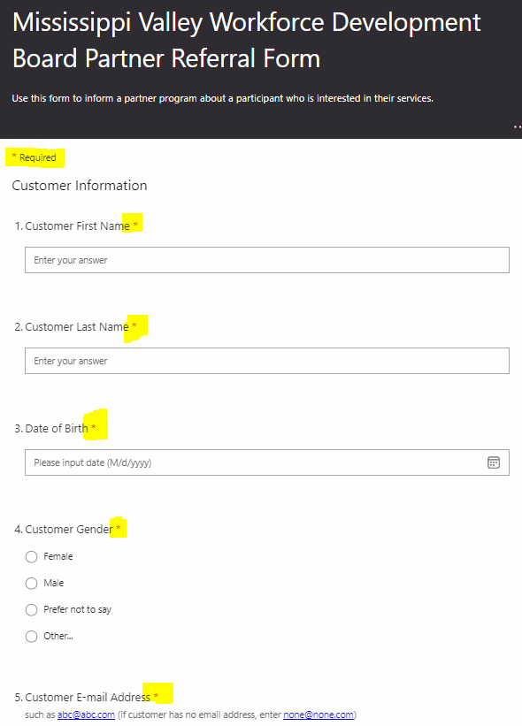
The next question (Veteran or eligible spouse) is required. Knowing the answer to this question may help a service provider determine a client’s possible eligibility quicker.
County of residence is required, and it will determine what follows on the form. Some programs have a presence in multiple locations; identifying where the client lives ensures we are making the referral to the appropriate location. Selecting Des Moines, Henry, Lee or Louisa counties will send you to a page with referral choices for Burlington-centered programs, and choosing Clinton, Jackson, Muscatine or Scott counties sends you to a page giving you Davenport-centered programs. (If the client lives in a surrounding county, such as Rock Island County in the Davenport area or Henderson County in the Burlington area, use the buttons at the bottom to make your selection.)

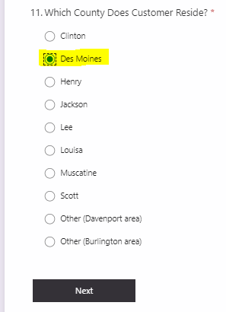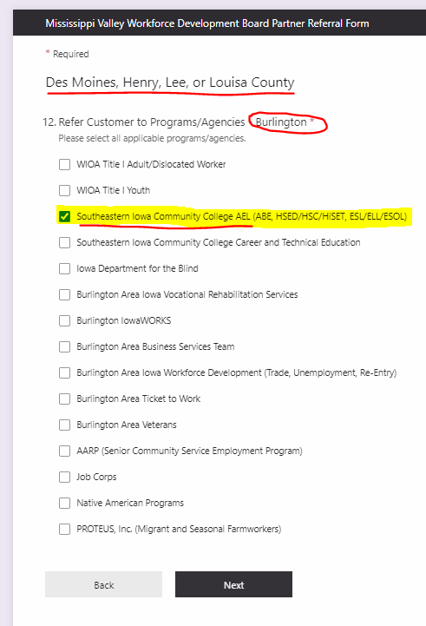
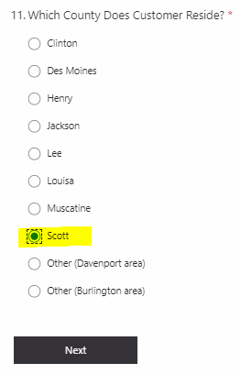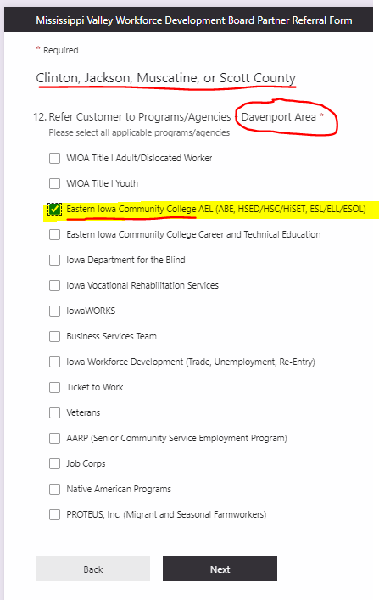
This form allows you to make referrals to more than one program at a time, so if for example you want to refer an individual to AEL and Voc Rehab, that can be done on the same form. Select the program(s) to which you want to refer the individual and hit “next”. You now are given a choice of several services (below). There is no limit to the number of services you can select on this part of the form. You will also see a list of possible situations that could indicate a customer's need for additional services, accommodations, or assistance. Please indicate if any of these statements apply to your customer and then provide the details in the next question. Again, this information is not required, but it may prove to be helpful.
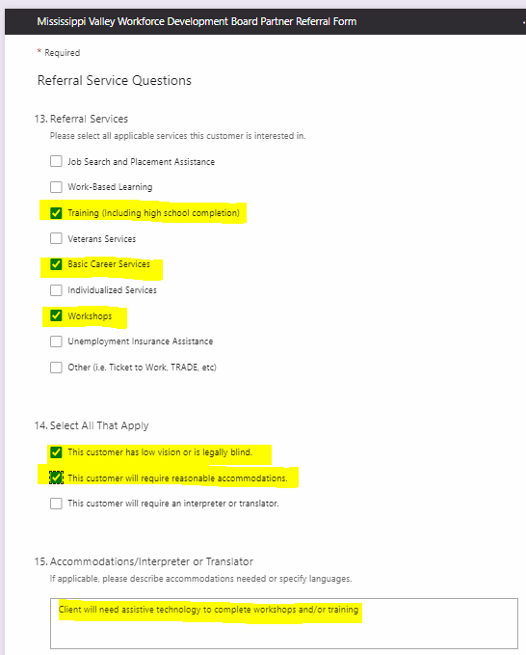
The next question regarding age is required. If you click “Yes”, indicating that the individual is under 18, the next page will be two required data points relating to contact information for their parent or legal guardian. If you click “No” indicating that they are 18 or over, these questions will not appear.
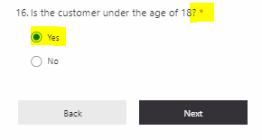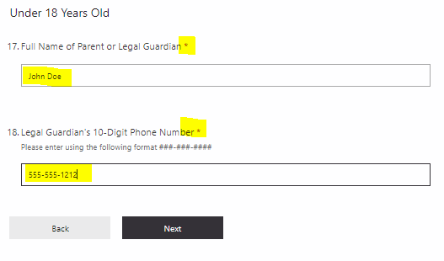
Once you have completed the age/guardian section, you will proceed to this screen asking you to enter your information about the referring staff person and agency (you). Enter your name, email, and agency/program name. Make sure the customer (or their parent/guardian) has agreed either verbally or in writing to have their information shared among our partner agencies and then select the release authorization agreement option.
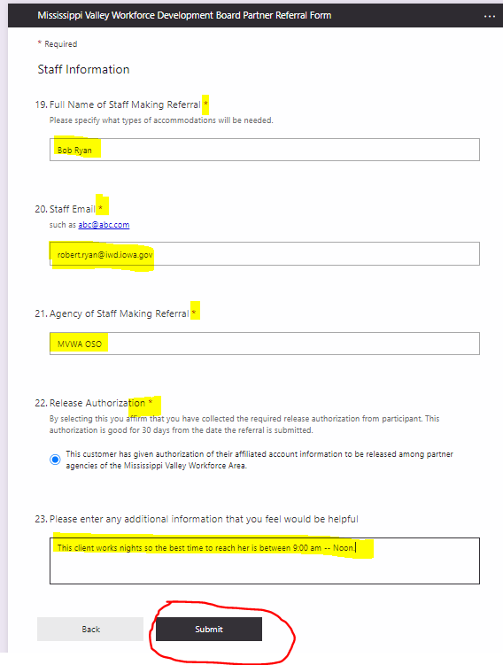
When you click submit, you may be asked to complete a “Captcha” verification. Once you do, you will see a page that indicates your response has been recorded. The designated person (for instance in our first example we chose SCC AEL so it would be Martha Bell) will receive an email notification of the referral, you will receive a notification, and the client will also receive a notification.
On the backside of this system sits a spreadsheet into which all referrals flow. It will be the OSO’s job to monitor and maintain the spreadsheet and ensure that referrals are given appropriate follow-up.
Again, if you have any questions at all please do not hesitate to contact the MVWA OSO, Nick Clayton. Thank you.

Clinton county resources
For a complete resource listing by zip code and the ability to sort by category: visit www.AuntBertha.com. Aunt Bertha provides categorized resource listings for food, housing, goods, transit, health, money, care, education, work, and legal services. Or call 211 to find local resources for food, mental health, and assistance with housing and utility expenses.

Childcare
Organization Name: Iowa Department of Health and Human Services
Description: Dependent care assistance.
Phone: 563-242-0573
Address: 121 6th Avenue South, Clinton, IA 52732
Website: https://hhs.iowa.gov/childcare/providers

Organization Name: Head Start Preschool & Early Head Start Childcare
Description: Head Start and Early Head Start providing educational & social activities, nutritious meals and snacks and medical & dental screenings, at no cost, to qualifying low-income children ages 0 to five.
Phone: 563-324-3236
Address: 350 5th Avenue North, Clinton IA 52732
Website: https://www.caeiowa.org

Organization Name: Clinton Housing Authority Daycare – Stay N Play
Description: Stay N Play Child Care Center to provide quality childcare and preschool at an affordable rate to enable the parent(s) to establish and maintain a better quality of life for their family.
Phone: 563-242-1214
Address: 1811 27th Ave S, Clinton, IA 52732
Website: http://staynplay.org/

Clothing and Household Items
Organization Name: Goodwill of the Heartland
Description: Sells secondhand household goods, furniture, and clothing. Open to everyone.
Phone: 563-484-3744
Address: Westview Crossing, 1015 13th Ave N, Clinton, IA 52732
Website: https://www.goodwillheartland.org/

Organization Name: The Salvation Army Family Store & Donation Center
Description: Sells secondhand household goods, furniture, and clothing. Open to everyone.
Phone: 563-242-2293
Address: 2808 S 25th St, Clinton, IA 52732
Website: https://satruck.org/

Organization Name: DeWitt Referral Center & Thrift Store
Description: Provides food, emergency assistance, referral services, and a thrift shop.
Phone: 563-659-9612
Address: 615 8th St, DeWitt, IA 52742
Website: https://www.victorycenter.com/housingsolutions

Organization Name: Associate Benevolent Society
Description: Free clothing, household items and occasionally furniture. Donations accepted 9-4 M, T, Th, F (back door). Shopping hours: 1:30pm-4:00pm Closed Wednesday
Phone: 563-243-4148
Address: 100 South 2nd Street, Clinton, IA 52732
Website: http://benevolentofclinton.org/

Food
Organization Name: Pantries United
Description: Local food program provided at sires for residents of Clinton, Camanche and outlying areas of Clinton County.
Phone: 563-242-5818
Address: 221 2nd Ave S, Clinton, IA 52732
Website: http://irasclinton.com/pantries-united/

Organization Name: Gateway Area Community Center
Description: Food pantry every 1st & 3rd Tuesday of The Month 12:00 P.M to 2:00 P.M
Phone: 563-559-2004
Address: 1850 S Bluff Blvd, Clinton, IA 52732
Website: https://gacciowa.org/

Organization Name: Carroll Assistance Center – Food Distribution Center
Description: Food pantry every Tuesday from 4 to 6 pm
Phone: 563-374-1520
Address: 102 W Washington St, Wheatland, IA 52777
Website: http://www.cityofwheatland.org/carrollassistancecenter.html

Organization Name: Sisters of Saint Francis Share Our Sandwiches Soup Kitchen
Description: Share Our Sandwiches is held each Thursday from noon to 1:00 p.m. in the parking lot of St. Paul Lutheran Church, 715 S 3rd Street in Clinton. Sack lunches are also available at the Clinton Public Library - Lyons Local History & Genealogy Center at 105 Main Avenue in Clinton.
Phone: 563-242-7611
Address: 843 13th Ave N, Clinton, IA 52732
Website: https://clintonfranciscans.com

Housing
Organization Name: Clinton Housing Authority - Municipal Housing Agency
Description: Operates and manages public housing in Clinton County.
Phone: 563-243-1280
Address: 215 6th Ave S, Clinton, IA 52732
Website: https://www.cityofclintoniowa.gov/404/Housing-Authority

Organization Name: Victory Center Rescue Mission
Description: Housing and Shelter Programs. Open to everyone.
Phone: 563-242-9016 (men); 563-242-1744 (women)
Address: 505 9th Ave South, Clinton, IA 52732
Website: https://www.victorycenter.com/housingsolutions

Organization Name: Family Resources
Description: Provides transitional housing services.
Phone: 563-242-0887
Address: 240 N. Bluff Blvd, Clinton, IA 52732
Website: https://www.famres.org/

Organization Name: YMCA
Description: Assists with rent, security deposits and utilities for
those overcoming homelessness.
Phone: 563-242-2118; Hotline: 833-849-8976
Address: 317 7th Avenue South, Clinton IA 52732
Website: https://www.ywcaclinton.org/empowerment-center/

General Assistance
Organization Name: Community Action of Eastern Iowa
Description: Offer a wide variety of programs to meet basic needs.
Phone: 563-243-5220
Address: 240 North Bluff Blvd., Clinton IA 52732
Website: https://www.caeiowa.org/

Organization Name: United Way of Clinton County Iowa
Description: United Way of Clinton County, Iowa works to create a better opportunity for all residents by building stronger Clinton County communities.
Phone: 563-242-1209
Address: 405 South 3rd Street, Suite 200, Clinton IA 52732
Website: https://www.clintonunitedway.org/

Organization Name: Carroll Assistance Center
Description: Offers referrals & assistance for medical, prescriptions, fuel, school supplies, food, electricity and rent.
Phone: 563-374-1520
Address: 102 W Washington St, Wheatland, IA 52777
Website: http://www.cityofwheatland.org/carrollassistancecenter.html

Mental Health
Iowa Crisis Counseling Helpline 800-332-4224
Your Life Iowa - https://yourlifeiowa.org/ 855-581-8111

Organization Name: Eastern Iowa Mental Health & Disability Services Region
Description: The community-based, person-centered mental health and disability services system for adults provides locally delivered services.
Phone: 563-652-1743; Warm Line: 844-775-9276; Crisis Line: 855-581-8111
Address: N/A
Website: https://easterniowamhds.org

Organization Name: Bridgeview Community Mental Health Center
Description: Accredited, non-profit community mental health center, sliding fee, and emergency services.
Phone: 563-243-5638
Address: 638 South Bluff Blvd 2nd Floor Bluff Building, Clinton IA 52732
Website: www.bridgeviewcmhc.com

Transportation
Organization Name: River Bend Transit
Description: Regional public transit system provides rides for Clinton residents.
Phone: 800-292-8959
Address: 7440 Vine Street Court, Davenport, IA 52806
Website: https://riverbendtransit.org/

Organization Name: Municipal Transit Administration
Description: Providing safe, accessible, economical and efficient public transportation service to the citizens of the City of Clinton, Iowa. Fixed Route for the general public and para transit door-to-door service for those who are ADA eligible. Monday-Friday, 6 a.m. to 6 p.m.; Saturday 8 a.m. to 3:30 p.m.
Phone: 563-242-3721
Address: 1320 S 2nd St, Clinton, IA 52732
Website: https://www.cityofclintoniowa.gov/215/MTA-Transit

Educational Assistance
Organization Name: GAP Tuition Assistance Program
Description: This program provides need-based financial support for tuition and other eligible costs for approved, short-termed non-credit training opportunities focused on employment and select credit courses.
Phone: 563-336-5243
Address: EICC Urban Campus, 101 W Third St, Davenport, Iowa 52801
Website: https://www.eicc.edu

Organization Name: Federal Student Aid
Description: Pell grants and other government assistance programs
Phone: NA
Address: NA
Website: https://studentaid.gov/h/apply-for-aid/fafsa

Organization Name: ISU Extension & Outreach – Clinton County Extension Services
Description: Information and educational programs on aging, childcare, child development,
consumer decisions, financial management, family relationships, leadership, nutrition,
parent education, and youth.
Phone: 563-659-5125
Address: 400 E 11th St, DeWitt, IA 52742
Website: https://www.extension.iastate.edu/clinton/

Healthcare
Organization Name: Iowa Department of Health and Human Services (Medicaid)
Description: Apply for financial assistance for health care, find health providers. Medicaid,
Family Planning Program, Hawki.
Phone: 563-242-0573
Address: 121 6th Ave S Ste 200, Clinton, IA 52732
Website: https://hhs.iowa.gov/

Organization Name: Clinton County Health Department
Description: Provides access to multiple community health programs.
Phone: 563-659-8148
Address: Clinton County Satellite Offices, 226 11th Street, DeWitt, Iowa 52742
Website: https://www.clintoncounty-ia.gov/Health_Department

Jackson County RESOURCES
For a complete resource listing by zip code and to sort by category: visit www.AuntBertha.com. Aunt Bertha provides categorized resource listings for food, housing, goods, transit, health, money, care, education, work and legal services. Or call 211 to find local resources for food, mental health, and assistance with housing and utility expenses.

Childcare
Organization Name: Iowa Department of Health and Human Services
Description: Dependent care assistance.
Phone: 563-242-0573
Address: 121 6th Avenue South, Clinton, IA 52732
Website: https://hhs.iowa.gov/childcare/providers

Organization Name: Head Start Preschool & Early Head Start Childcare
Description: Head Start and Early Head Start providing educational & social activities, nutritious meals and snacks and medical & dental screenings, at no cost, to qualifying low-income children ages 0 to five.
Phone: 319-393-7811
Address: 1515 Hawkeye Dr, Hiawatha, Iowa 52233
Website: http://www.hacap.org

Clothing and Household Items
Organization Name: Maquoketa Community Services Inc
Description: Sells secondhand household goods, furniture, and clothing. Open to everyone.
Phone: 563-652-2640
Address: 107 S Jones St, Maquoketa, IA 52060
Website: N/A

Food
Organization Name: Maquoketa Community Cupboard
Description: Food pantry
Phone: 563-652-4102
Address: 1019 Wesley Dr, Maquoketa, IA 52060
Website: N/A

Organization Name: Preston Manner Center
Description: St John’s Lutheran Church food pantry.
Phone: 563-689-6107
Address: 204 Anna St, Preston, IA 52069
Website: N/A

Organization Name: Bellevue Bread Basket
Description: Food distribution center. Open Thursday’s 2PM to 4PM.
Phone: 563-879-3438
Address: 1700 State St, Bellevue, IA 52031
Website: N/A

Housing
Organization Name: Community Solutions of Eastern Iowa
Description: Serving individuals and families experiencing a housing crisis situation.
Phone: 800-942-4648
Address: 7600 Commerce Park, Dubuque, IA 52002
Website: https://www.ecia.org

Organization Name: Eastern Iowa Regional Housing Authority
Description: Provides Section 8, public housing, and other rental assistance programs.
Phone: 563-556-4166
Address: 7600 Commerce Park, Dubuque, IA 52002
Website: https://www.eirha.org/

Organization Name: Maquoketa Housing Authority
Description: Operates and manages public housing in Jackson County.
Phone: 563-652-5601
Address: 201 East Pleasant Street, Maquoketa, IA, 52060
Website: N/A

General Assistance
Organization Name: Operation New View
Description: Offer a wide variety of programs to meet basic needs.
Phone: 563-652-5197
Address: 904 E Quarry St, Maquoketa, IA 52060
Website: N/A

Organization Name: Jackson County General Assistance
Description: Provides residents of Jackson County emergency payments and/or vouchers to needy and poor people in need of immediate assistance or people who cannot obtain assistance from any other source. Appointment required.
Phone: 563-652-1710
Address: 201 West Platt Street, Maquoketa, IA 52060
Website: N/A

Mental Health
Iowa Crisis Counseling Helpline 800-332-4224
Your Life Iowa - https://yourlifeiowa.org/ 855-581-8111

Organization Name: Eastern Iowa Mental Health & Disability Services Region
Description: The community-based, person-centered mental health and disability services system for adults provides locally delivered services.
Phone: 563-652-1743; Warm Line: 844-775-9276; Crisis Line: 855-581-8111
Address: N/A
Website: https://easterniowamhds.org

Transportation
Organization Name: Regional Transit Authority 8
Description: Providing accessible, safe, convenient, and efficient on-demand and scheduled ride services for all citizens in the cities, communities, and rural areas of Jackson County.
Phone: 800-839-5005
Address: 1000 E Quarry St, Maquoketa, IA 52060
Website: http://www.rta8.org/

Educational Assistance
Organization Name: GAP Tuition Assistance Program
Description: This program provides need-based financial support for tuition and other eligible costs for approved, short-term non-credit training opportunities focused on employment and select credit courses.
Phone: 563-336-5243
Address: EICC Urban Campus, 101 W Third St, Davenport, Iowa 52801
Website: https://www.eicc.edu/future-students/financial-aid/ParticipantTrainingApplication.pdf

Organization Name: Federal Student Aid
Description: Pell grants and other government assistance programs
Phone: NA
Address: NA
Website: https://studentaid.gov/h/apply-for-aid/fafsa

Organization Name: ISU Extension & Outreach – Jackson County Extension Services
Description: Information and educational programs on aging, childcare, child development,
consumer decisions, financial management, family relationships, leadership, nutrition,
parent education, and youth.
Phone: 563-652-4923
Address: 201 W Platt St, Maquoketa, IA 52060
Website: N/A

Healthcare
Organization Name: Iowa Department of Health and Human Services (Medicaid)
Description: Apply for financial assistance for health care, find health providers. Medicaid,
Family Planning Program, Hawki. Served by Dubuque County office by appointment only.
Phone: 563-242-0573
Address: 311 Platt St, Maquoketa, IA 52060
Website: https://hhs.iowa.gov/

Organization Name: Jackson County Public Health
Description: Provides access to multiple community health programs.
Phone: 563-652-1729
Address: 201 W Platt St, Maquoketa, IA 52060
Website: https://jacksoncounty.iowa.gov/health-department/

Muscatine County RESOURCES
For a complete resource listing by zip code and to sort by category: visit www.AuntBertha.com. Aunt Bertha provides categorized resource listings for food, housing, goods, transit, health, money, care, education, work and legal services. Or call 211 to find local resources for food, mental health, and assistance with housing and utility expenses.

Childcare
Organization Name: Iowa Department of Health and Human Services
Description: Dependent care assistance.
Phone: 563-263-9302
Address: 315 Iowa Suite 2, Muscatine, IA 52761
Website: https://hhs.iowa.gov/childcare/providers

Organization Name: Head Start Preschool & Early Head Start Childcare
Description: Head Start and Early Head Start providing educational & social activities, nutritious meals and snacks and medical & dental screenings, at no cost, to qualifying low-income children ages 0 to five.
Phone: 563-264-2026
Address: 148 Colorado Street Muscatine IA 52761
Website: https://www.caeiowa.org

Organization Name: Early Childhood Iowa Muscatine County
Description: ECIMC is a community group promoting the well-being and healthy development of Muscatine County children ages 0-5.
Phone: 563-263-0273
Address: PO Box 672, Muscatine, Iowa 52761
Website: https://www.ecimc.org/

Clothing and Household Items
Organization Name: Adventist Community Service Center
Description: The Community Service Center provides free clothing, coats, and household items to anyone in need. Tuesdays @ 9AM
Phone: 563-263-2562
Address: 1103 E 9th Street, Muscatine, IA 52761
Website: http://muscatineia.adventistchurch.org/

Organization Name: The Salvation Army
Description: Offering multiple services to those in need.
Phone: 563-263-8272
Address: 1000 Oregon St, Muscatine, IA 52761
Website: http://samuscatine.org/

Organization Name: Goodwill Muscatine
Description: Long-standing nonprofit chain with a range of pre-owned clothing, housewares & more.
Phone: 563-484-3731
Address: 2001 Cedar Plaza Drive, Muscatine, IA 52761
Website: https://www.goodwillheartland.org/location/muscatine/

Food
Organization Name: MCSA Food Pantry
Description: Food pantry Tuesday and Thursday 10AM-12PM
Phone: 563-264-3278 or 563-260-4874
Address: 310 Iowa Avenue, Lower Level of MCSA
Website: https://www.mcsaiowa.org/foodpantry

Organization Name: Durant - Wilton Food Pantry - Grace United Church of Christ
Description: The 1st and 3rd Tuesday of the month 9:00am - 11:00am & 6:00pm - 7:00pm.
Phone: 563-732-2461
Address: 408 Cedar Street, Wilton, IA 52778
Website: N/A

Organization Name: Pearl City Outreach
Description: Food distribution center.
Phone: 563-264-5430
Address: 513 Mulberry Avenue, Muscatine, IA 52761
Website: https://pearlcityoutreach.org/

Housing
Organization Name: Muscatine Public Housing
Description: The Public Housing Department provides low-income housing assistance to families in Muscatine County.
Phone: 563-264-1554
Address: 215 Sycamore Street, Muscatine, IA 52761
Website: http://www.muscatineiowa.gov/74/Housing

Organization Name: Muscatine Center for Social Action
Description: Emergency housing and rentals.
Phone: 563-264-3278
Address: 312 Iowa Avenue, Muscatine, IA 52761
Website: https://www.mcsaiowa.org/

General Assistance
Organization Name: Community Action of Eastern Iowa
Description: Offer a wide variety of programs to meet basic needs.
Phone: 563-263-9290
Address: 1903 Park Ave, Muscatine, IA 52761
Website: https://www.caeiowa.org/branches/muscatine/

Organization Name: Muscatine County Community Services
Description: General assistance is available through the Community Services Department to families and individuals who are poor or in need.
Phone: 563-263-7512
Address: 315 Iowa Ave, Suite 1, Muscatine, Iowa 52761
Website: https://www.muscatinecountyiowa.gov/216/General-Assistance

Mental Health
Iowa Crisis Counseling Helpline 800-332-4224
Your Life Iowa - https://yourlifeiowa.org/ 855-581-8111

Organization Name: Eastern Iowa Mental Health & Disability Services Region – Muscatine County Community Services
Description: The community-based, person-centered mental health and disability services system for adults provides locally delivered services.
Phone: 563-579-7790
Address: 315 Iowa Ave, Suite 1, Muscatine, Iowa 52761
Website: https://www.muscatinecountyiowa.gov/210/Point-of-Access-for-Mental-Health-Servic

Organization Name: Muscatine Center for Social Action (MCSA)
Description: Family empowerment services for assessment and treatment.
Phone: 563-263-7512
Address: 312 Iowa Ave, Muscatine, IA 52761
Website: https://www.mcsaiowa.org/

Transportation
Organization Name: River Bend Transit
Description: Provides weekday door-to-door transportation to elderly and disabled rural residents and to the general public in Muscatine County.
Phone: 800-292-8959
Address: 7440 Vine Street Court, Davenport, IA 52806
Website: https://riverbendtransit.org/

Organization Name: Muscabus
Description: Fixed route in the city of Muscatine with paratransit available at least one day ahead.
Phone: 563-263-8152
Address: 1459 Washington St, Muscatine, IA 52761
Website: https://www.muscatineiowa.gov/1363/MuscaBus-Route-Maps

Educational Assistance
Organization Name: GAP Tuition Assistance Program
Description: This program provides need-based financial support for tuition and other eligible costs for approved, short-term non-credit training opportunities focused on employment and select credit courses.
Phone: 563-336-5243
Address: EICC Urban Campus, 101 W Third St, Davenport, Iowa 52801
Website: https://www.eicc.edu/future-students/financial-aid/ParticipantTrainingApplication.pdf

Organization Name: Federal Student Aid
Description: Pell grants and other government assistance programs
Phone: NA
Address: NA
Website: https://studentaid.gov/h/apply-for-aid/fafsa

Organization Name: ISU Extension & Outreach – Muscatine County Extension Services
Description: Information and educational programs on aging, childcare, child development,
consumer decisions, financial management, family relationships, leadership, nutrition,
parent education, and youth.
Phone: 563-263-5701
Address: 1601 Plaza Pl, Muscatine, IA 52761
Website: http://www.extension.iastate.edu/muscatine/

Healthcare
Organization Name: Iowa Department of Health and Human Services (Medicaid)
Description: Apply for financial assistance for health care, find health providers. Medicaid,
Family Planning Program, Hawki.
Phone: 563-263-9302
Address: 315 Iowa Ave, Muscatine, IA 52761
Website: https://hhs.iowa.gov/

Organization Name: Muscatine County Public Health – Trinity Muscatine
Description: Provides access to multiple community health programs.
Phone: 563-652-1729
Address: 1609 Cedar St, Muscatine, IA 52761
Website: https://www.unitypoint.org

Scott County RESOURCES
For a complete resource listing by zip code and to sort by category: visit www.AuntBertha.com. Aunt Bertha provides categorized resource listings for food, housing, goods, transit, health, money, care, education, work and legal services. Or call 211 to find local resources for food, mental health, and assistance with housing and utility expenses.

Childcare
Organization Name: Iowa Department of Health and Human Services
Description: Dependent care assistance.
Phone: 563-326-8680
Address: 600 W 4th St, Davenport, IA 52801
Website: https://hhs.iowa.gov/childcare/providers

Organization Name: Head Start Preschool & Early Head Start Childcare
Description: Head Start and Early Head Start providing educational & social activities, nutritious meals and snacks and medical & dental screenings, at no cost, to qualifying low-income children ages 0 to five.
Phone: 563-324-3236
Address: 500 East 59th Street, Davenport IA 52807
Website: https://www.caeiowa.org/help-my-children/head-start/

Organization Name: Scott County Kids
Description: The Scott County Kids Early Childhood Iowa childcare scholarship, administered by Friendly House, is designed to help Scott County families with a portion of their child care fees for children ages birth through five years old, not yet in kindergarten.
Phone: 563.326.8221
Address: 600 West 4th Street, Davenport, Iowa 52801
Website: https://scottcountykids.org/

Clothing and Household Items
Organization Name: St. Matthews Clothing Closet
Description: Saturdays 9:00AM – 11:00AM
Phone: 563-391-2802
Address: 1915 W. Kimberly Rd., Davenport, IA 52806
Website: https://www.bbbsmv.org/wp-content/uploads/sites/66/2020/08/RESOURCES-FOR-FAMILIES-Clothing-Assistance.pdf

Organization Name: The Clothing Center at Minnie's Maison
Description: Shop for free clothes on Wednesday and Saturday 10-noon.
Phone: 563-362-0915
Address: 1119 LeClaire Street, Davenport, IA 52803
Website: https://clothingcenterqca.com/

Organization Name: The Salvation Army of the Quad Cities
Description: Offering multiple services to those in need.
Phone: see below
Address: 301 West 6th Street, Davenport, IA 52801 563-324-4808
4303 N. Brady St., Davenport, IA 52806 563-386-0044
Website: https://centralusa.salvationarmy.org/quadcities/ or https://satruck.org/

Organization Name: Goodwill in Scott County
Description: Long-standing nonprofit chain with a range of pre-owned clothing, housewares & more.
Phone: see below with address
Address: 2302 Spruce Hills Drive Bettendorf, IA 52722 563-344-9431
2333 Cumberland Square Drive Bettendorf, IA 52722 563-484-3745
121 Locust Street Davenport, IA 52803 866-466-7881
1376 West 35th Street Davenport, IA 52806 563-327-0150
415 North Perry Street Davenport, IA 52801 563-324-9343
805 West 35th Street Davenport, IA 52806 563-386-1692
5360 Villa Drive Davenport, IA 52806 563-484-3732
Website: https://www.goodwillheartland.org

Food
Organization Name: River Bend Food Bank
Description: Food pantry Open Mondays 9 am – 1 pm and Wednesdays 2 pm – 6:30pm
Phone: 563-345-6490
Address: 320 W Kimberly Rd., Davenport, IA 52807
Website: https://riverbendfoodbank.org/find-food/

Organization Name: Central Community Circle Food Pantry
Description: Food pantry Wednesday and Friday 9AM – 12PM
Phone: 563-322-8253
Address: 1008 West 6th St., Davenport, IA, 52802
Website: https://cccfoodpantry.org/

Organization Name: North Scott Food Pantry
Description: Friday 9:30AM-11:00AM and Tuesday 5:30PM-7:00PM
Phone: 563-285-8444
Address: 500 W Le Claire Rd, Eldridge, IA 52748
Website: N/A

Organization Name: Community of Hope Food Pantry
Description: Food distribution center Mondays 6-7:30PM
Phone: 563-391-4519
Address: 415 W 53rd St, Davenport, IA 52806
Website: N/A

Housing
Organization Name: Davenport Office of Assisted Housing
Description: The Office of Assisted Housing (OAH) provides non-emergency rental assistance to low-income families and administers the Section 8 Housing Choice Voucher program. This office also staffs the Davenport Housing Commission.
Phone: 563-326-7899
Address: 226 West 4th Street, Davenport, IA 52801
Website: https://www.davenportiowa.com/

Organization Name: Humility Homes and Services, Inc.
Description: Homeless shelter and multiple services for veterans and anyone in need.
Phone: 563-322-8065
Address: 1016 W 5th St, Davenport, IA 52802
Website: https://www.humilityhomes.org/

General Assistance
Organization Name: Community Action of Eastern Iowa
Description: Offer a wide variety of programs to meet basic needs.
Phone: 563-324-3236
Address: 500 E. 59th Street, Davenport, IA 52807
Website: https://www.caeiowa.org/branches/scott/

Organization Name: Scott County General Assistance
Description: Community Services department provides programs which assist Scott County residents in situations meeting basic needs.
Phone: 563-326-8723
Address: 600 West 4th Street, Davenport, Iowa 52801
Website: https://www.scottcountyiowa.gov/community/general-assistance-program

Mental Health
Iowa Crisis Counseling Helpline 800-332-4224
Your Life Iowa - https://yourlifeiowa.org/ 855-581-8111
Scott County Crisis Line 844-430-0375

Organization Name: Scott County Community Services
Description: H – Human Service Coordination; E – Empathy; L – Linkage; P – Protection.
Phone: 563-326-8723
Address: 600 West 4th Street, Davenport, IA 52801-1003
Website: https://www.scottcountyiowa.gov/community

Transportation
Organization Name: River Bend Transit
Description: Provides weekday door-to-door transportation to elderly and disabled rural residents and to the general public in Muscatine County.
Phone: 800-292-8959
Address: 7440 Vine Street Court, Davenport, IA 52806
Website: https://riverbendtransit.org/

Organization Name: CitiBus
Description: Fixed route and provides paratransit service.
Phone: 563-888-2151
Address: 226 West 4th Street, Davenport, IA 52801
Website: https://www.davenportiowa.com/cms/One.aspx?portalId=6481456&pageId=9762332

Educational Assistance
Organization Name: GAP Tuition Assistance Program
Description: This program provides need-based financial support for tuition and other eligible costs for approved, short-term non-credit training opportunities focused on employment and select credit courses.
Phone: 563-336-5243
Address: EICC Urban Campus, 101 W Third St, Davenport, Iowa 52801
Website: https://www.eicc.edu/future-students/financial-aid/ParticipantTrainingApplication.pdf

Organization Name: Federal Student Aid
Description: Pell grants and other government assistance programs
Phone: NA Address: NA
Website: https://studentaid.gov/h/apply-for-aid/fafsa

Healthcare
Organization Name: Iowa Department of Health and Human Services (Medicaid)
Description: Apply for financial assistance for health care, find health providers. Medicaid,
Family Planning Program, Hawki.
Phone: 563-326-8680
Address: 600 W 4th St, Davenport, IA 52801
Website: https://hhs.iowa.gov/

Organization Name: Scott County Health Department
Description: Provides access to multiple community health programs.
Phone: 563-326-8618
Address: 600 W 4th St, Davenport, IA 52801
Website: https://www.scottcountyiowa.gov/health

Equal Opportunity Programs/Employer
Auxiliary aids and services are available upon request for individuals with disabilities.

