Mississippi Valley Workforce Area Burlington IowaWORKS Center
v
partners, referral process, and Community resources
550 South Gear Avenue, Suite 35, West Burlington, IA 52655
PY 2023
TABLE OF CONTENTS
BURLINGTON IowaWORKS PARTNERS 5
Title I Adult/Dislocated Worker 5
Title I Youth 5
Adult Education and Literacy (AEL) 5
Title III Wagner Peyser 6
Vocational Rehabilitation Services 6
Iowa Department for the Blind 6
Re-Entry 6
RESEA 7
Promise Jobs (TANF) 7
Veterans Services 7
Career and Technical Education 7
Trade 8
Unemployment 8
Migrant and Seasonal Farmworkers 8
AARP (Senior Community Service Employment Program) 8
Job Corps 9
Ticket to Work 9
MVWA PARTNER REFERRAL FORM 9
Link to MVWA Referral Form 9
Form Instructions 10
DES MOINES COUNTY RESOURCES 14
Childcare 14
Clothing and Household Items 14
Food 15
Housing 15
General Assistance 16
Mental Health 16
Transportation 16
Educational Assistance 17
Healthcare 17
HENRY COUNTY RESOURCES 18
Childcare 18
Clothing and Household Items 18
Food 18
Housing 19
General Assistance 19
Mental Health 20
Transportation 20
Educational Assistance 21
Healthcare 22
LEE COUNTY RESOURCES 23
Childcare 23
Clothing and Household Items 23
Food 24
Housing 25
General Assistance 26
Mental Health 26
Transportation 27
Educational Assistance 27
Healthcare 28
LOUISA COUNTY RESOURCES 29
Childcare 29
Clothing and Household Items 29
Food 30
Housing 31
General Assistance 31
Mental Health 32
Transportation 32
Educational Assistance 33
Healthcare 33

BURLINGTON IowaWORKS PARTNERS
IowaWORKS Centers must provide access to all required WIOA one-stop partners. Customers must have access to these programs, services, and activities during regular business hours. For WIOA partners not co-located through the IowaWORKS Centers must have either cross-trained staff at the Center or a direct technology linkage must be available. A “direct linkage” means providing direct connection at the IowaWORKS Center, within a reasonable time, by phone or through a real-time Web-based communication to a program staff member who can provide program information or services to the customer.
Listed below are the WIOA required workforce partners in the Mississippi Valley Workforce Area. This information provides staff a direct linkage to all partner programs and is provided as a quick reference guide for populations served, brief summary of services provided, and contact information for each program. If you have any further questions about the specific program, you can contact the person listed below. Participant referrals are required to be made through the One Stop Operator referral form in addition to providing the participant a direct linkage to each program as provided below.

Title I Adult/Dislocated Worker
Population Served: Adults with barriers to employment and Dislocated Workers
Services Provided: Basic/Individualized Career Services, Tuition Assistance, Work Based Learning, and Support Services
Contact: Shannon Weaver
Email: Shannon.weaver@iwd.iowa.gov Phone: 319-753-1671 ext. 30450

Title I Youth
Population Served: Youth ages 14-24 with a barrier to employment
Services Provided: Work experience, tuition assistance, work readiness activities.
Contact: Shannon Weaver
Email: Shannon.weaver@iwd.iowa.gov Phone: 319-753-1671 ext. 30450

Adult Education and Literacy (AEL)
Population Served: Individuals without a high school diploma or who have limited English language proficiency
Services Provided: HiSET and English as a Second Language Classes
Contact: Martha Bell
Email: mbell@scciowa.edu Phone: 319-208-5254
Website: Click here

Title III Wagner Peyser
Population Served: Anyone in need and willing to participate
Services Provided: Basic labor exchange services such as job referrals, labor market information, and job search assistance.
Contact: Tim Snyder
Email: Timothy.Snyder@iwd.iowa.gov Phone: 319-753-1671 ext. 30411

Vocational Rehabilitation Services
Population Served: People with disabilities
Services Provided: Rehabilitation services include training, support services, transition services from school to work, personal care assistance, technology services, job placement, post-employment services, supported employment, and independent living services.
Contact: Cindy Whalen
Email: Cynthia.whalen@iowa.gov Phone: 319-753-2231

Iowa Department for the Blind
Population Served: People who are visually impaired/blind
Services Provided: Independent living skills, work readiness training, tuition assistance, assistance with accommodations and job placement.
Contact: Travis Robinson
Email: Travis.Robinson@blind.state.ia.us Phone: 515-981-8439
Website: https://blind.iowa.gov/department-programs

Re-Entry
Population Served: Ex-offenders
Services Provided: Transition from incarceration-life in prison, jail, or juvenile justice facilities-to-life in the community or require assistance in overcoming barriers to employment resulting from a record of arrests or convictions.
Contact: Tim Snyder
Email: Timothy.Snyder@iwd.iowa.gov Phone: 319-753-1671 ext. 30411

RESEA
Population Served: Individuals receiving unemployment
Services Provided: Support in the development of an individual reemployment plan, customized career and labor market information, enrollment in Wagner-Peyser and information and access to other AJC services and resources that support the claimant’s return to work.
Contact: Christina Watson
Email: christina.watson@iwd.iowa.gov Phone:319-365-9474 ext. 31129

Promise Jobs (TANF)
Population Served: FIP participants
Services Provided: Support services, education, job training, employment activities and Temporary cash assistance
Contact: Jill Malmer
Email: jill.malmer@iwd.iowa.gov Phone: 563-445-3200 ext. 43320

Veterans Services
Population Served: Veteran or spouse of an eligible Veteran with a significant barrier to employment
Services Provided: Individualized career and training-related services.
Contact: Tim Snyder
Email: Timothy.Snyder@iwd.iowa.gov Phone: 319-753-1671 ext. 30411

Career and Technical Education
Population Served: Students
Services Provided: Develop more fully the academic, career, and technical skills of secondary and postsecondary students who elect to enroll in career and technical education programs.
Contact: Dr. Ashlee Spannagel
Email: aspannagel@scciowa.edu Phone: 319-208-5380
Website: https://www.scciowa.edu/conted/index.aspx

Trade
Population Served: Employees affected by a businesses certified Trade petition
Services Provided: Services include re-employment services, job search allowances, relocation allowances, funded training, weekly trade readjustment allowances for eligible workers who have exhausted their Unemployment Compensation benefits and are in training, Alternative Trade Adjustment Assistance/Re-employed Trade Adjustment Assistance, and On-the- job training
Contact: Tim Snyder
Email: Timothy.Snyder@iwd.iowa.gov Phone: 319-753-1671 ext. 30411

Unemployment
Population Served: Workers who have lost their job through no fault of their own
Services Provided: The benefits include a maximum weekly amount for 16 weeks if eligible.
Contact: Tim Snyder
Email: Timothy.Snyder@iwd.iowa.gov Phone: 319-753-1671 ext. 30411

Migrant and Seasonal Farmworkers
Population Served: Migrant and seasonal farm workers who are U.S. citizens
Services Provided: Services include farmworker housing assistance, career counseling, work experience, classroom training, on the job training, job search assistance, and emergency assistance to address the immediate needs of the farmworker and family.
Contact: Emily Meister
Email: emilym@proteusinc.net Phone: 319-541-5744
Website: https://www.proteusinc.net/about/contact-us/

AARP (Senior Community Service Employment Program)
Population Served: Low-income, unemployed individuals aged 55 years and older.
Services Provided: Provides subsidized, part-time work experience for a limited time.
Contact: Angela Richardson
Email: arichardson@aarp.org Phone: 563-396-1587

Job Corps
Population Served: Youth 16-24
Services Provided: Help students complete their education, obtain career technical skills and gain employment, provides transitional support services, such as help finding employment, housing, childcare, and transportation.
Contact: Shiloh Seim
Email: Seim.shiloh@jobcorps.org Phone: 641-631-6891
Website: https://www.jobcorps.gov/recruiting/enrollment-interest

Ticket to Work
Population Served: Social Security disability beneficiaries (persons who receive SSI or SSDI) age 18 through 64 who want to work with free job support.
Services Provided: Job coaching, job counseling, training, benefits counseling and job placement.
Contact: Tim Snyder
Email: Timothy.Snyder@iwd.iowa.gov Phone: 319-753-1671 ext. 30411

MVWA PARTNER REFERRAL FORM
The following is a brief explanation of how to use the Microsoft form referral system for the Mississippi Valley Workforce Area.
One of the most important parts of improving the integration and communication among our partners is to have a simple and effective system for making interagency referrals. We are introducing a Microsoft form to input all of the details for a referral and then send it off to the appropriate contact in our partner agencies. If you ever have a question about the form or the process, please do not hesitate to contact the One Stop Operator with any questions or concerns that you have.
To use this form, you do not need to have an Outlook address, or access to Teams. All you have to do is keep the referral form hyperlink (below) bookmarked on your computer so that it's readily available for whenever you need to make a referral to another partner agency.

Link to MVWA Referral Form
Clicking on the link takes you to the form: Link to MVWA Referral Form or copy paste the following URL: https://forms.office.com/pages/responsepage.aspx?id=nfQNOZuBo02gUDlgZQIjliQ8tamoLyZNuwrYluj-EAZUNUo0RFVJV0wyQ09UWE1KTkQxOTgzNVVEOC4u
If the hyperlink directs you to a message asking you to update your browser, do the following: Right click on the hyperlink, select “Copy Hyperlink”, and paste it into your URL box in your browser. Once the form comes up, bookmark it.

Form Instructions
The first fields you come to will collect the personal details and contact information for the customer; these items will give the recipient of the referral the information they will need to reach out to the customer. Any question with an asterisk is a required field. (First name, last name, DOB, gender, email, phone, are all required fields; address and preferred method of communication are not required. If a customer doesn’t have email, enter something like none@none.com as a placeholder).
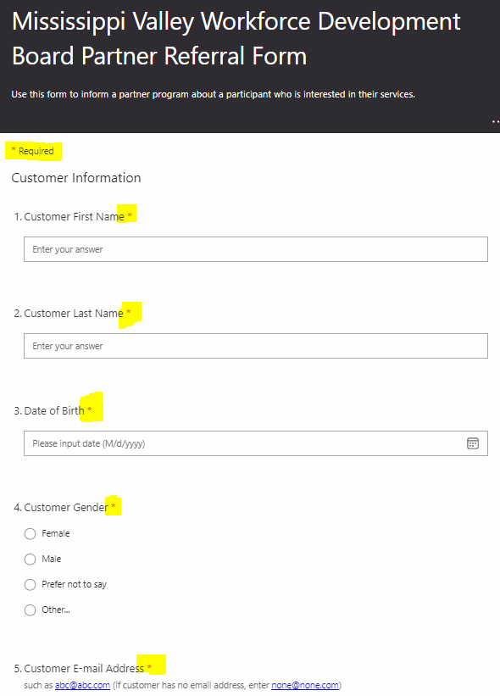
The next question (Veteran or eligible spouse) is required. Knowing the answer to this question may help a service provider determine a client’s possible eligibility quicker.
County of residence is required, and it will determine what follows on the form. Some programs have a presence in multiple locations; identifying where the client lives ensures we are making the referral to the appropriate location. Selecting Des Moines, Henry, Lee or Louisa counties will send you to a page with referral choices for Burlington-centered programs, and choosing Clinton, Jackson, Muscatine or Scott counties sends you to a page giving you Davenport-centered programs. (If the client lives in a surrounding county, such as Rock Island County in the Davenport area or Henderson County in the Burlington area, use the buttons at the bottom to make your selection.)
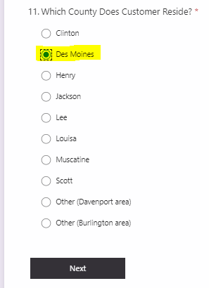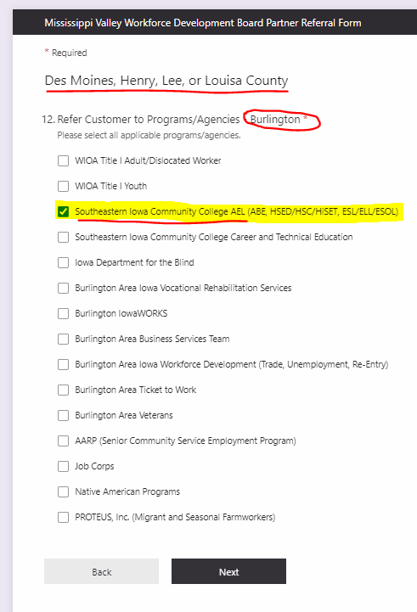
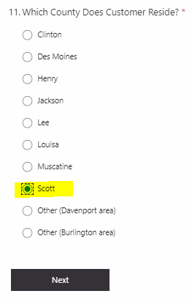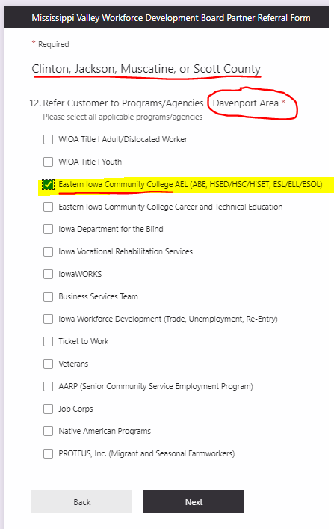
This form allows you to make referrals to more than one program at a time, so if for example you want to refer an individual to AEL and Voc Rehab, that can be done on the same form. Select the program(s) to which you want to refer the individual and hit “next”. You now are given a choice of several services (below). There is no limit to the number of services you can select on this part of the form. You will also see a list of possible situations that could indicate a customer's need for additional services, accommodations, or assistance. Please indicate if any of these statements apply to your customer and then provide the details in the next question. Again, this information is not required, but it may prove to be helpful.
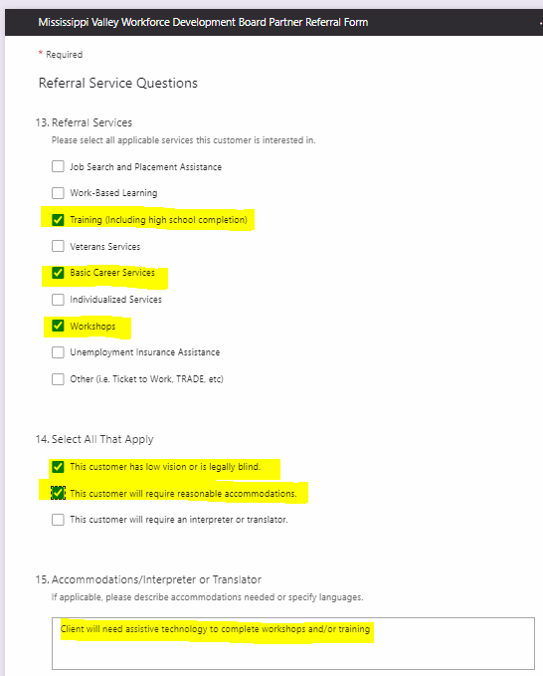
The next question regarding age is required. If you click “Yes”, indicating that the individual is under 18, the next page will be two required data points relating to contact information for their parent or legal guardian. If you click “No” indicating that they are 18 or over, these questions will not appear.
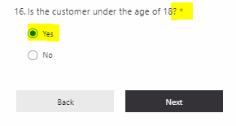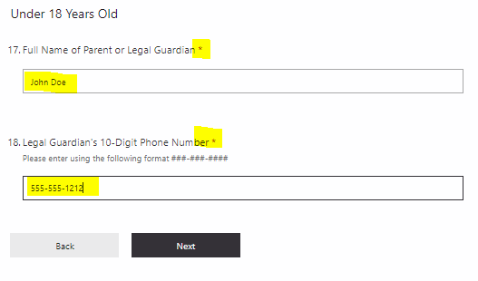
Once you have completed the age/guardian section, you will proceed to this screen asking you to enter your information about the referring staff person and agency (you). Enter your name, email, and agency/program name. Make sure the customer (or their parent/guardian) has agreed either verbally or in writing to have their information shared among our partner agencies and then select the release authorization agreement option.
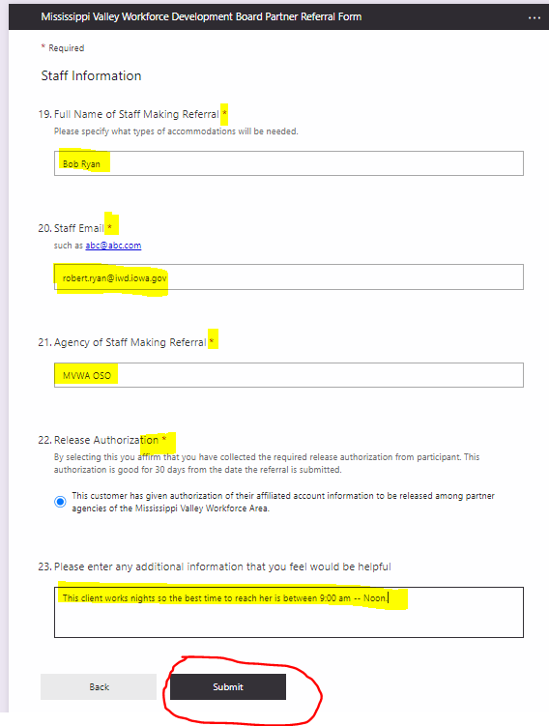
When you click submit, you may be asked to complete a “Captcha” verification. Once you do, you will see a page that indicates your response has been recorded. The designated person (for instance in our first example we chose SCC AEL so it would be Martha Bell) will receive an email notification of the referral, you will receive a notification, and the client will also receive a notification.
On the backside of this system sits a spreadsheet into which all referrals flow. It will be the OSO’s job to monitor and maintain the spreadsheet and ensure that referrals are given appropriate follow-up.
Again, if you have any questions at all please do not hesitate to contact the MVWA OSO, Nick Clayton. Thank you.

DES MOINES COUNTY RESOURCES
Access a comprehensive Des Moines County Resource Guide at: http://caofseia.org/resources/. For a complete resource listing by zip code and to sort by category: visit www.AuntBertha.com. Aunt Bertha provides categorized resource listings for food, housing, goods, transit, health, money, care, education, work and legal services. Or call 211 to find local resources for food, mental health, and assistance with housing and utility expenses.

Childcare
Organization Name: Iowa Department of Health and Human Services
Description: Dependent care assistance
Phone: 1-866-448-4605
Address: 560 Division St # 200, Burlington, IA 52601
Website: https://hhs.iowa.gov/a-z-services

Clothing and Household Items
Organization Name: Goodwill
Description: Access to clothing, household goods, job training and placement services.
Phone: 319-208-0290
Address: 165 West Burlington Ave West Burlington, IA 52655
Website: https://www.goodwillheartland.org/

Organization Name: Church of the Nazarene
Description: Free clothing
Phone: 319-752-4245
Address: 1015 S. Roosevelt Burlington, IA
Website: https://www.iowanazarene.org/burlington-first

Organization Name: Donation Connection
Description: Free clothing, household and personal hygiene items
Phone: 319-520-0863
Address: 3138 Sunnyside Ave., Burlington, IA 52601
Website: https://www.facebook.com/Donation-Connection-100125088844915/?ref=page_internal

Food
Organization Name: Lend a Paw Food Pantry
Description: Food pantry open Wednesdays from 3-6
Phone: 319-435-1151
Address: 2132 Madison Ave., Burlington, IA 52601 (old James Madison Middle School)
Website: https://www.facebook.com/LendAPawPantry/

Organization Name: St Vincent de Paul
Description: food pantry
Phone: 319-752-9332
Address: 700 Division Street, Burlington, IA 52601
Website: https://dmcountycatholic.org/need-help/st-vincent-de-paul-food-pantry

Housing
Organization Name: Transitions DMC
Description: Homeless shelter, meals and connections to other resources available
Phone: (319) 209-2217
Address: 515 S Main Street, Burlington, IA 52601
Website: https://www.transitionsdmc.org

Organization Name: Burlington Area Homeless Shelter
Description: Short-term shelter
Phone: 319-754-6791
Address: 123 N Marshall St, Burlington, IA 52601
Website: https://www.facebook.com/burlingtonareahomelessshelter/

Organization Name: Iowa State Housing Authority
Description: Subsidies for low-income housing, access public housing programs, and learn about other resources.
Phone: 319-753-5109
Address: 218 North 3rd Street, Ste 309, Burlington, Iowa, 52601
Website: http://www.seirha.com/

General Assistance
Organization Name: Community Action of Southeast Iowa
Description: Offer a wide variety of programs, visit their website for a complete list.
Phone: 319-753-0193
Address: 2850 Mt. Pleasant St., Suite 108, Burlington, IA 52601
Website: https://caofseia.org/services/

Mental Health
Organization Name: Young House Family Services
Description: Programs offered include mental health therapy, substance abuse treatment, in-home parenting skills and behavioral health services.
Phone: 319-752-4000
Address: 400 S. Broadway St. West Burlington, IA
Website: https://www.younghouse.org/services/

Organization Name: Alcohol and Drug Dependency Services (ADDS) of Southeast Iowa
Description: Provides prevention and treatment for substance use disorder.
Phone: 319-753-6567
Address: 1340 Mt. Pleasant Street, Burlington, IA 52601
Website: https://addsiowa.org/

Transportation
Organization Name: SEIBUS
Description: Providing on-demand and scheduled ride services
Phone: 1-866-753-5107
Address: 211 North Gear Avenue, West Burlington, IA 52655
Website: https://www.seibus.org/

Organization Name: Burlington Urban Service
Description: Burlington Urban Service provides Public Transit service 6 days a week for the Cities of Burlington and West Burlington.
Phone: 319-753-8162
Address: 3150 Division St, Burlington, IA 52601
Website: https://www.burlingtoniowa.org/2265/Burlington-Urban-Service-BUS

Educational Assistance
Organization Name: Southeastern Community College: GAP Tuition Assistance Program
Description: This program provides need-based financial support for tuition and other eligible costs for approved, short-termed non-credit training opportunities focused on employment.
Phone: 319-208-5200
Address: Southeastern Community College, PACE Programs, 1500 West Agency St., West Burlington, Iowa 52655
Website: https://www.scciowa.edu/conted/pace/pace_main.aspx

Organization Name: Federal Student Aid
Description: Pell grants and other government assistance programs
Phone: N/A Address: N/A
Website: https://studentaid.gov/h/apply-for-aid/fafsa

Healthcare
Organization Name: Iowa Department of Health and Human Services (Medicaid)
Description: Apply for financial assist for health care, find health providers. Medicaid, Family Planning Program, Hawki.
Phone: 319-754-4622
Address: 460 Division St, Ste. 200, Burlington, IA 52601
Website: https://hhs.iowa.gov/

Organization Name: Community Health Centers of Southeast Iowa
Description: Provide quality comprehensive healthcare accessible to all.
Phone: 319-768-5858
Address: 1223 S. Gear Ave. Ste 108, West Burlington, IA 52655
Website: https://www.chcseia.com/

HENRY COUNTY RESOURCES
Access a list of Henry County resource is available at: http://caofseia.org/resources/. For a complete resource listing by zip code and to sort by category: visit www.AuntBertha.com. Aunt Bertha provides categorized resource listings for food, housing, goods, transit, health, money, care, education, work and legal services. Or call 211 to find local resources for food, mental health, and assistance with housing and utility expenses.

Childcare
Organization Name: Iowa Department of Health and Human Services
Description: Dependent care assistance.
Phone: 319-986-5157
Address: 205 W. Madison St., Mt. Pleasant, IA 52641
Website: https://hhs.iowa.gov/childcare/providers

Organization Name: Head Start Preschool & Early Head Start Childcare
Description: Providing educational & social activities, nutritious meals and medical & dental screenings, at no cost, to qualifying low-income children ages 0 to 5.
Phone: 319-385-2310
Address: 1303 W. Washington, Mt. Pleasant, IA 52641
Website: www.iowaheadstart.com

Clothing and Household Items
Organization Name: Quarter Maybe More Store - Fellowship Cup
Description: Sells secondhand household goods, furniture, and clothing. Open to everyone.
Phone: 319-385-3262
Address: 112 N. Jefferson St., Mt. Pleasant, IA 52641
Website: www.thefellowshipcup.org

Food
Organization Name: Fellowship Cup
Description: Monday - Friday 8am-4:30pm. Food pantry that serves individuals/families who are residents of Henry County and holiday meals for the needy. Community Meal: Wednesdays at 11:30am. Open to everyone.
Phone: 319-385-3242
Address: 203 N. Jefferson St., Mt. Pleasant, IA 52641
Website: www.thefellowshipcup.org

Organization Name: WACO Food Pantry
Description: Crawfordsville Community Church.
Phone: 319-461-0532
Address: 105 N. Chestnut St., Crawfordsville, IA 52621
Website: https://www.facebook.com/WACO-Community-Food-Pantry-110859707318336/

Organization Name: Winfield Food Pantry
Description: Winfield Methodist Church.
Phone: 319-257-6741
Address: 204 E. Pine St., Winfield, IA 52659
Website: https://www.facebook.com/WMU.UMC/

Housing
Organization Name: Henry County Habitat for Humanity
Description: Home ownership program that seeks to eliminate poverty housing by making decent shelter a matter of conscience and action.
Phone: 319-931-0656
Address: P.O. Box 1584, Fairfield, IA 52556
Website: http://www.henrycountyiowahabitat.org/home.html

Organization Name: USDA Rural Development
Description: Provides rental assistance, loans, and grants for home purchase and home repairs.
Phone: 319-986-5800
Address: 709 S. Iris St., Ste 103, Mt. Pleasant, IA 52641
Website: www.usda.gov/topics/rural/housing-assistance

General Assistance
Organization Name: Community Action of Southeast Iowa
Description: Offer a wide variety of programs to meet basic needs, visit their website for a complete list.
Phone: 319-385-2310
Address: 1303 W. Washington St., Mt. Pleasant, IA 52641
Website: https://caofseia.org/services/

Organization Name: Henry County General Assistance
Description: Provides residents of Henry County with temporary financial assistance for basic needs such as rent, utility, burial, or limited medical assistance.
Phone: 319-385-0790
Address: 106 E. Clay St., Ste 102, Mt. Pleasant, IA 52641
Website: www.henrycountyiowa.us/offices/genassistance

Mental Health
Iowa Crisis Counseling Helpline 800-332-4224
Your Life Iowa - https://yourlifeiowa.org/ 855-581-8111

Organization Name: CHOICES Drop-In Center
Description: CHOICES is a consumer run drop-in center that provides a critically important social support for persons with psychiatric needs.
Phone: 319-201-1064
Address: 211 W. Monroe, Mt. Pleasant, IA 52641
Website: N/A

Organization Name: Henry County Coordinator for Disability Services
Description: Provides funding assistance and referrals for mental health, intellectual disability, and developmental disability related services.
Phone: 319-385-4050
Address: 106 E. Clay St., Ste 102, Mt. Pleasant, IA 52641
Website: www.henrycountyiowa.us/offices/cpc

Transportation
Organization Name: SEIBUS
Description: Providing on-demand and scheduled ride services
Phone: 1-866-753-5107
Address: 211 North Gear Avenue, West Burlington, IA 52655
Website: https://www.seibus.org/

Organization Name: RSVP Retired Senior Volunteer Program – The Fellowship Cup
Description: Provides medical transportation for seniors and those with disabilities. Call at least 48 hours in advance.
Phone: 319-385-3242
Address: 203 N. Jefferson St., Mt. Pleasant, IA 52641
Website: www.thefellowshipcup.org/rsvp

Educational Assistance
Organization Name: GAP Tuition Assistance Program
Description: This program provides need-based financial support for tuition and other eligible costs for approved, short-termed non-credit training opportunities focused on employment and select credit courses.
Phone: 319-208-5375
Address: Southeastern Community College, Gap Tuition Assistance Program, 610 N. 4th St. Suite 220, Burlington, Iowa 52601
Website: https://www.scciowa.edu/conted/fundassist.aspx

Organization Name: Federal Student Aid
Description: Pell grants and other government assistance programs
Phone: N/A
Address: N/A
Website: https://studentaid.gov/h/apply-for-aid/fafsa

Organization Name: ISU Extension and Outreach – Henry County
Description: Information and educational programs on aging, childcare, child development,
consumer decisions, financial management, family relationships, leadership, nutrition,
parent education, and youth.
Phone: 319-385-8126
Address: 127 N. Main St., Mt. Pleasant, IA 52641
Website: www.extension.iastate.edu/henry

Healthcare
Organization Name: Iowa Department of Health and Human Services (Medicaid)
Description: Apply for financial assist for health care, find health providers. Medicaid,
Family Planning Program, Hawki.
Phone: 319-986-5157
Address: Address: 205 W Madison St, Mt Pleasant, IA 52641
Website: https://hhs.iowa.gov/

Organization Name: Henry County Public Health
Description: Provides access to multiple community health programs.
Phone: 319-385-0779
Address: 106 N. Jackson St., Ste 103, Mt. Pleasant, IA 52641
Website: www.henrycountyiowa.us/offices/publichealth

LEE COUNTY RESOURCES
Access a comprehensive Lee County Resource Guide at: http://caofseia.org/resources/. For a Complete Resource Listing by Zip Code and to sort by category: visit www.AuntBertha.com. Aunt Bertha provides categorized resource listings for food, housing, goods, transit, health, money, care, education, work and legal services. Or call 211 to find local resources for food, mental health, and assistance with housing and utility expenses.

Childcare
Organization Name: Iowa Department of Health and Human Services
Description: Dependent care assistance
Phone: 1-866-448-4605
Address: 933 Ave H, Ft Madison, IA 52627
307 Bank St, Keokuk IA 52632
Website: https://hhs.iowa.gov/childcare/providers

Organization Name: Head Start Preschool & Early Head Start Childcare
Description: Head Start and Early Head Start providing educational & social activities, nutritious meals and snacks and medical & dental screenings, at no cost, to qualifying low-income children ages 0 to five.
Phone: see below with address
Address: 3433 Ave O, Ft Madison, IA 52627 319-372-4471
1020 34th St, Ft Madison, IA 52627 319-372-5462
220 S 22nd St. Keokuk, IA 52632 319-524-6383
Website: http://caofseia.org/services/head-start/

Clothing and Household Items
Organization Name: Goodwill
Description: Access to clothing, household goods, job training and placement services.
Phone: 319-208-0290
Address: 226 Main St, Keokuk, IA 52632
Website: https://www.goodwillheartland.org/

Organization Name: Salvation Army
Description: Low-cost clothing and household goods.
Phone: see below with address
Address: 1415 Ave M, Ft Madison, IA 52627 319-372-2770
31 S 30th St, Keokuk, IA 52632 319-524-6164
Website: https://centralusa.salvationarmy.org/keokuk/

Organization Name: Acts 2:45 Closet
Description: Acts 2:45 Closet is a mission of a small group of caring, friendly and non-judgmental people here to help anyone in need in the tristate area.
Phone: 319-470-3154; 319-795-0200
Address: 329 Main St Keokuk, IA 52632
Website: https://www.facebook.com/act245closet/

Organization Name: Seventh Day Adventist Church
Description: Clothes give away: Tuesdays 9:00 am to 1:00 pm and Sundays Noon to 2:00 pm
Phone: 319-372-3291
Address: 1700 Avenue I, Ft Madison, IA 52627
Website: http://fortmadisonia.adventistchurch.org/

Food
Organization Name: End of the Month Meals – St John’s United Church
Description: M-F 5:00-6:00 the last full week of every month. Dinners are free.
Phone: 319-372-1688
Address: 501 10th St, Ft Madison, IA 52627
Website: N/A

Organization Name: First Baptist Church
Description: Food pantry every Sun around 11:30 & 3rd Th 9:00-2:00. Enter at door w/ ramp.
Phone: 319-524-3684
Address: 25 N 8th St, Keokuk, IA 52632
Website: https://keokukfbc.org/notices

Organization Name: Fort Madison Food Pantry
Description: Fort Madison Food Pantry is a nonprofit, all volunteer tax-exempt food pantry that has worked to serve the needs of our neighbors in the Lee County area since 1984.
Phone: 319-372-8071
Address: 3421 Avenue L, Fort Madison, IA 52627
Website: https://fmpantry.com/

Organization Name: God’s Way Christian Center
Description: Soup kitchen, emergency grocery, clothing closet.
Phone: 319-524-2525
Address: 226 Main Street, Keokuk, IA 52632
Website: https://www.facebook.com/godswaychristiancenter/

Housing
Organization Name: Emma Cornelis Hospitality House
Description: Temporary housing for those who are homeless.
Phone: 319-372-3983
Address: 2733 Ave N, Ft Madison, IA 52627
Website: none

Organization Name: God’s Way Christian Center
Description: Homeless shelter.
Phone: 319-524-8329
Address: 1629 Des Moines St, P.O. Box 962, Keokuk, IA 52632
Website: https://www.facebook.com/godswaychristiancenter/

Organization Name: Serenity House Keokuk Emergency Shelter
Description: For men and women leaving domestic violence.
Phone: 319-850-8633
Crisis Line: 800-693-1399
Website: https://dvipiowa.org/ or https://www.facebook.com/iowadvip/

Organization Name: Ft Madison Housing Authority
Description: Subsidies for low-income housing, access public housing programs, and learn about other resources.
Phone: 319-372-6083
Address: 1102 48th St, Ft Madison, IA 52627
Website: https://www.fortmadison-ia.com/390/Fort-Madison-Housing-Authority

Organization Name: Keokuk Housing Authority
Description: Subsidies for low-income housing, access public housing programs, and learn about other resources.
Phone: 319-524-4386
Address: 111 S. 2nd St, Keokuk, IA 52632
Website: http://www.homelessnessinamerica.com/html/Low_Income_Housing/Iowa/#gsc.tab=0

General Assistance
Organization Name: Community Services Office/General Relief
Description: May include rent, medical, funeral and/or transportation assistance.
Phone: 319-372-5681
Address: 307 Bank St, Keokuk, IA 52632
Website: https://leecounty.org/pview.aspx?id=20933&catid=26

Organization Name: Neighborhood Centers: Community Action of Southeast Iowa
Description: Variety of assistance programs.
Phone: see below in address
Address: Eichacker Center- 3433Ave O, Ft Madison, IA 52627 319-372-4476
Marie Tallarico Center- 220 S 22nd St, Keokuk, IA 52632 319-524-6383
Website: http://caofseia.org/

Mental Health
Iowa Crisis Counseling Helpline 800-332-4224
Your Life Iowa - https://yourlifeiowa.org/ 855-581-8111

Organization Name: Young House Family Services
Description: Programs offered include mental health therapy, substance abuse treatment, in-home parenting skills and behavioral health services.
Phone: 319-524-2386
Address: 629 Blondeau, Suite 201, Keokuk, IA 52632
Website: https://www.younghouse.org/services/

Organization Name: Counseling Associates Inc
Description: Serving adults with serious mental illness.
Phone: see below in address
Address: 1225 Ave H, Ft Madison, IA 52627 319-372-7689
1522 Morgan Street Keokuk, IA 52632 319-524-0510
Website: https://www.counselingassociatesonline.com/

Transportation
Organization Name: SEIBUS
Description: Providing on-demand and scheduled ride services
Phone: 1-866-753-5107
Address: 211 North Gear Avenue, West Burlington, IA 52655
Website: https://www.seibus.org/

Organization Name: Salvation Army
Description: May provide emergency assistance for transportation expenses.
Phone: see below with address
Address: 1415 Ave M, Ft Madison, IA 52627. 319-372-2770
31 S 30th St, Keokuk, IA 52632 319-524-6164
Website: https://centralusa.salvationarmy.org/keokuk/

Educational Assistance
Organization Name: GAP Tuition Assistance Program
Description: This program provides need-based financial support for tuition and other eligible costs for approved, short-termed non-credit training opportunities focused on employment and select credit courses.
Phone: 319-208-5375
Address: Southeastern Community College, Gap Tuition Assistance Program, 610 N. 4th St. Suite 220, Burlington, Iowa 52601
Website: https://www.scciowa.edu/conted/fundassist.aspx

Organization Name: Federal Student Aid
Description: Pell grants and other government assistance programs
Phone: N/A Address: N/A
Website: https://studentaid.gov/h/apply-for-aid/fafsa

Organization Name: Goodwill Helms Career Center
Description: Provide job seekers with computer and internet access, computer skills training, job search help, resume assistance and business connections. Center is located inside the Goodwill store and services are free and open to the public.
Phone: 319-208-0290
Address: 226 Main St, Keokuk, IA 52632
Website: https://www.goodwillheartland.org/

Healthcare
Organization Name: Iowa Department of Health and Human Services (Medicaid)
Description: Apply for financial assist for health care, find health providers. Medicaid, Family Planning Program, Hawki.
Phone: see below in address
Address: 933 Ave H, Ft Madison, IA 52627 319-372-3651
307 Bank St, Keokuk, IA 52632 319-524-1052
Website: https://hhs.iowa.gov/

Organization Name: Community Health Centers of Southeast Iowa
Description: Provide quality comprehensive healthcare accessible to all.
Phone: 319-524-5734
Address: 400 N 17th St, Keokuk, IA 52632 General Health
1620 Main St, Keokuk, IA 52632 Dental
Website: https://www.chcseia.com/

Organization Name: My Care Walk-In Clinic
Description: Our Walk-In Clinic is available for the care of non-emergency conditions.
M-F 10:00-6:00; Sat 8:00-2:00
Phone: 319-376-2134
Address: 5409 Ave O, Suite 1, Ft Madison, IA 52627
Website: https://www.greatriverhealth.org/health-services/walk-in-clinic/

LOUISA COUNTY RESOURCES
Access a comprehensive Louisa County Resource Guide at: http://caofseia.org/resources/. For a Complete Resource Listing by Zip Code and to sort by category: visit www.AuntBertha.com. Aunt Bertha provides categorized resource listings for food, housing, goods, transit, health, money, care, education, work and legal services. Or call 211 to find local resources for food, mental health, and assistance with housing and utility expenses.

Childcare
Organization Name: Iowa Department of Health and Human Services
Description: Dependent care assistance; by appointment only
Phone: 1-866-448-4605; 563-263-9302
Address: 12635 County Road G56, Wapello, IA 52641
Website: https://hhs.iowa.gov/childcare/providers

Organization Name: Head Start Preschool & Early Head Start Childcare
Description: Head Start and Early Head Start providing educational & social activities, nutritious meals and snacks and medical & dental screenings, at no cost, to qualifying low-income children ages 0 to five.
Phone: 319-523-3827
Address: 506 Townsend Ave Wapello, IA 52653
Website: https://www.countyoffice.org/louisa-co-head-start-wapello-ia-a69/

Clothing and Household Items
Organization Name: Clothes Depot
Description: The Clothes Depot is a clothing pantry available at the Presbyterian Church in Wapello. It is open on the 1st & 3rd Saturdays of each month from 10:00am-12:00pm and the 2nd and 4th Wednesday from 4:30pm-6:00pm.
Phone: 319-523-6991
Address: Presbyterian Church, 127 N. Main Street, Wapello, Iowa 52653
Website: https://www.goodwillheartland.org/

Organization Name: Clothes Closet – Morning Sun
Description: The Clothes Closet is a clothing pantry located at the United Methodist Church in Morning Sun, Iowa. It is open Thursdays from 2:00pm-5:00pm.
Phone: 319-868-4120 | 319-868-4168
Address: United Methodist Church, 106 E. Division Street, Morning Sun, IA 52640
Website: https://morningsunoakvilleumchurch.aboundant.com/

Organization Name: Clothes Closet – Columbus Junction
Description: The Clothes Closet is a clothing pantry located at the United Methodist Church in Columbus Junction. It is open Mondays-Thursdays from 9:00am-12:30pm.
Phone: 319-728-2669
Address: United Methodist Church, 517 2nd Street, Columbus Junction, IA 52738
Website: http://www.umc.org/

Food
Organization Name: South Eastern Louisa County Food Pantry
Description: Mondays 10AM-12PM
Phone: 319-523-5125
Address: 503 Franklin St. Wapello, IA 52653 / 407 Washington St., Wapello, IA 52653

Organization Name: Community Action of Southeast Iowa Louisa County Food Pantry
Description: Tuesdays-Thursdays 8AM-4:30PM.
Phone: 319-728-2314
Address: 202 East Access Road, Columbus Junction, IA 52738
Website: https://caofseia.org/services/food-pantry/

Organization Name: Morning Sun Food Pantry – Presbyterian Church
Description: Thursdays 1PM-5PM.
Phone: 319-868-7695
Address: 15 E Division St, Morning Sun, IA 52640
Website: http://www.msfupc.com/

Housing
Organization Name: Louisa County Community Services
Description: Assistance could include food, rent, shelter, emergency medical, transportation, utilities and burial.
Phone: 319-523-5125
Address: 503 Franklin St, Wapello, IA 52653
Website: https://louisacountyia.gov/government/departments-a-f/louisa-county-community-services/

General Assistance
Organization Name: Louisa County Community Action
Description: May include rent, medical, funeral and/or transportation assistance.
Phone: 319-728-2314
Address: 202 E. Access St. Ste. D, PO Box 29, Columbus Junction, IA 52738
Website: https://caofseia.org/

Organization Name: Louisa County Community Services
Description: Assistance could include food, rent, shelter, emergency medical, transportation, utilities and burial.
Phone: 319-523-5125
Address: 503 Franklin St, Wapello, IA 52653
Website: https://louisacountyia.gov/government/departments-a-f/louisa-county-community-services/

Organization Name: ISU Extension, Louisa County
Description: We offer education for Families, professionals and volunteers to build health families through nutrition and health, development and resource management.
Phone: 319-523-2371
Address: 317 Van Buren St. Wapello, IA 52653
Website: www.extension.iastate.edu/louisa

Mental Health
Iowa Crisis Counseling Helpline 800-332-4224
Your Life Iowa - https://yourlifeiowa.org/ 855-581-8111

Organization Name: Alcohol and Drug Dependency Services (ADDS) of Southeast Iowa
Description: Provides prevention, substance use disorder and problem gambling treatment services.
Phone: 319-523-8436
Address: 304 US Hwy. 61 Wapello, IA 52653
Website: https://addsiowa.org/

Organization Name: Louisa County Community Services
Description: Local access point for Southeast Iowa Link mental health and disability services.
Phone: 319-523-5125
Address: 503 Franklin St, Wapello, IA 52653
Website: https://louisacountyia.gov/government/departments-a-f/louisa-county-community-services/

Transportation
Organization Name: SEIBUS
Description: Providing on-demand and scheduled ride services
Phone: 1-866-753-5107
Address: 211 North Gear Avenue, West Burlington, IA 52655
Website: https://www.seibus.org/

Organization Name: Port Louisa Transport
Description: Public transportation for non-emergency medical – waiver – airport – private pay – door-to-door service.
Phone: 319-523-6006
Address: 1150 Industrial Park Road, Wapello, Iowa 52653
Website: https://portlouisatransport.com/

Educational Assistance
Organization Name: GAP Tuition Assistance Program
Description: This program provides need-based financial support for tuition and other eligible costs for approved, short-termed non-credit training opportunities focused on employment and select credit courses.
Phone: 319-208-5375 (Southeastern Community College)
563-336-5243 (Eastern Iowa Community College)
Address: Southeastern Community College, Gap Tuition Assistance Program, 610 N. 4th St.
Suite 220, Burlington, Iowa 52601
EICC Urban Campus, 101 West Third Street, Davenport, IA 52801
Website: https://www.scciowa.edu/conted/fundassist.aspx
https://www.eicc.edu/future-students/financial-aid/reskilling-tuition-program.aspx

Organization Name: Federal Student Aid
Description: Pell grants and other government assistance programs
Phone: N/A Address: N/A
Website: https://studentaid.gov/h/apply-for-aid/fafsa

Healthcare
Organization Name: Iowa Department of Health and Human Services (Medicaid)
Description: Apply for financial assist for health care, find health providers. Medicaid,
Family Planning Program, Hawki. By appointment only.
Phone: 563-263-9302
Address: 12635 County Road G56, Wapello, IA 52641
Website: https://hhs.iowa.gov/

Organization Name: Louisa County Public Health
Description: Provide nurses and home health aides, who take care of individuals in their homes, immunization clinics for children and adults, blood pressure clinics and Environmental Health Services.
Phone: 319-523-3981
Address: 805 James L Hodges Ave. Wapello, IA 52653
Website: https://www.louisacountypublichealth.com/

Organization Name: Community Health Centers of SE Iowa
Description: Provides affordable, comprehensive, primary health care. Especially to those individuals and families with limited resources or other barriers to health care.
Phone: 319-728-7400
Address: 2409 Spring St. Columbus City, IA 52737
Website: www.chcseia.com

Equal Opportunity Programs/Employer
Auxiliary aids and services are available upon request for individuals with disabilities.

